- Creep

Concrete Propertie

  - Deformations (strains) under sustained loads.
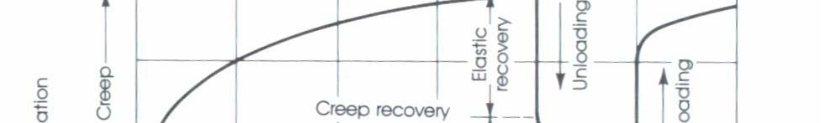
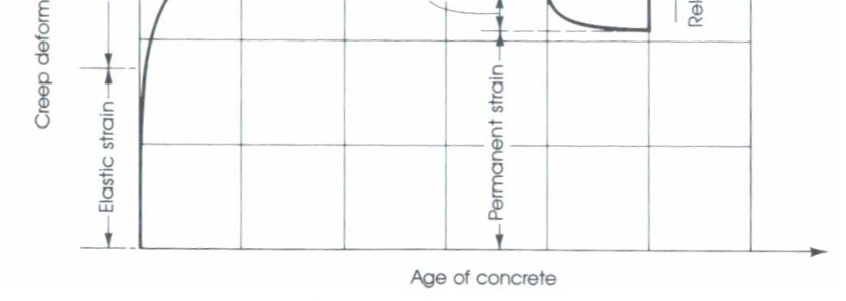
  - Like shrinkage, creep is not completely
P
L
δL, elastic
δL, creep
P
=δL/L

- Magnitude of creep strain is a function of all the above that affect shrinkage, plus
  - magnitude of stress
  - age at loading

- Creep strain develops over time…
  - Absorbed water layers tend to become thinner between gel particles that are transmitting compressive stresses
  - Bonds form between gel particles in their deformed position.

Concrete Propertie
where,
- Tri-axial Compression
  - Confined Cylinder
  - Improved strength and ductility versus uniaxial compression F
- Example: spiral reinforced
1
σ1 = f 'c + 4.1σ 3
F₁ = longitudinal stress at failure F₃ = lateral pressure
F
3
F1

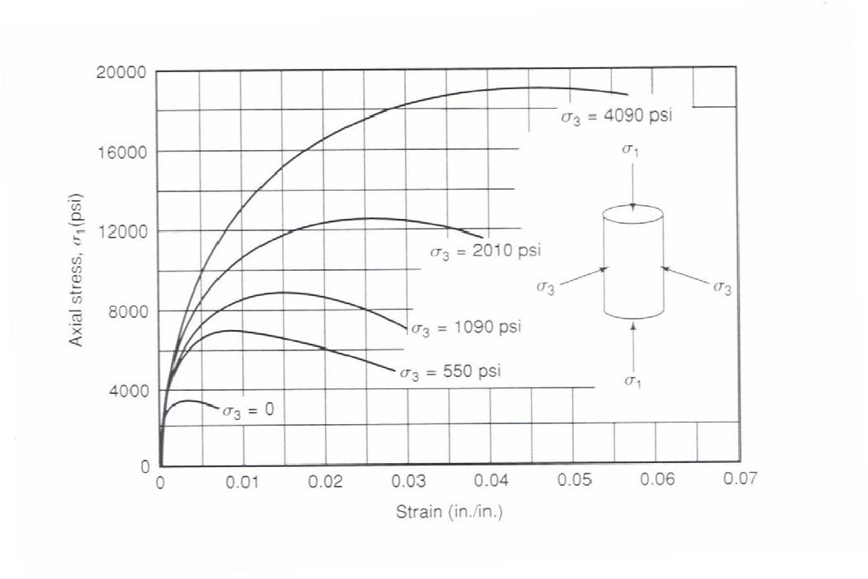
concrete Propertie
- Tri-axial Compression

Fig. 3-15, MacGregor (1997)

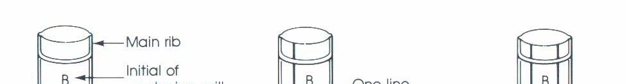
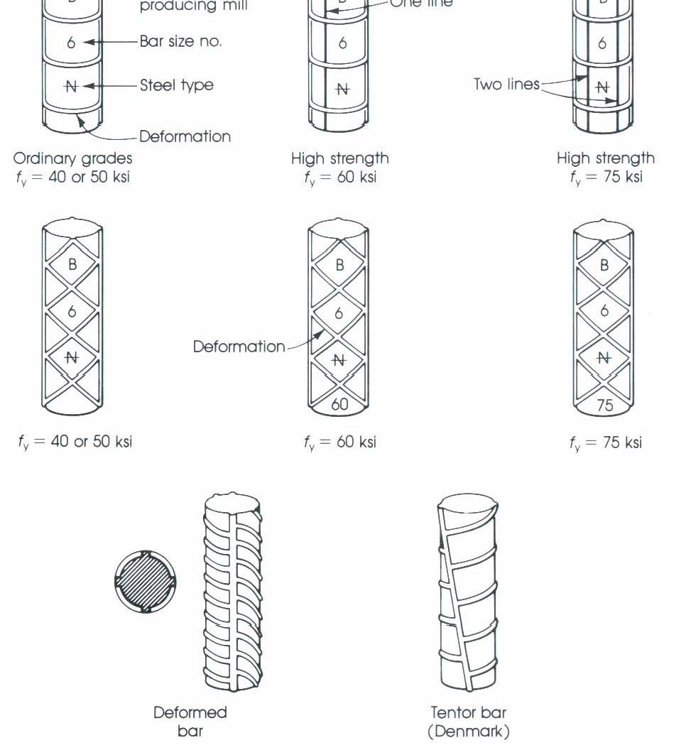
Steel Reinforcement

  - General
– Standard Reinforcing Bar Markings

    - General

Steel Reinforcement

      - Most common types for non-prestressed members:
        - hot-rolled deformed bars
        - welded wire fabric
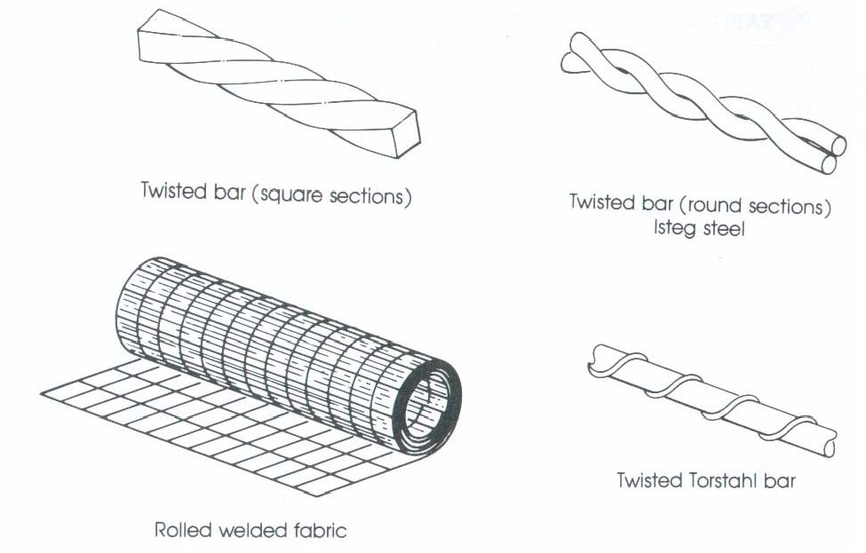

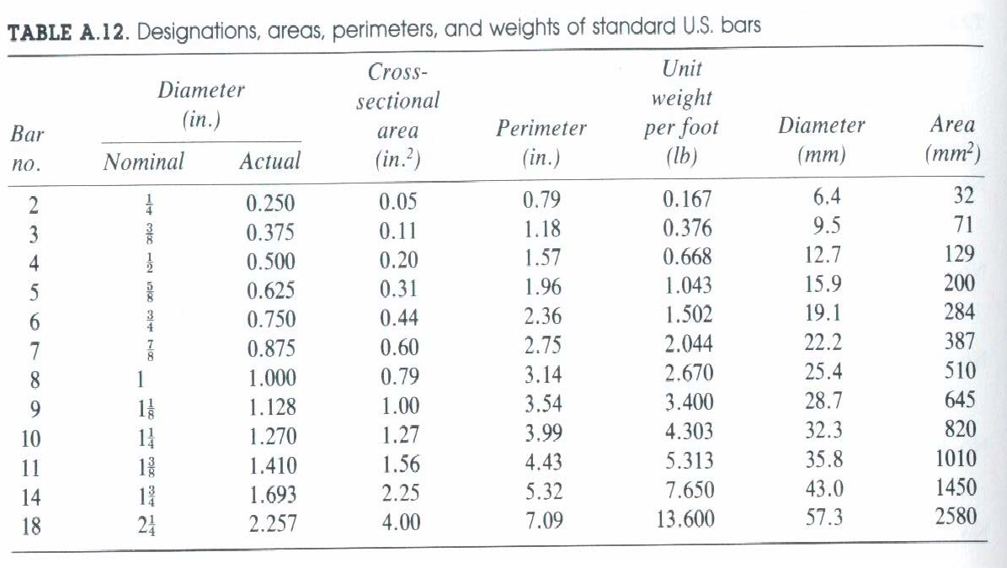
Steel Reinforcement
      - Areas, Weights, Dimensions

Steel Reinforcemen

    - Types
      - ASTM A615 - Standard Specification for Deformed and Plain-Billet Steel Bars
        - Grade 60: fy = 60 ksi, #3 to #18
          - most common in buildings and bridges
        - Grade 40: fy = 40 ksi, #3 to #6
          - most ductile
        - Grade 75: fy = 75 ksi, #6 to #18

Steel Reinforcement

- Types

  - ASTM A616 - Rail-Steel Bars
  - ASTM A617 - Axle-Steel Bars
  - ASTM A706 - Low-Alloy-Steel Bars
    - more ductile GR60 steel
    - min. length of yield plateau = εsh/εy = 5

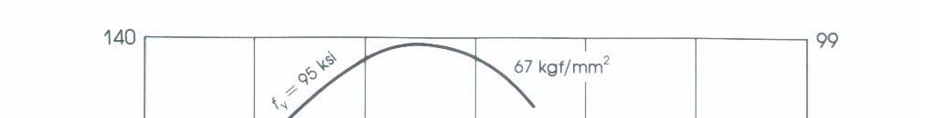
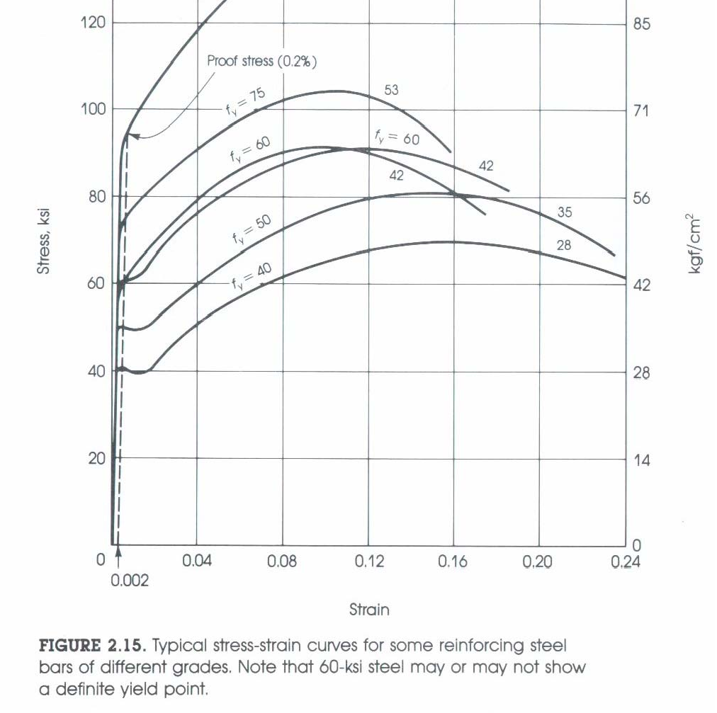
Steel Reinforcement

- Stress versus Strain
– Stress-Strain curve for various types of steel reinforcement bar.

Steel Reinforcemen

- Es = Initial tangent modulus
= 29,000 ksi (all grades)

Stress
- Note: Es
GR40 has a longer 1
yield plateau
GR 60 (less ductile) GR 40

0.20
S

