Lecture Goals

Loading (continued)
- Concrete Mixing and Proportioning

Concrete Properties
- Steel Reinforcement

Earthquake Load
Inertia forces caused by earthquake motion

F = m * a

- Distribution of forces can be found using equivalent
static force procedure (code, not allowed for every
building) or using dynamic analysis procedures

Earthquake Load
Inertia forces caused by earthquake motion. Equivalent Static Force Procedure for example, in ASCE 7-95:

where
V = Cs * W

V = Total lateral base shear
Cs = Seismic response coefficient W = Total dead load

Earthquake Load

Total Dead Load, W:
1.0 * Dead Load

+ 0.25 * Storage Loads
+ larger of partition loads or 10 psf

+ Weight of permanent equipment
+ contents of vessels
+ 20% or more of snow load

Earthquake Load

⎧1.2 C
2.5 C

C = smaller of
⎨ v
and a

s ⎩ R T
2 / 3 R

where
Cv = Seismic coefficient based on soil profile and Av Ca = Seismic coefficient based on soil profiled and Aa
R = Response modification factor (ability to deform in inelastic range)
T = Fundamental period of the structure

Earthquake Load

⎧1.2 C
2.5 C

C = smaller of
⎨ v
and a

s

where
⎩ R T
2 / 3 R

T = Fundamental period of the structure

T = CT hn 3/4

where CT = 0.030 for MRF of concrete
0.020 for other concrete buildings. hn = Building height

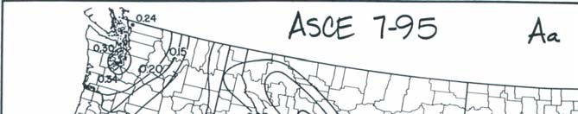
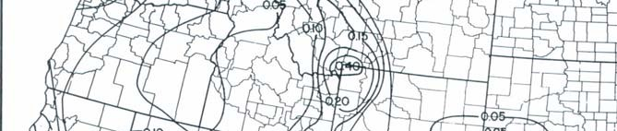
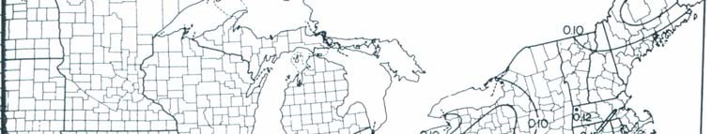
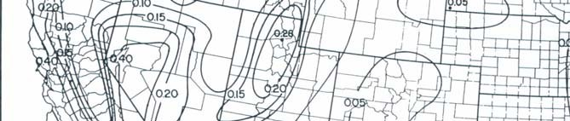
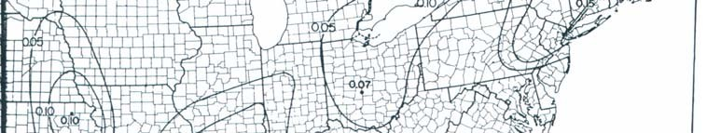
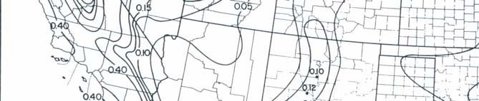
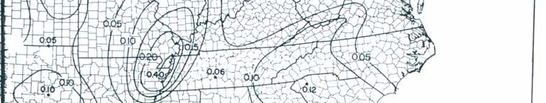
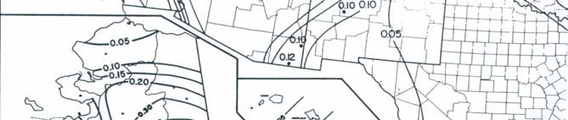
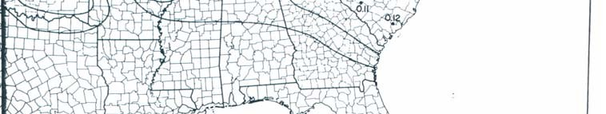
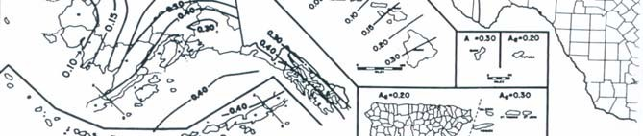
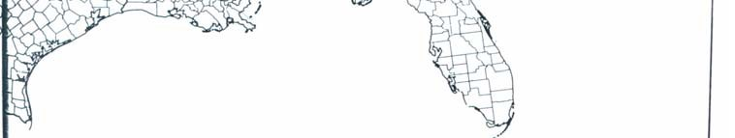
Earthquake Map

Roof Load
- Ponding of rainwater
  - Roof must be able to support all rainwater that could accumulate in an area if primary drains were blocked.
  - Ponding Failure:
→ Rain water ponds in area of maximum deflection
→ increases deflection
→ allows more accumulation of water → cycle continues…→ potential failure

Roof Load

    - Roof loads are in addition to snow loads

    - Minimum loads for workers and construction materials during erection and repair

Construction Loads

Construction materials

    - Weight of formwork supporting weight of fresh concrete

Proportioning
Failure Mechanism of Concrete
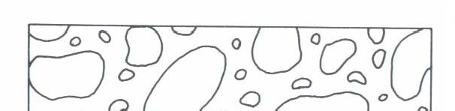
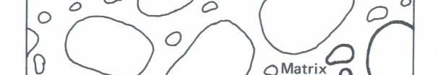
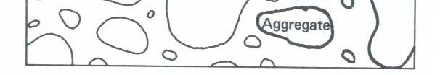


Shrinkage Microcracks are the initial shrinkage cracks due to carbonation shrinkage, hydration shrinkage, and drying shrinkage.

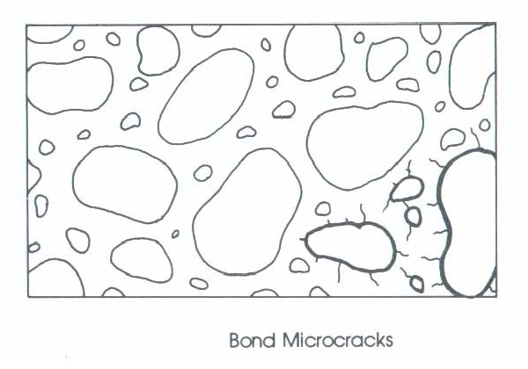
Proportioning
Failure Mechanism of Concrete
Bond Microcracks are extensions of shrinkage microcracks, as the compression stress field increases, the shrinkage microcracks widen but do not propagates into the matrix. Occur at 15- 20 % ultimate strength of concrete.

Proportioning

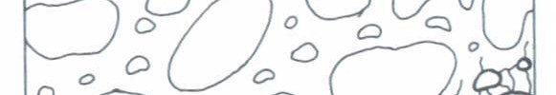
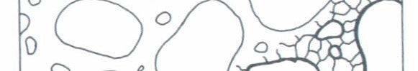
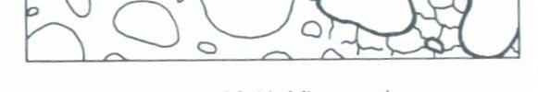
Failure Mechanism of Concrete
Matrix Microcracks - are microcracks that occur in the matrix. The propagate
from 20% fc. Occur up to
30-45 % ultimate strength
of concrete. Matrix
microcracks start bridge one another at 75%.
Aggregate microcracks occur just before failure (90%).

Concrete Properties
1. Uniaxial Stress versus Strain Behavior in Compression
fc
f’c
Ec
12”
0.45f’c
6”
o u 
c

Concrete Propertie

The standard strength test generally uses a cylindrical sample. It is tested after 28 days to test for strength, fc.
The concrete will continue to harden with time and for a
normal Portland cement will increase with time as follows:

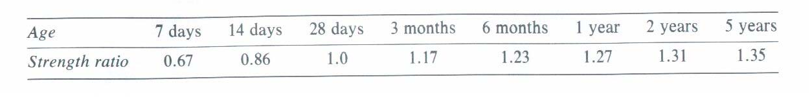

Concrete Propertie
- Compressive Strength, f’c
  - Normally use 28-day strength for design strength
- Poisson’s Ratio, ν
  - ν ~ 0.15 to 0.20
f’c
fc
Ec
- Usually use ν = 0.17 0.45f’c
o u 
c

Concrete Properties
- Modulus of Elasticity, Ec
  - Corresponds to secant modulus at 0.45 f’c
  - ACI 318-02 (Sec. 8.5.1):

E c (
psi
) = 33
w 1 . 5

where w = unit weight (pcf) 90 pcf < wc <155 pcf
f ' c
( psi
)

E c (
psi
) = 57
, 000

For normal weight concrete (wc ≅ 145 pcf)
f ' c
( psi
)

Concrete Propertie
- In-Class Exercise:
Compute Ec for f’c = 4500 psi for normal weight (145 pcf) concrete using both ACI equations:

E
c
( psi
) =
33
w
1 . 5
f '
c
( psi
)

E c (
f ' c
( psi
)
psi
) = 57
, 000

Concrete Properties
  - Concrete strain at max. compressive stress, o
    - For typical  curves in compression
    - o varies between 0.0015-0.003
    - For normal strength concrete, o ~ 0.002

fc
Ec
f’c

0.45f’c

o u

Concrete Properties
  - Maximum useable strain, u
    - ACI Code: u = 0.003
    - Used for flexural and axial compression

fc Ec
f’c

0.45f’c

o u

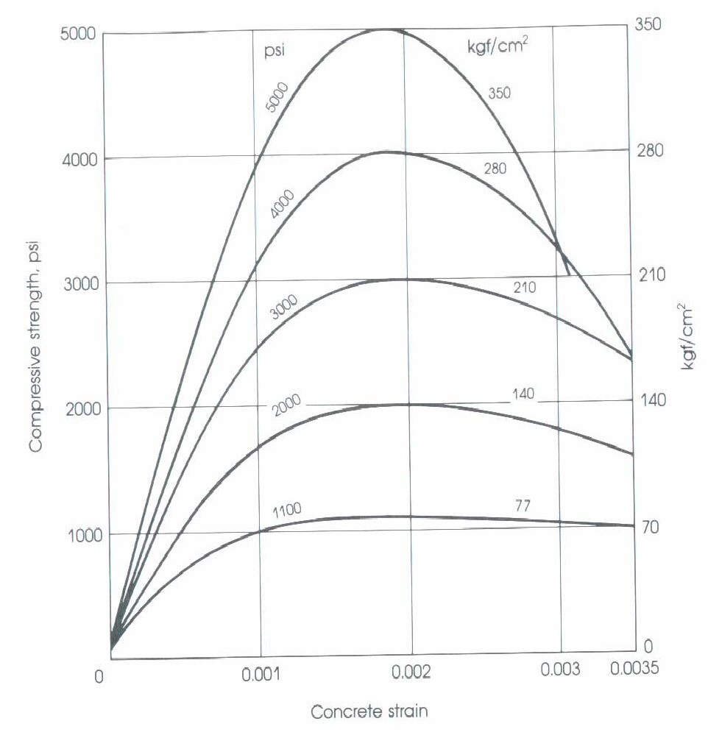
Concrete Propertie
Typical Concrete Stress-Strain Curves in Compression

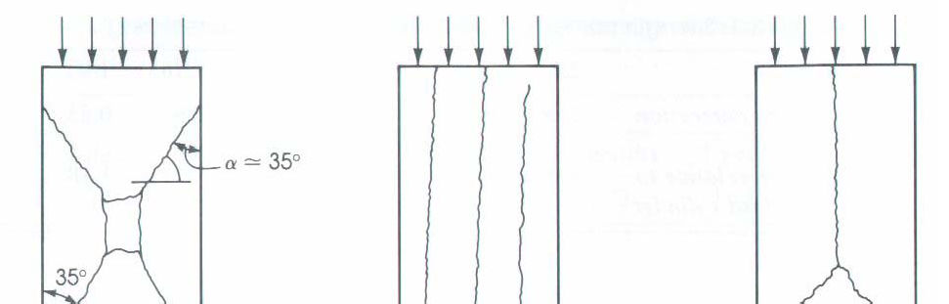
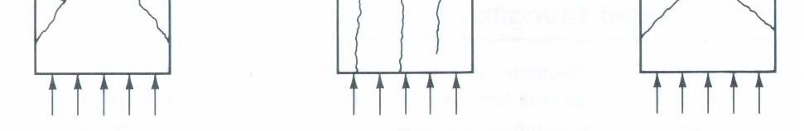
Concrete Propertie

Types of compression failure
There are three modes of failure.
- Under axial compression concrete fails in shear.
- the separation of the specimen into columnar pieces by what is known as splitting or columnar fracture.
- Combination of shear and splitting failure.

Concrete Properties
- Tensile Strength
  - Tensile strength ~ 8% to 15% of f’c
  - Modulus of Rupture, fr
    - For deflection calculations, use:




fr
f
– Test:
r
=
7 . 5
f ' c
( psi
)
ACI Eq. 9-10
P
unreinforced
concrete beam
f r =
Mc
I
=
6M
bh²
Mmax = P/2*a

Concrete Propertie

Tensile Strength (cont.)
  - Splitting Tensile Strength, fct
  - Split Cylinder Test
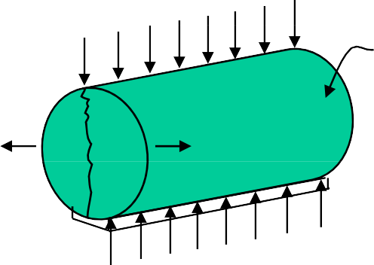
P
Concrete Cylinder
Poisson’s Effect

Concrete Propertie
- Tensile Strength (cont.)

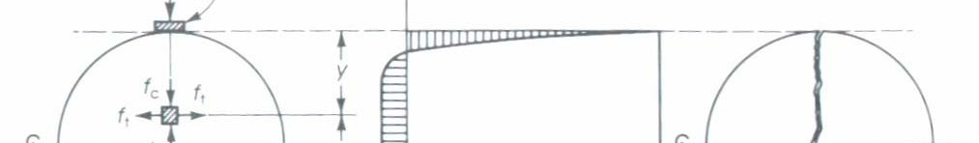
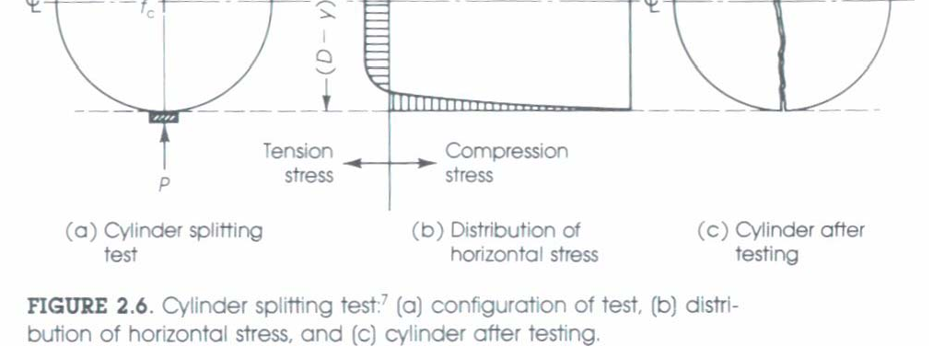
f
ct
= 2P
πld
fct = (5 to 7)
f 'c ( psi)
(Not given in ACI Code)

concrete Properties
- Shrinkage and Creep
  - Shrinkage: Due to water loss to atmosphere (volume loss).
    - Plastic shrinkage occurs while concrete is still “wet” (hot day, flat work, etc.)
    - Drying shrinkage occurs after concrete has set
    - Most shrinkage occurs in first few months (~80% within one year).
    - Cycles of shrinking and swelling may occur as environment changes.
    - Reinforcement restrains the development of shrinkage.

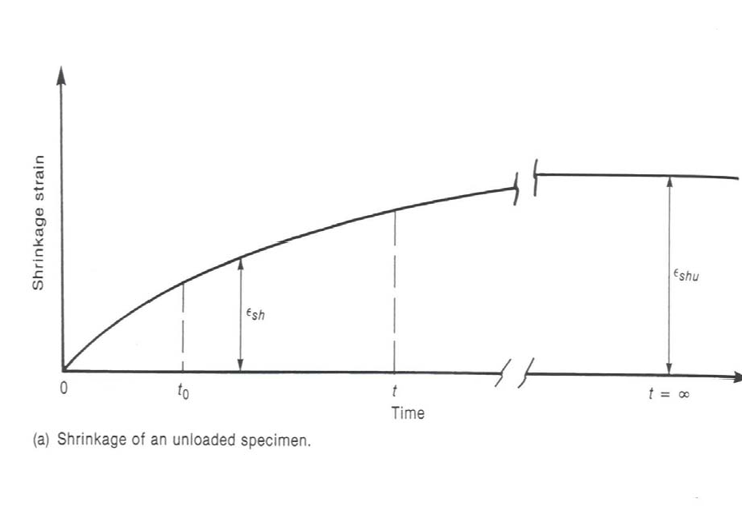
Concrete Properties
Shrinkage of an Unloaded Specimen
Fig. 3-21, MacGregor (1997)
- 80% of shrinkage occurs in first year

Concrete Properties

Shrinkage is a function of
    - W/C ratio (high water content reduces amount of aggregate which restrains shrinkage)
    - Aggregate type & content (modulus of Elasticity)
    - Volume/Surface Ratio

Concrete Properties

Shrinkage is a function of
  - Type of cement (finely ground…)
  - Admixtures
  - Relative humidity (largest for relative humidity of 40% or less).
  - Typical magnitude of strain: (200 to 600) * 10-6 (200 to 600 microstrain)

train

