Example

Notice that the centroid changes from 9.47 in. to
5.62 in. and the moment of inertia decreases from
6491 in4 to 2584 in4 . The cracked section loses
more than half of its’ strength.

Flexural Stress

Basic Assumptions in Flexure Theory
- Plane sections remain plane ( not true for deep beams h > 4b)
- The strain in the reinforcement is equal to the strain in the concrete at the same level,
i.e. εs = εc at same level.
- Stress in concrete & reinforcement may be calculated from the strains using σ−ε curves for concrete & steel.

Flexural Stress

Additional Assumptions for design (for simplification)
- Tensile strength of concrete is neglected for
calculation of flexural strength.
- Concrete is assumed to fail in compression, when
εc (concrete strain) = εcu (limit state) = 0.003
- Compressive σ−ε relationship for concrete may be assumed to be any shape that results in an acceptable prediction of strength.

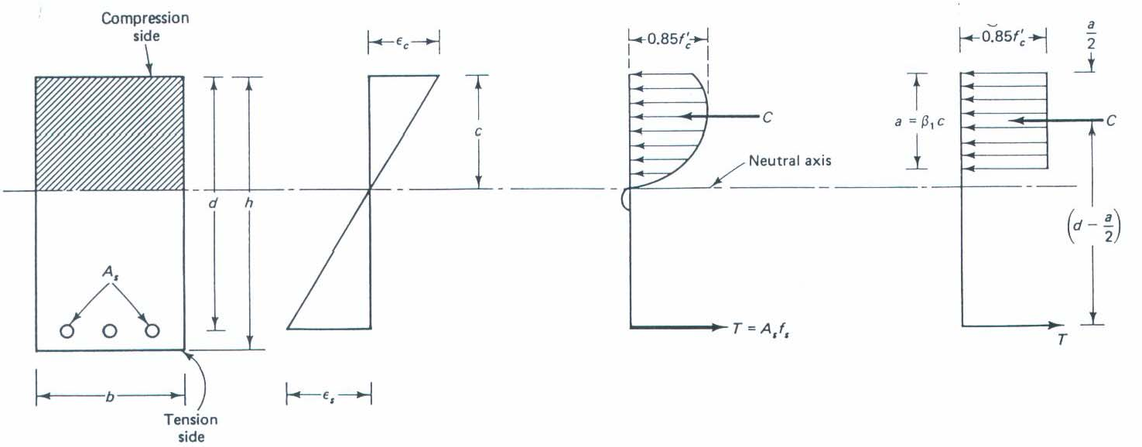
Flexural Stress

The concrete may exceed the εc
of the compressive zone.
at the outside edge

Flexural Stress
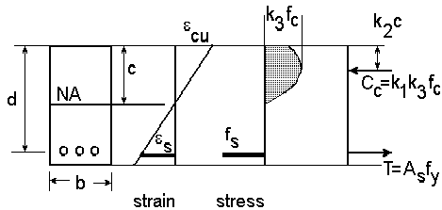
The compressive force is modeled as Cc = k1k3f’c b*c at the location x = k₂*c

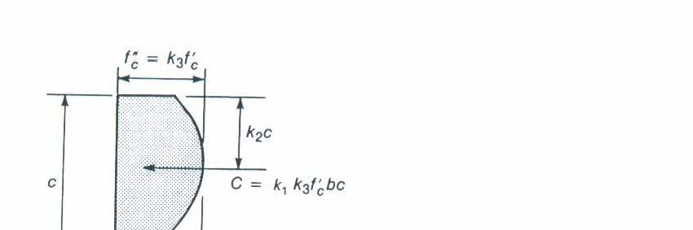
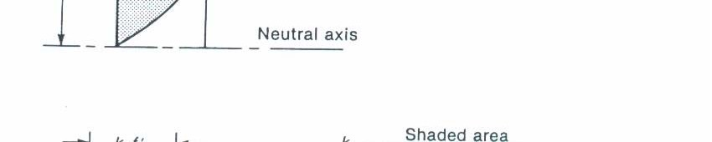
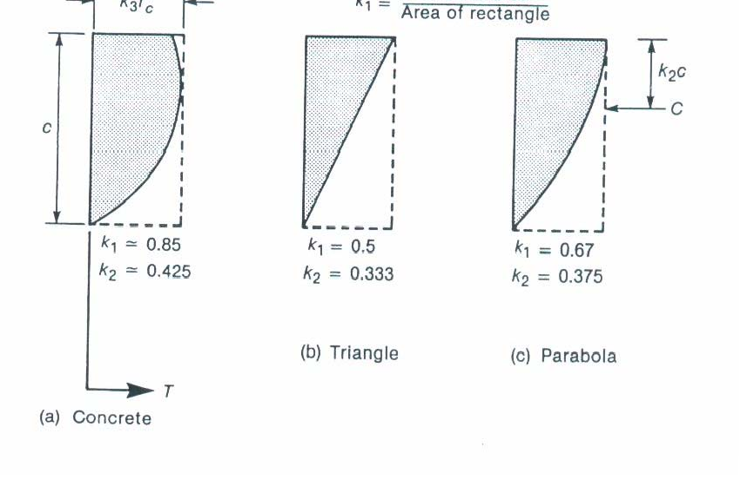
Flexural Stress
The compressive coefficients of the stress block at given for the following shapes.
k₃ is ratio of maximum stress at fc in the compressive zone of a beam to the cylinder strength, fc’ (0.85 is a typical value for common concrete)

The compressive zone is modeled with a equivalent stress block.
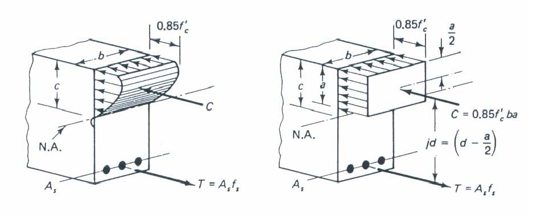

The equivalent rectangular concrete stress distribution has what is known as a β1 coefficient is proportion of average stress distribution covers.

β₁ =

for
fc ≤

4000
psi

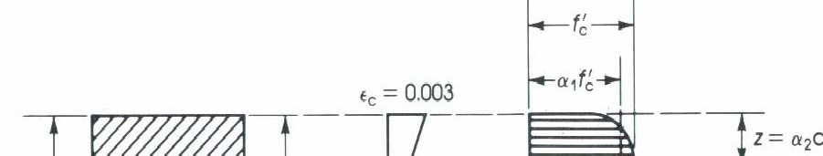
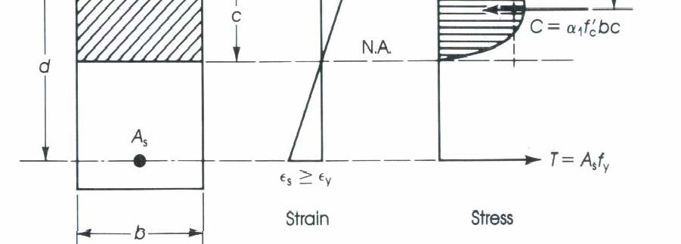
Requirements for analysis of reinforced concrete beams

- Stress-Strain Compatibility – Stress at a point in member must correspond to strain at a point.
- Equilibrium – Internal forces balances with external forces

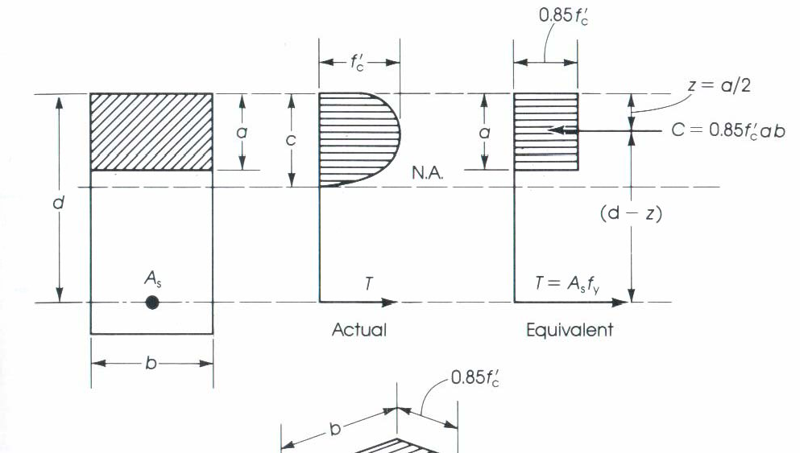


Flexural Stress
Example of rectangular reinforced concrete beam.
  - Setup equilibrium.

∑ Fx = 0 ⇒
T = C

As fs = 0.85 fc ab

∑ M = 0 ⇒
⎛ a ⎞
⎝ ⎟
⎜
2
−
=
M
T d
⎠

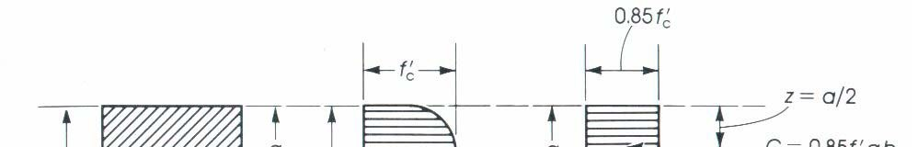
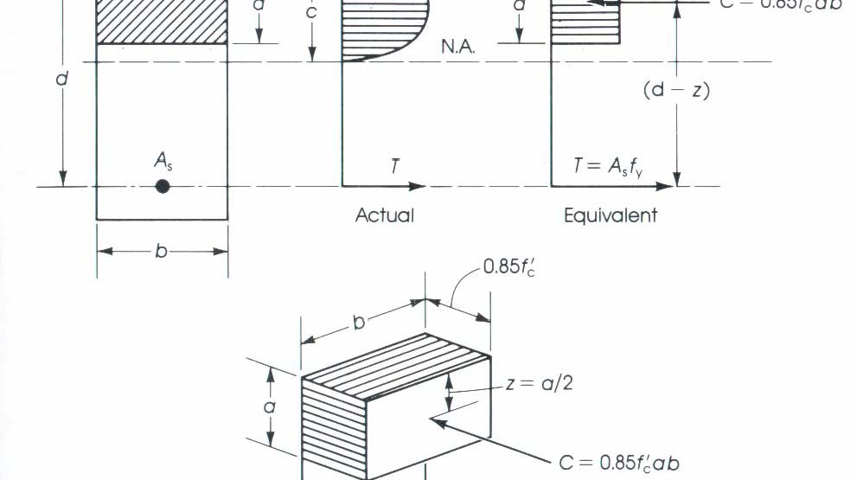

Flexural Stress
Example of rectangular reinforced concrete beam.
  - Find flexural capacity.
T = As fs

C = 0.85
a = As
fc ab fy

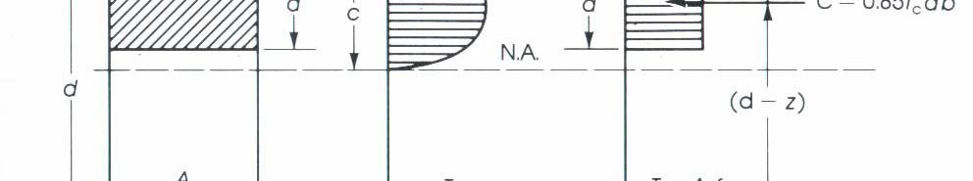
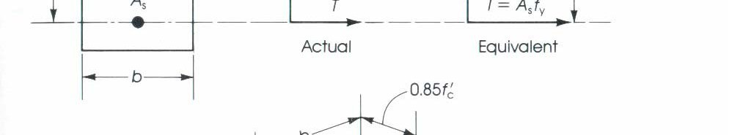
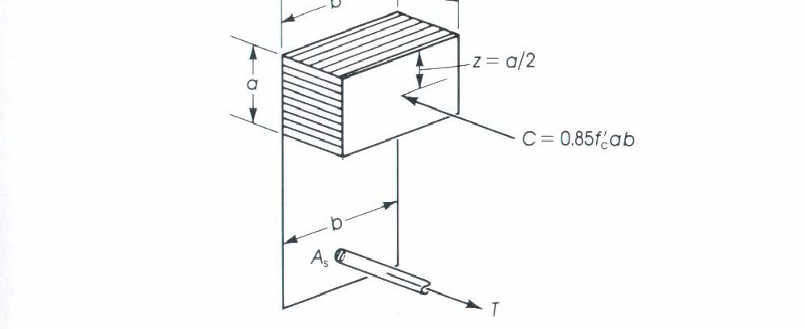
Flexural Stress
Example of rectangular reinforced concrete beam.
- Find flexural capacity.

Mn = T
(moment arm)

= As fy ⎜ 2 ⎟
d
⎛
−
a ⎞
⎝ ⎠

Flexural Stress
Example of rectangular reinforced concrete beam.
- Need to confirm εs > εy
ε = σ y
y
Es
c = a
β1

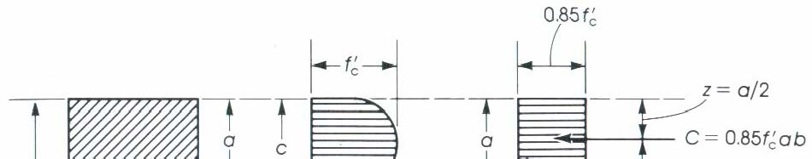
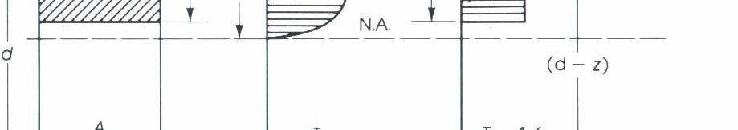
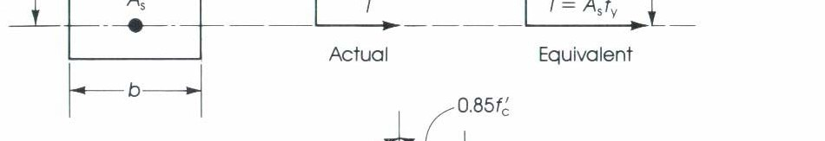

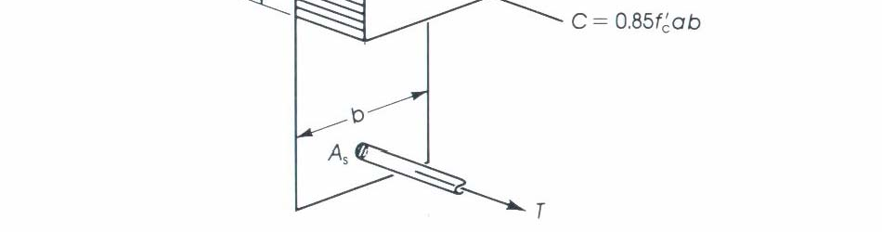
εs =
(d − c)ε
c c

- ε y

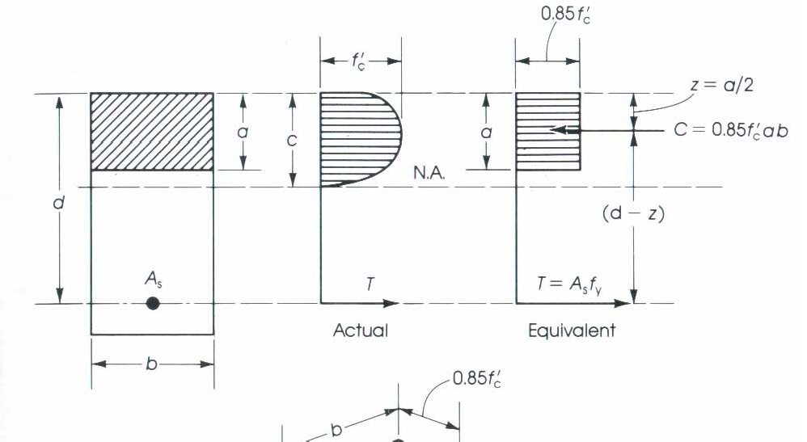
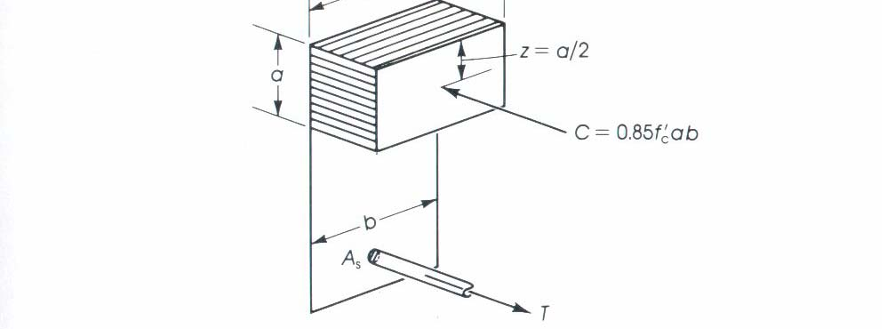

Flexural Stress Example
Example of rectangular reinforced concrete beam.
Given a rectangular beam fc = 4000 psi
fy = 60 ksi (4 #7 bars)
b = 12 in. d = 15.5 in. h= 18 in. Find the neutral axis.
Find the moment capacity of the beam.

