




Electromagnetic waves

Lecture 1

Vector Analysis and Vector Algebra
Msc. Ammar Kurem

Tow stage
Department of medical physics
Al-Mustaqbal University

2024-2025

  - Physical Quantities
In general, physical quantities are divided into two types:
- Scalar Quantities
These are quantities that are defined by their magnitude (magnitude) only. Examples include work, time, and mass, and they can be subject to normal algebraic operations when adding and subtracting.
- Vector Quantities
These are quantities that are defined by both their magnitude (Magnitude) and their direction (Direction). Examples include speed, force, and acceleration. These quantities are not subject to simple algebraic operations, but rather are subject to directional algebra when adding, subtracting, and multiplying.

- Vector Analysis and Vector Algebra

  - Vector is a quantity having both magnitude and direction such as displacement, velocity, force and acceleration.
Q - ……… is a quantity having both magnitude and direction such as displacement, velocity, force and acceleration.
a- vector b-Momentum c-energy d-Wave e-all

Vector: It is the basic building unit of linear algebra. Rather, it is the foundation on which all linear algebra is based.
Q- …….It is the basic building unit of linear algebra.
a- linear algebra b- Vector c-(a and b) d-all

- Vector Algebra
Laws of vector algebra. If A, B and C are vectors and m and n are scalars, then
A+ B = B + A Commutative Law for Addition
A+ (B+C) = (A+B) + C Associative Law for Addition
mA = Am Commutative Law for Multiplication
m (nA) = (mn) A Associative Law for Multiplication
(m+ n) A = mA + nA Distributive Law
m (A+ B) = mA + mB Distributive Law

- Example:
Let us take A = 10 and B = 5
A+ B = B + A Commutative Law for Addition
10 + 5 = 5 + 10
15 = 15

- Example:
Prove: - (3+7) = (-3)+(-7)
Proof:
-(10) = -3-7
-10 = -10
L.H.S = R.H.S

- Example:
Let us take A = 2, B = 4 and C = 6 L.H.S =A+(B+C) = 2 + (4 + 6)
= 12
R.H.S = (A+B)+C = (2 + 4) + 6
=12
L.H.S = R.H.S 12 = 12

- Example1- Find 1- A+B 2-A-B 3-A+2B
A= 2i+6j+3k B=i+2j+2k
Solution:
1- A+B=(2+1)i+ (6+2)j+(3+2)k = 3i+8j+5k
2-A-B= (2-1)i+(6-2)j+(3-2)k = i+6j+k
3-A+2B= ?

- Example:
Let us take A = 2, B = 4 and C= 6
L.H.S =A+(B+C) = 2 + (4 + 6)
= 12
R.H.S = (A+B)+C = (2 + 4) + 6
=12
L.H.S = R.H.S 12 = 12
12 = 12

Q-(Associative Law for Multiplication) What is the value of the left and right parts of the vector?: a=5 , m=3 , n=2 :………….
a- 30 b-40 c-50 d-60 e-70

1-3 Scalar product The process of multiplying a vector quantity by another vector quantity, the product of which is a non-vector scalar quantity, which has only an amount..

Q- …………..The process of multiplying a vector quantity by another vector quantity, the product of which is a non-vector scalar quantity, which has only an amount.
a- dot b- Cross c-(a and b) d-( b and c) e- all
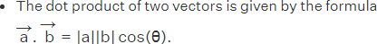

The following laws are valid:
- A . B = B . A Commutative Law for Dot Products
- A . (B + C) = A . B + A . C Distributive Law
- m(A . B) = (mA) . B = A . (mB) = (A . B)m, where m is a scalar. m
- i . i = j . j = k . k = 1, i . j = j . k = k . i = 0
- If A = Al i + A2 j + A3 k and B = Bl i + B2 j + B3 k, then
A . B = A1B1+A2 B2+A3 B3
A . A = A2 = A1 2 + A2 2 + A3 2 B . B = B 2 = B1 2 + B2 2 + B3 2
6. If A . B = 0 and A and B are not null vectors, then A and B are perpendicular.

Example: Find the scalar product of the vectors
a = 2i + 3j - 6k and b = i + 9k.
Solution: To find the scalar product of the given vectors a and b, we will multiply their corresponding components.
a.b = (2i + 3j - 6k).(i + 0j + 9k)
= 2.1 + 3.0 + (-6).9
= 2 + 0 – 54 ؟
= -52

Example:
Calculate the scalar product of vectors a and b when the modulus of a is 9, modulus of b is 7 and the angle between the two vectors is 60°.
Solution:
To determine the scalar product of vectors a and b, we will use the scalar product formula.
a.b = |a| |b| cosθ
= 9 × 7 cos 60°
= 63 × 1/2
= 31.5

Q - Calculate the scalar product of vectors a and b when the modulus of a is 9, modulus of b is 7 and the angle between the two vectors is 60°.
a-31.5 b-31.6 c-31.7 d-31.8 e-31

Q- In the scalar product, the value of the relationship i . i = j . j = k . k = …………
a- 0 b-1 c-2 d-(a and b) e-all

1-4 Vector products
The process of multiplying a vector quantity by another vector quantity, the product of which is a vector quantity with magnitude and direction.
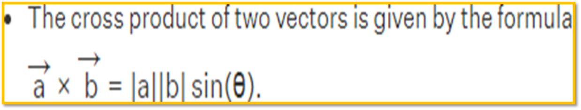

Cross or vector product
1-4-1 The following laws are valid:
- A × B = - B × A Commutative Law for Cross Products Fails
- A × (B + C) = A × B + A × C Distributive Law
- m(A × B) = (mA) × B = A × (mB) = (A × B)m , where m is a scalar.
- i × i = j × j = k × k = 0
i × j = −j × i = k,
j × k = −k × j = i,
k × i = −i × k = j.
5. If A = Al i + A2 j + A3 k and B = Bl i + B2 j + B3 k, then
6. The magnitude of A × B is the same as the area of a parallelogram with sides A and B.
7. If A × B = 0 and A and B are not null vectors, then A and B are parallel.
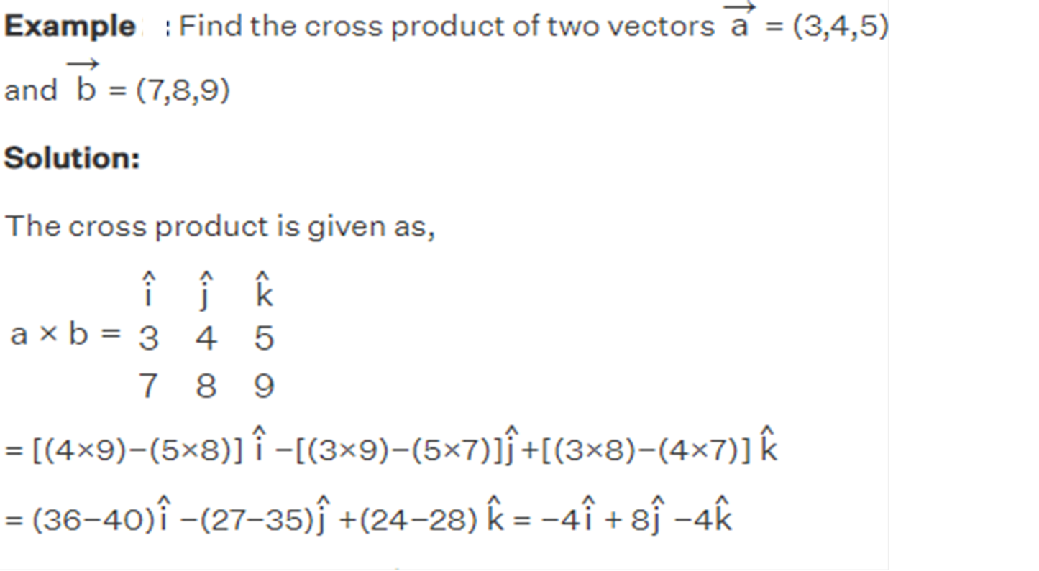

Example: Two vectors have their scalar magnitude as
∣a∣=2√3 and ∣b∣ = 4, while the angle between the two vectors is 60∘.
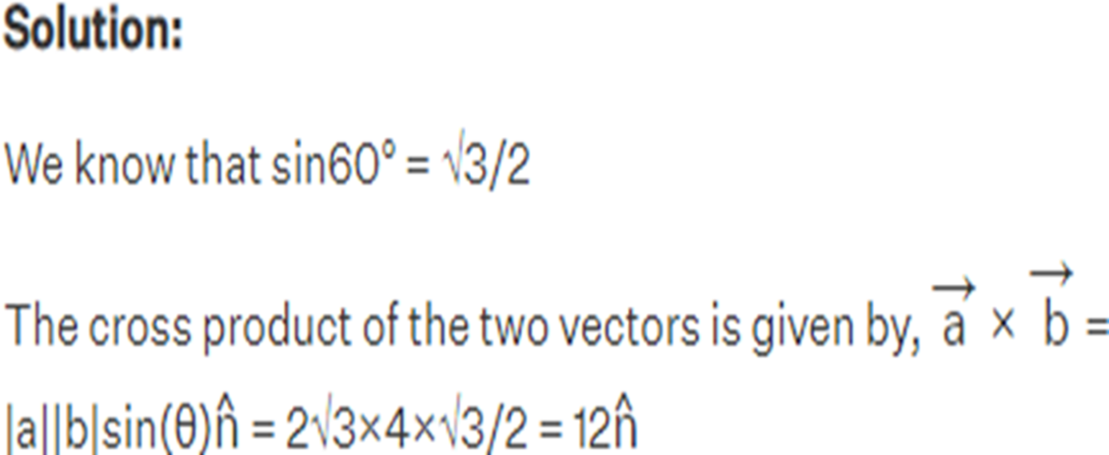
Calculate the cross product of two vectors

Key points
• Cross multiplication is an operation that can be performed on two vectors to produce another vector.
- Cross product is represented by a multiplication sign placed between the two vectors.
• Cross product ⃑𝑖×⃑𝑗 It equals ⃑𝑘
- The cross product ⃑𝑗×⃑𝑖 equals −⃑𝑘
- If the two vectors are parallel in the same direction or parallel in the opposite directions, then their cross product is 0.
- The cross product has a maximum value when the two vectors make a right angle to each other.

