




Electromagnetic waves

Lecture 2

System of Coordinates and Application
Msc. Ammar Karem
Tow stage
Department of medical physics
Al-Mustaqbal University-College

- Coordinate System
- Used to describe the position of a point in space
- Coordinate System consists of
- A fixed reference point called the origin
- Specific axes with scales and labels
- Instruction on how to label a point relative to the origin and the axes

- Types of Coordinate Systems
- Number line. . A number line (also called a number axis) is an infinite line on which real numbers are designated: every point on the number line fits a real number, which may be a positive integer, a negative integer, zero, a fraction, or an irrational decimal number.
- Cartesian coordinate system.
- Polar coordinate system.
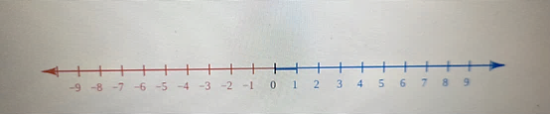
- Cylindrical and spherical coordinate systems.
- Homogeneous coordinate system.
- Other commonly used systems.
- Relativistic coordinate systems.

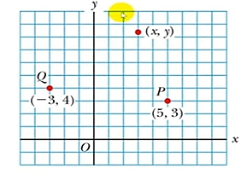
- Cartesian Coordinate System
- Also called rectangular Coordinate System
- x- and y- axes intersect at the origin
- Points are labeled ( x , y )
- The plural of axis is axes
- Ordered pair (x , y) with x-value first

Example /Determine the following points
a.(2 ,3 )
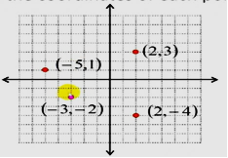
b.(-5 ,1)
c.(-3,-2)
d.(2,-4)
solution :

- Polar coordinate system
- Origin and reference line are noted.
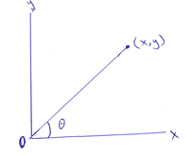
- Point is distance r from the origin in the direction of angle θ , from reference line .
- Points are labeled (r , θ) .

- Polar to Cartesian coordinates
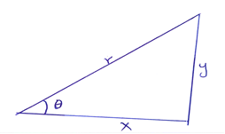
$sinθ=\frac{y}{r}$ , $cosθ=\frac{x}{r}$ , $tanθ=\frac{y}{x}$
- Based on forming a right triangle from r and θ .
- $x=r\cos{θ}$
- $y=r\sin{θ}$

- Cartesian to Polar coordinates
- If the Cartesian coordinates are known :
- r is the hypotenuse and θ an angle
$$tanθ=\frac{y}{x}$$
$$r=\sqrt{x^{2}+y^{2}}$$
- θ must be ccw from positive x axis for these equations to be valid
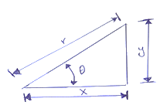
Example : The Cartesian coordinates of a point in the xy Plane are (x,y)=(12 , 5 ) . Fined the polar coordinates of this point .
Solution : from equation
$r=\sqrt{x^{2}+y^{2}}$
$$r=\sqrt{{12}^{2}+5^{2}}$$
$$r=13$$
And from equation ,
$$tanθ=\frac{y}{x}$$
$$tanθ=\frac{5}{12}$$
$$θ=\tan^{-1}\left(\frac{5}{12}\right)$$
θ=${22,6}^{°}$
- Cylindrical coordinate systems
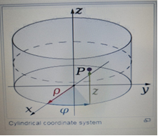
- There are two common methods for extending the polar coordinate system to three dimensions.
- In the cylindrical coordinate system, a z coordinate with the same meaning as in Cartesian coordinates is added to the r and θ polar coordinates giving a triple (r , θ , z).

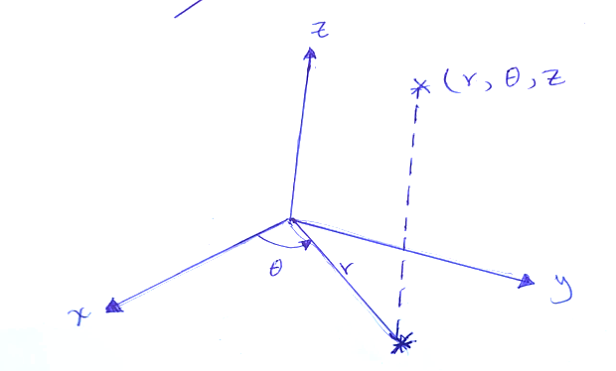
- Convert from Cartesian coordinates to cylindrical coordinates

(x, y,z) $→$ (r,θ,z)
$θ=\tan^{-1}\left(\frac{y}{x}\right)$
$z=z$
- Convert from cylindrical coordinates to Cartesian coordinates

(r,θ,z) $→$ (x,y,z)
$x=rcosθ$
$y=rsinθ$
z=z

Example: Convert from cylindrical coordinates to Cartesian coordinates $(4, \frac{2π}{3}$ ,-2 )
Solution : $x=rcosθ$
$x=4\cos{\frac{2π}{3}}$
$x=-2$
$y=rsinθ$

$y=4sin\frac{2π}{3}$
$y=2\sqrt{3}$
z=z
z=-2
p=(-2,2$\sqrt{3}$ ,-2)

Example: Convert from Cartesian coordinates to cylindrical coordinates $(1,-3, 5)$

Solution :
$r=\sqrt{x^{2}+y^{2}}$
$r=\sqrt{1^{2}+{-3}^{2}}$
$r=\sqrt{10}$
$θ=\tan^{-1} (\frac{y}{x})$
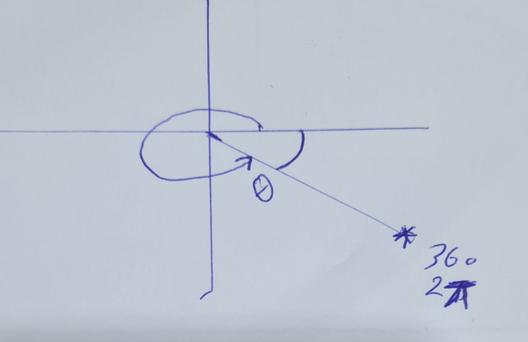
$θ=\tan^{-1} (\frac{-3}{1})$
$θ=-71.56$
$θ=2π+71.56$
$θ=431.56$
z = z
z = 5
(r,θ,z) = ($\sqrt{10}$ , 5.03 , 5 )

Homework :
Convert from Cartesian coordinates to polar coordinates (3,-3,-7) .
$r=\sqrt{x^{2}+y^{2}}$
$r=\sqrt{18}$
$θ=\tan^{-1} \left(\frac{y}{x}\right)$
$θ=\tan^{-1} \left(\frac{-3}{3}\right)$
$θ=\tan^{-1} (-1)$
$θ=-45$
$θ=-45+2π=….$
(r,$θ$) = ($\sqrt{18}, ….$)

- Spherical Coordinate System
In mathematics, a spherical coordinate system is a coordinate system for three-dimensional space where the position of a point is specified by three numbers: the radial distance of that point from a fixed origin, its polar angle measured from a fixed zenith direction, and the azimuthal angle of its orthogonal projection on a reference plane that passes through the origin and is orthogonal to the zenith, measured from a fixed reference direction on that plane. It can be seen as the three-dimensional version of the polar coordinate system.
- The radial distance is also called the radius or radial coordinate. The polar angle may be called colatitude, zenith angle, normal angle, or inclination angle.
Definition
To define a spherical coordinate system, one must choose two orthogonal directions, the zenith and the azimuth reference, and an origin point in space. These choices determine a reference plane that contains the origin and is perpendicular to the zenith. The spherical coordinates of a point P are then defined as follows:
1-The radius or radial distance is the Euclidean distance from the origin O to P.
2-The inclination (or polar angle) is the angle between the zenith direction and the line segment OP.
3-The azimuth (or azimuthal angle) is the signed angle measured from the azimuth reference direction to the orthogonal projection of the line segment OP on the reference plane.

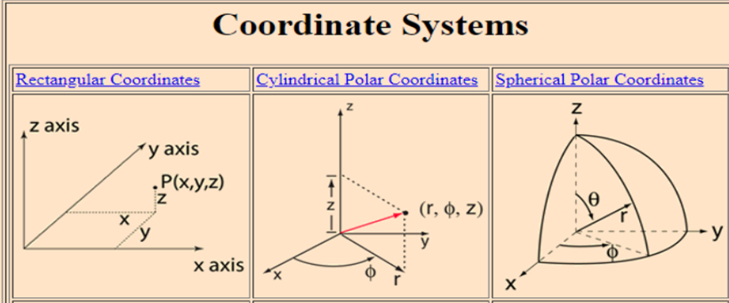

=r sin ɵ cos Φ
Y= r sin ɵ sin Φ
Z= r cos ɵ
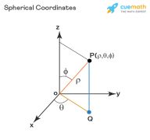
Example: Convert from Spherical coordinates to Cartesian Coordinate System (4,30,60)
Solution:-
X=r sin ɵ cos Φ
X= 4sin(30 ) cos (60)
x=1
Y= 4sin( 30).sin (60)
Y=$\sqrt{3}$
Z= 4cos (30)
Z= 2$\sqrt{3}$
r=$\sqrt{x^{2}+y^{ 2}}$+z²
Φ = tan⁻¹ (y/x)
ɵ = tan⁻¹ ($\frac{\sqrt{x2+y2}}{z}$ )

- Homogeneous coordinate system
A point in the plane may be represented in homogeneous coordinates by a triple (x,y,z) where x/z and y/z are the Cartesian coordinates of the point. this introduces an extra coordinate since only two are needed to specify a point on the plane, but this system is useful in that it represents any point on the projective plane without the use of infinity . in general, a homogeneous coordinate system is one where only the ratios of the coordinates are significant and not the actual values.

- Other commonly used systems
Some other common coordinate systems are the following:
1- Curvilinear coordinates are a generalization of coordinate systems generally; the system is based on the intersection of curves.
- Orthogonal coordinates: coordinate surfaces meet at right angles
- Skew coordinates: coordinate surfaces are not orthogonal
2- The log-polar coordinate system represents a point in the plane by the logarithm of the distance from the origin and an angle measured from a reference line intersecting the origin.
3- Plücker coordinates are a way of representing lines in 3D Euclidean space using a six-tuple of numbers as homogeneous coordinates.
4- Generalized coordinates are used in the Lagrangian treatment of mechanics.
5- Trilinear coordinates are used in the context of triangles.
- Applications
- Just as the two-dimensional Cartesian coordinate system is useful on the plane, a two-dimensional spherical coordinate system is useful on the surface of a sphere. In this system, the sphere is taken as a unit sphere, so the radius is unity and can generally be ignored. This simplification can also be very useful when dealing with objects such as rotational matrices.

- Three dimensional modeling of loudspeaker output patterns can be used to predict their performance. A number of polar plots are required, taken at a wide selection of frequencies, as the pattern changes greatly with frequency. Polar plots help to show that many loudspeakers tend toward Omni directionality at lower frequencies.

- Spherical coordinates are useful in analyzing systems that have some degree of symmetry about a point, such as volume integrals inside a sphere, the potential energy field surrounding a concentrated mass or charge, or global weather simulation in a planet's atmosphere. A sphere that has the Cartesian equation x2 + y2 + z2 = c2 has the simple equation r = c in spherical coordinates.

Homework:-
Convert from Spherical coordinates to Cartesian Coordinate System (8,30,60) .

