ALMUSTAQBAL UNIVERSITY


College of Medical and Health Techniques
Medical Laboratories Techniques Departments

Biochemistry Lectures for 2nd Year Students

(2 Credit Hrs. Theory + 2 Credit Hrs. Practice / Week = 3 Credit Unit
Academic Year: 2024 - 2025

Course Organizers:

- Prof. Dr. Fadhil Jawad Al-Tu'ma, Ph.D., Professor of Clinical Biochemistry.
- Dr. Dalya Shakir Obaida, Ph.D. Lecturer of Clinical Biochemistry.

Enzymes, Properties, Functions and Enzymes Classifications
Date: OCT, 6 , 2024

Enzyme Specificity:
Enzyme specificity defines the capacity of protein catalysts to recognize and bind only one or a few molecules, the substrate [S], excluding all others, a process referred to as binding specificity. Binding specificity permits many biochemical reactions to occur simultaneously within the same biological space. The specificity is of three different types namely:
- Stereochemical specificity,
- Reaction specificity
- Substrate specificity.
Stereo specificity
Optical Specificity. There can be many optical isomers of a substrate. However, it is only one of the isomers which acts as a substrate for an enzyme action, e.g. for the oxidation of D- and L-amino acids, there are two types of enzyme which will act on D- and L-isomers of amino acids. Secondly there can be a product of enzyme action which can have isomers. However, it is only one kind of isomer which will be produced as a product, e.g. Succinic dehydrogenase while acting on succinic acid will give only fumaric acid and not malic acid which is its isomer.
Example of stereospecificity
Enzymes exhibit geometric specificity exemplified by the fumarase reaction, in which the Krebs cycle intermediate, fumarate (the trans isomer), but not malate (the cis isomer) undergoes hydration. This type of enzymes specificity is called stereochemical specificity. Lactate dehydrogenase, acting on pyruvate will form only L-lactate, but not the D-lactate,

Reaction Specificity:
A substrate can undergo many reactions but in reaction specificity one enzyme can catalyze only one of the various reactions. For example, oxaloacetic acid can undergo several reactions but each reaction is catalyzed by its own separate enzyme which catalyzes only that reaction and none of the others.
Substrate Specificity:
The extent of substrate specificity varies from enzyme to enzyme. There are two types of substrate specificity viz, absolute specificity and relative specificity.
- Absolute specificity is comparatively rare such as urease which catalysis hydrolysis of urea. Some enzymes are absolutely specific. For example, hydrolysis of urea to ammonia and carbon dioxide is catalyzed by urease. Urea is the only substrate for urease. Thiourea, though structurally similar to urea, will not act as the substrate for urease. Thus, these enzymes show absolute specificity.
- Relative substrate specificity is further divided as:
- Group Dependent. Examples of group specificity are trypsin, chymotrypsin. Trypsin hydrolyses the residues of only lysine and arginine, while chymotrypsin hydrolyses residues of only aromatic amino acids.
- Bond Specificity: Bond specificity is observed in case of proteolytic enzymes, glycosidases and lipases which act on peptide bonds, glycosidic bonds and ester bonds respectively. Most of the proteolytic enzymes are showing group (bond) specificity. For example, trypsin can hydrolyze peptide bonds formed by carboxyl groups of arginine or lysine residues in any protein.
Enzyme Active Site:
What is the active site or catalytic site of an enzyme?
Active site or catalytic site of an enzyme is:
- The region that binds substrate(s) and converts it into product(s);
- Relatively small part of the whole enzyme molecule;
- Three-dimensional entity formed by amino acid residues that can lie far apart in the linear polypeptide chain;
- Substrate binds in active site by multiple weak forces such as (Electrostatic interactions, Hydrogen bonds, Van der Waals bonds, Hydrophobic interactions, Reversible covalent bonds).
- Binding of substrate to active site gives the Enzyme-Substrate complex (ES) as shown in figure below;
- Catalytically active residues within the active site acts on substrate, forming “Transition state” and then products, which are released to product and the enzyme was liberated unchanged.

Michaelis-Menten Theory:
- In 1913, Michaelis and Menten put forward the Enzyme-Substrate complex theory. Accordingly, the enzyme (E) combines with the substrate (S), to form an enzyme-substrate (ES) complex, which immediately breaks down to the enzyme and the product (P) as in figure below
E + S ◄====► ES Complex ---------► E + P
- Alkaline phosphatase hydrolyzes a number of phosphate esters including glucose-6-phosphate. The active center of this enzyme contains a Serine residue, and the reaction is taking place in the following two steps:

- E-Serine-OH + Glucose-6-P ------------► E-Serine-O-P + Glucose
- E-Serine-O-P ------------► E-Serine-OH+Pi
Thus, the overall reaction is Glucose-6-P -----------► Glucose + Pi
In this reaction mixture, the enzyme substrate complex, E-Serine-O-P, has been isolated.

Fischer’s Template Theory
- It states that the three-dimensional structure of the active site of the enzyme is complementary to the substrate.
- Thus enzyme and substrate fit each other. Substrate fits on the enzyme, similar to lock and key. The lock can be opened by its own key only (Fig 1 and 2).
- However, Fischer envisaged a rigid structure for enzymes, which could not explain the flexibility shown by enzymes.

Fig. 1: Fischer’s template theory

Fig. 2: Enzyme and substrate are specific to each other. This is similar to key and lock (Fischer's theory)

Koshland’s Induced–Fit Theory
- Conformational changes are occurring at the active site of enzymes concomitant with the combination of enzyme with the substrate. At first, substrate binds to a specific part of the enzyme.
- This leads to more secondary binding and conformational changes. The substrate induces conformational changes in the enzyme, such that precise orientation of catalytic groups is effected (Fig. 3 and 4). A simplified explanation is that a glove is put on a hand. At first, the glove is in a partially folded position, but hand can enter into it. When the hand is introduced, the glove is further opened. Similarly, conformational changes occur in the enzyme when the substrate is fixed.
- When substrate analog is fixed to the enzyme, some structural alteration may occur; but reaction does not take place due to lack of proper alignment (Fig. 9). Allosteric inhibition can also be explained by the hypothesis of Koshland.

Fig. 3: Correct alignment of amino acids in the

Fig. 4 : Koshland’s induced fit theory

    - Enzyme has shallow grooves; substrate alignment is not correct.
    - Fixing of substrate induces structural changes in enzyme
    - Now substrate correctly fits into the active site of enzyme.
    - Substrate is cleaved into two products
Enzymes contain a surface region referred to as the active site where binding and catalysis occur. It is a cleft or crevice in which are embedded specific groups, suitably oriented, which carry out the roles of binding, and bond-making or bond cleavage. The three-dimensional shape of the active site is a vital determinant in the recognition and specificity process. The enzyme–substrate complex (ES) is the adduct formed by the physical adsorption of the substrate to the active site. Enzyme–substrate complex formation requires specific alignment of atoms in the active site with atoms in the substrate molecule.Fig. 5 and 6

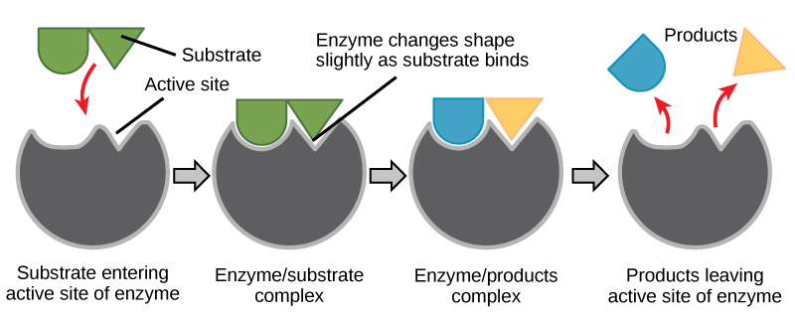
Fig. 5 : Lock and key model
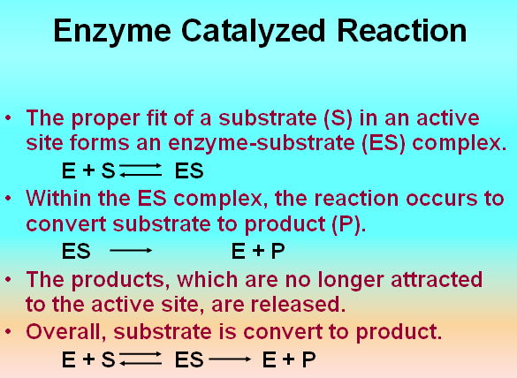
.
Isoenzymes:
They are physically distinct forms of the same enzyme activity. Multiple molecular forms of the same enzyme synthesized from various tissues are called iso-enzymes. Hence, study of iso-enzymes is very useful to understand diseases of different organs. If the subunits are all the same, the protein is a homomultimer represented by a single gene. If the subunits are different, protein is said to be a heteromultimer, produced by different genes.
Iso-enzymes may be Formed in Different Ways
- true iso-enzymes: They may be products of different genes in which case e.g. salivary and pancreatic amylase.
- In certain cases, all the different forms are present in the same individual, e.g. Lactate dehydrogenase (LDH) has 5 iso-enzymes and all are seen in all persons in the population.
- allozymes :The same locus of the gene may have different .only one form will be present in one individual; but all the different forms will be seen in total population. For example, more than 455 distinct forms of glucose-6-phosphate dehydrogenase (GPD) have been identified.
- iso-forms, e.g. sialic acid content in alkaline phosphatase (ALP) iso-enzymes. Different types of iso-forms may be seen in the same individual.

Factors Affecting Enzyme Activity
Activity of enzymes is markedly affected by several factors such as temperature, pH, conc. of other substances, presence of activators or inhibitors, etc.
- Effect of Temperature:
Each enzyme is most active at a specific temperature which is called its optimum temperature. Temperature increases the total energy of the chemical system with the result the activation energy is increased. The exact ratio by which the velocity changes of 10 ºC temperature rise is the Q₁₀ or temperature coefficient. A measure of the effect of a 10 °C rise in temperature on the velocity of a chemical reaction. The Q₁₀ is expressed as the ratio of the velocity of a chemical reaction at a given temperature to that of the same reaction at a temperature 10 °C lower. Reactions velocity almost doubles with 10 ºC rise (Q₁₀ = 2) in many enzymes. Activity of enzyme progressively decreases when the temperature of reaction is below or above the optimum temperature. However, increase in temperature also causes denaturation of enzyme. Note: The shape of the curve is bell-shape. Most of the enzymes of human system have an optimum temperature within the range of 35-40 ºC. Thus, the optimum temperature is that temperature at which the activity of the enzyme is maximum (Fig. 1).

Fig. 1: Effect of temperature on enzymatic reaction Fig. 2: Effect of enzyme concentration

- Effect of Enzyme Concentration:
Rate of a reaction or velocity (Ʋ_{o}) is directly proportional to the enzyme concentration, when sufficient substrate is present. Velocity of reaction is increased proportionately with the concentration of enzyme, provided substrate concentration is unlimited (Fig. 2).
- Effect of Substrate Concentration:
In a typical reaction, the enzyme may be present in nanomolar quantities, whereas [S] may be five or six orders of magnitude higher. If only the beginning of the reaction is monitored (often the first 60 seconds or less), changes in [S] can be limited to a few percent and [S] can be regarded as constant. The initial velocity, Ʋ_{o} can then is explored as a function of [S], which is adjusted by the investigator. The effect on Ʋ_{o} of varying [S] when the enzyme concentration is held constant is shown in
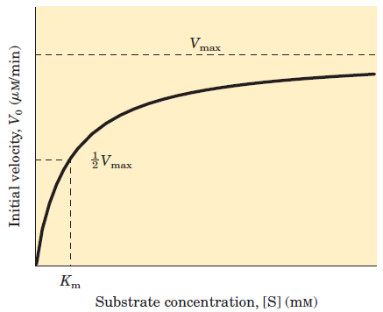
Fig. 4: Effect of substrate concentration on the Fig. 3: Effect of substrate concentration

initial Velocity of an enzyme-catalyzed reaction
At relatively low concentrations of substrate, Ʋ_{o} increases almost linearly with an increase in [S] (First-order kinetics). At higher substrate concentrations, Ʋ_{o} increases by smaller and smaller amounts in response to increases in [S]. Finally, a point is reached beyond which increases in Ʋ_{o} are vanishingly small as [S] increases (reach to zero-order kinetics). This plateau-like Ʋ_{o} region is close to the maximum velocity, V_{max}.

This idea was expanded into a general theory of enzyme action, particularly by Michaelis and Menten in 1913.

They postulated that the enzyme first combines reversibly with its substrate to form an enzyme-substrate complex in a relatively fast reversible step.see box 1 bellow
k₁
E + S ◄===========► ES ………………(1)
k₋₁
The ES complex then breaks down in a slower second step to yield the free enzyme and the reaction product P:
k₂
ES ◄===========► E + P ………………(2)
k₋₂
Assumption Employed for the Derivation of Henri-Michaelis-Menten equation:
- The enzyme is a catalyst reacts rapidly with its substrate to form ES complex
- Only a single substrate and a single ES complex are involved and the ES complex breakdown directly to form free E and product.
- E, S and ES are at equilibrium, that is mean the rate at which ES dissociate to E + S is much faster than the rate at which ES breakdown to free E and P. or k₋₁ >> k_{p} where k_{p} is the rate catalytic constant of the system.
- [S] >> [E], so that the formation of ES complex does not alter [S].
- The overall rate of a reaction is limited by the breakdown of ES complex to form E + P.
- The velocity is measured during the early stage of the reaction, so that the reverse reaction is insignificant.
- As the ratio of [S] / [E]_{total} is increased, the steady-state region account for an increasing fraction of the reaction time.

k₁ k_{p}
E + S ◄======► ES ------------► E + P
k₋₁
If concentration of substrate is increased, the forward reaction k₁ is increased, and so k_{p} as well as total velocity is correspondingly enhanced. The three different constants may be made into one equation,
k_{m} = k₂ + k₃ / k₁
k_{m} is called as Michaelis-Menten Constant. It is further shown that:
V_{max} [S]
Velocity (Ʋo) = --------------
k_{m} + [S]
When concentration of substrate is made equal to k_{m}, i.e. When [S] = k_{m} , or when the initial reaction rate is exactly one-half the V_{max}
Velocity (Ʋo) = V_{max} [S] / [S]+ [S]
= V_{max} [S] / 2[S] = V_{max} / 2 or Ʋo = ½ V_{max}
Box 1

The following facts can be derived from the equations given in
- The equilibrium constant of the reaction is the ratio of reaction rate constants of forward and backward reactions.
- At equilibrium, forward and backward reactions are equal. Equilibrium is a dynamic state. Even though no net change in concentrations of substrate and product occurs, molecules are always interconverted.
- Numerical value of the constant can be calculated by finding the concentrations of substrates and products.
- If K_{eq} is more than 1, the forward reaction is favored. In such instances, the reaction is spontaneous and exothermic.
- The concentration of enzyme does not affect the K_{eq}. Concentration of enzyme certainly increases the rate of reaction; but not the K_{eq} or the ultimate state. In other words, enzyme makes it quicker to reach the equilibrium catalysts increase the rate of reaction, but do not alter the equilibrium.

Measures of enzyme activity: Generally, enzyme activity is measured instead of concentration.
Enzyme Unit is defined as that amount or quantity of an enzyme that will catalyzed the transformation of one micromole of substrate into product per unit time under specified conditions. One International unit (I.U/L) is the amount of enzyme that will convert one micromole of substrate per minute per liter of sample.
Methods of Enzyme Activity Measurement:
- Continuous assays, where the assay gives a continuous reading of activity,
- Discontinuous assays, where samples are taken, the reaction stopped and then the concentration of substrates/products determined.

Continuous or Coupled Enzyme Activity Assays:
Continuous assays are much more convenient in that the result is seen immediately and any deviation the initial rate shows from linearity can be observed. On the other hand not all enzymes have an assay method that can be observed continuously. The simplest continuous assay is one in which the action of the enzyme itself can be followed by changes in absorbance (e.g. NAD(P)H at 340 nm with dehydrogenases), ﬂuorescence, viscosity, pH, or one of several other possible physical parameters. A great advantage of coupled assays is that the product is removed, so helping to keep the measured rate constant over a long period by avoiding product inhibition and reversal of reaction. There are many different types of continuous assays. Coupled enzyme assay for hexokinase activity. The production of G-6-P by hexokinase is coupled to the oxidation of this product by G6PD in the presence of added enzyme and NADP+. When an excess of G6PD is present, the rate of formation of NADPH, which can be measured at 340 nm, is governed by the rate of formation of G-6-P by hexokinase.

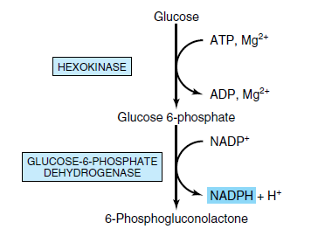

Discontinuous Activity Assays:
Discontinuous or stopped assays are when samples are taken from an enzyme reaction at intervals and the amount of product production or substrate consumption is measured in these samples.
Ex: Creatine phosphate + ADP ◄----------► ATP + Creatine
Creatine + α-Naphthol + Diacetyl -----------► Colored product
The absorbance of the colored end product is measured at 520 nm and it proportional with the activity of CK in any sample used.

