ALMUSTAQBAL UNIVERSITY


College of Medical and Health Techniques
Medical Laboratories Techniques Departments

Biochemistry Lectures for 2nd Year Students

(2 Credit Hrs. Theory + 2 Credit Hrs. Practice / Week = 3 Credit Unit
Academic Year: 2024 - 2025

Course Organizers:

- Prof. Dr. Fadhil Jawad Al-Tu'ma, Ph.D., Professor of Clinical Biochemistry.
- Dr. Dalya Shakir Obaida, Ph.D. Lecturer of Clinical Biochemistry.

Date: OCT, 12, 2024

Enzyme Inhibition:
Enzymes are protein and they can be inactivated by the agents that denature them. The chemical substances which inactivate the enzymes are called as inhibitors and the process is called as enzyme inhibition. Inhibitors are sometimes referred to as negative modifier. They may be small inorganic ions, or organic substances. Enzyme inhibition is classified under three major groups:
- Competitive inhibition (Reversible).
- Non-competitive inhibition (Irreversible or reversible).
- Allosteric inhibition.
There are two broad classes of enzyme inhibitors: reversible and irreversible.
Reversible versus irreversible
- Irreversible inhibitors interact with an enzyme via covalent, associations for eg, Nerve agents like sarin are irreversible inhibitors of acetylcholine esterase

- Reversible inhibitors interact with an enzyme via non-covalent associations. For therapeutic drug design we’re almost always interested in reversible inhibitors

Enzyme inhibitors are molecular agents that interfere with catalysis, slowing or halting enzymatic reactions. Enzymes catalyze virtually all cellular processes, so it should not be surprising that enzyme inhibitors are among the most important pharmaceutical agents known. For example, aspirin (acetylsalicylate) inhibits the enzyme that catalyzes the first step in the synthesis of prostaglandins, compounds involved in many processes, including some that produce pain.
The activity of certain enzymes is regulated by a feedback mechanism such that an end product inhibits the enzyme’s function in an initial stage of a sequence of reactions . In (Figure below) Control of regulatory enzymes frequently involves feedback mechanisms. In this sequence of reactions catalyzed by enzymes, the ﬁrst enzyme in the series is inhibited by product F. At the early stages of the reaction, the concentration of F is low and its inhibitory effect is minimal. As the concentration of F reaches a certain level, it can lead to total inhibition of the ﬁrst enzyme and hence turns its own source of production.
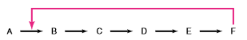
The glycolytic pathway is an example of this feedback mechanism. In effect, enzyme inhibition controls the amount of products formed. The action of an inhibitor on an enzyme can be described as either reversible or irreversible. In reversible inhibition, equilibrium exists between the enzyme and the inhibitor. In irreversible inhibitions, inhibition progressively increases with time. Complete inhibition results if the concentration of the irreversible inhibitor exceeds that of the enzyme.
Reversible Inhibition:
There are three important types of reversible inhibition:
- competitive inhibition,
- noncompetitive inhibition
- uncompetitive inhibition.
(a). Competitive Inhibition.
A competitive inhibitor competes with the substrate for the active site of an enzyme. While the inhibitor (I) occupies the active site it prevents binding of the substrate to the enzyme. Many competitive inhibitors are compounds that resemble the substrate and combine with the enzyme to form an EI complex, but without leading to catalysis. Even fleeting combinations of this type will reduce the efficiency of the enzyme. By taking into account the molecular geometry of inhibitors that resemble the substrate.
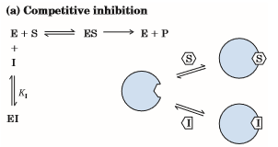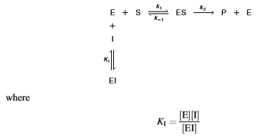
In this case, both the substrate S and the inhibitor I compete for the same active site :

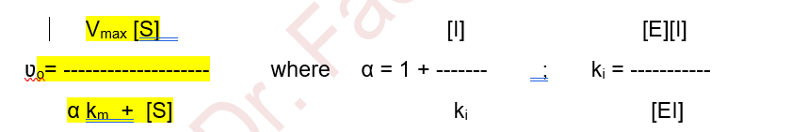

The experimentally determined variable αk_{m}, the k_{m} observed in the presence of the inhibitor, is often called the “apparent” k_{m}.
Note that the complex EI does not react with S to form products. Applying the steady-state approximation for ES, we obtain:
V_{max} [S]
ʋ_{o} = ------------------------------
k_{m} (1 + [I] / k_{i}) + [S]

The measured values of k_{m} in the presence of the inhibitor are altered, and are called the apparent k_{m}. The apparent k_{m} varies depending on the inhibitor concentration involved.
A well-known example of a competitive inhibitor is malonic acid, CH₂(COOH)₂, which competes with succinic acid in the dehydrogenation reaction catalyzed by succinate dehydrogenase.
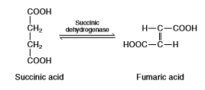
Because malonic acid resembles succinic acid in structure, it can combine with the enzyme, although no product is formed in this reaction.
A medical therapy based on competition at the active site is used to treat patients who have ingested methanol, a solvent found in gas-line antifreeze. The liver enzyme alcohol dehydrogenase converts methanol to formaldehyde, which is damaging too many tissues, blindness. Ethanol competes effectively with methanol as an alternative substrate for alcohol dehydrogenase. The effect of ethanol is much like that of a competitive inhibitor, with the distinction that ethanol is also a substrate for alcohol dehydrogenase and its concentration will decrease over time as the enzyme converts it to acetaldehyde. The therapy for methanol poisoning is slow intravenous infusion of ethanol, at a rate that maintains a controlled concentration in the bloodstream for several hours. This slows the formation of formaldehyde, lessening the danger while the kidneys filter out the methanol to be excreted harmlessly in the urine.
The inhibition of the hexokinase-catalyzed reaction between glucose and ATP by fructose or mannose is an example of competitive inhibition by alternate substrate. Glucose, fructose and mannose are all substrate of hexokinase and can be converted to product (hexose-6-phosphate). All three hexoses combine with the enzyme at the same active site. Consequently, the utilization of any one of the hexoses is inhibited in the presence of either of the other two.
Examples of Competitive Inhibitors in Biological System:
- Allopurinol: A drug used for treatment of Gout. Uric acid is formed in the body by oxidation of hypoxanthine by the enzyme Xanthine oxidase. Allopurinol structurally resembles hypoxanthine and thus by competitive inhibition, the drug inhibits the enzyme xanthine oxidase thus reducing uric acid formation.
- Sulphonamides: A very commonly used antibacterial agent. Para-aminobenzoic acid (PABA) is essential for synthesis of folic acid by the enzyme action. Folic acid is needed for bacterial growth and survival. Bacterial wall is impermeable to folic acid. Sulphonamide drugs are structurally similar to PABA and competitively inhibit enzyme action. Thus, folic acid is not synthesized and growth of bacteria suffers and they die.
- Methotrexate: A drug used for cancer therapy. Chemically it is 4-amino-N10-methyl folic acid. The drug structurally resembles folic acid. Hence it competitively inhibits “folate reductase” enzyme and prevents formation of FH4. Hence, DNA synthesis suffers.
- MAO inhibitors: The enzyme monoamine oxidase (MAO) oxidizes presser amines catecholamines, e.g. epinephrine and norepinephrine. Drugs Ephedrine and Amphetamine structurally resemble catecholamines. Thus, when administered they can competitively inhibit the enzyme “MAO” and prolong the action of pressor amines.
- Physostigmine: “Acetylcholinesterase” is the enzyme which hydrolyses acetylcholine to form choline and acetate. Physostigmine is a drug which competitively inhibits acetylcholinesterase and prevents destruction of acetylcholine. Thus, continued presence of acetylcholine in post-synaptic region prolongs the neural impulse.
- Dicoumarol: Used as an anticoagulant. It is structurally similar to vitamin K and can act as an anticoagulant by competitively inhibiting vitamin K.
- Succinylcholine: It is used as a muscle relaxant. Succinylcholine is structurally similar to acetylcholine. It competitively fixes on post-synaptic receptors. As it is not hydrolyzed easily by the enzyme acetylcholinesterase, produces continued depolarization with consequent muscle relaxation.

(b). Non-competitive
This is of two different types namely (i) reversible and (ii) irreversible. This occurs when the substances not resembling the geometry of the substrate do not exhibit mutual competition. Most probably the sites of attachment of the substrate and inhibitor are different. The inhibitor binds reversibly with a site on combine with both free enzyme and ES complex. This probably brings about the changes in 3D structure of the enzyme inactivating it catalytically. In noncompetitive inhibition V_{max} is lowered, but k_{m} is kept constant. If the inhibitor can be removed from its site of binding without affecting the activity of the enzyme, it is called as Reversible-Non-competitive Inhibition. However, if the inhibitor can be removed only at the loss of enzymatic activity, it is known as Irreversible Non-competitive Inhibition. However, the kinetic properties in case of both are the same.

Examples of Non-competitive Irreversible Inhibitors
Iodoacetate: An irreversible inhibitor of enzymes like glyceraldehyde-3-p dehydrogenase and papain. It combines with–SH group at the active site of the enzyme inactivating the enzyme.

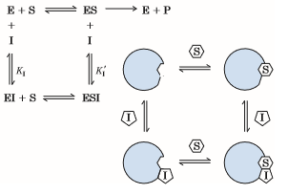

Neither EI nor ESI forms products. Because I does not interfere with the formation of ES, noncompetitive inhibition cannot be reversed by increasing the substrate concentration. The initial rate is given by:
noncompetitive inhibition is independent of [S] and depends only on [I] and k_{i}.

Examples of Non-competitive Irreversible Inhibitors
- Iodoacetate: An irreversible inhibitor of enzymes like glyceraldehyde-3-p dehydrogenase and papain. It combines with–SH group at the active site of the enzyme inactivating the enzyme.
- Heavy metal ions like Ag, Hg also act as irreversible noncompetitive inhibitor.
- Fluoride: Inhibits the enzyme emolase by removing Mg⁺⁺ and Mn⁺⁺ and stops glycolysis.
- BAL (British anti Lewesite): Called Dimercaprol, used as antidote for heavy metal poisoning. The heavy metals act as enzyme poisons by reacting with –SH groups. BAL has several –SH groups with which the heavy metal ions react, thus removing their poisonous effects.
- Disulfiram (Antabuse): Used in treatment of alcoholism, the drug irreversibly inhibits the enzyme aldehyde dehydrogenase preventing further oxidation of acetaldehyde which accumulates and produces sickening effect leading to aversion to alcohol.
- Di-isopropyl fluorophosphate (DFP): Inhibits enzymes with serine in their active site e.g. acetylcholine esterase.

Table gives the differences that are observed between competitive and non-competitive inhibition.

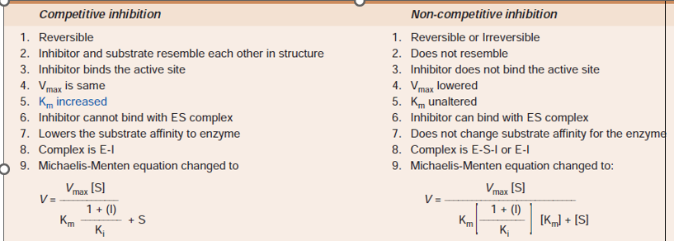

Suicide Inhibition
It is a special type of irreversible noncompetitive inhibition. In this type of inhibition, substrate analogue is converted to a more effective inhibitor with the help of the enzyme to be inhibited. The so formed new inhibitor binds irreversibly with the enzyme.
Examples
- Allopurinol. The best example of suicide inhibition. The drug is used in treatment of gout, as it inhibits the enzyme xanthine oxidase thus decreasing the uric acid formation. But allopurinol gets oxidized by the enzyme xanthine oxidase itself to form “alloxanthine” a more potent effective and stronger inhibitor of xanthine oxidase thus potentiating the action of allopurinol.
- Aspirin. Most commonly used drug for relieving pain. Anti-inflammatory action of aspirin is also based on the suicide inhibition. Aspirin acetylates a serine residue in the active centre of cyclooxygenase thus inhibiting the PG synthesis and the inflammation.
- 5-fluorouracil. Used in cancer therapy, 5-fluorouracil (5-Fu) is converted to fluorodeoxyuridylate (Fdump) by the enzymes of the salvage pathway. Fdump so formed inhibits the enzyme thymidylate synthase thus inhibiting nucleotide synthesis.

(c). Uncompetitive Inhibition.
An uncompetitive inhibitor does not bind to the free enzyme; instead, it binds reversibly to the enzyme–substrate complex to yield an inactive ESI complex. The reactions are:
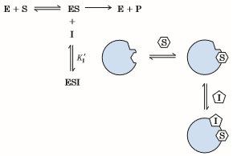

[ES][I]
Where k_{i} = --------------
[ESI]
The ESI complex does not form a product. Again, because I does not interfere with the formation of ES, uncompetitive inhibition cannot be reversed by increasing the substrate concentration.
V_{max}
------------ [S]
1 + [I] / k_{i}
ʋ_{o} = ---------------------------
k_{m}
------------- + [S]
(1 + [I] / k_{i})
Enzyme Regulation:

Allosteric Inhibition and Allosteric Enzymes
There is a mixed kind of inhibition when the inhibitor binds to the enzyme at a site other than the active site of the enzyme molecule called allosteric site. Allosteric inhibition does not follow the Michaelis-Menten hyperbolic kinetics. Instead it gives a sigmoid kinetics (Figure below). Allosteric inhibitors shift the substrate saturation curve to the right. However as opposite to inhibitors, the presence of activators shifts the curve to the left.

Types: Allosteric enzymes are of K and M series according to their kinetics.
- In K-enzymes, e.g. aspartate carbamoylase and phosphofructokinase, the allosteric inhibitor lowers the substrate affinity to raise the k_{m} of the enzyme; but the V_{max} is unchanged.
- In M-enzymes, e.g. acetyl-CoA carboxylase, the allosteric inhibitor reduces the maximum velocity but no change in k_{m} or substrate affinity. Allosteric activators produce a fall in K enzymes and a rise in V_{max} in M enzymes.
- When the final product allosterically inhibits the enzyme, it is called as feedback allosteric inhibition.

Sigmoid kinetics, allosteric inhibition

Aspartate transcarbamoylase is a model allosteric enzyme
Aspartate transcarbamoylase (ATCase) catalyses the first reaction unique to pyrimidine biosynthesis. ATCase is feedback inhibited by cytidine triphosphate (CTP). Following treatment with mercurials, ATCase loses its sensitivity to inhibition by CTP but retains its full activity for carbamoyl aspartate synthesis. This suggests that CTP is bound at a different (allosteric) site from either substrate. ATCase consists of multiple catalytic and regulatory protomers. Each catalytic protomer contains four aspartate (substrate) sites and each regulatory protomer atleast two CTP (regulatory sites).

Another example of allosteric enzyme and inhibition:
Synthesis of isoleucine from threonine involves at least 5 steps of enzymatic reactions. Isoleucine, the end product, inhibits the first enzyme threonine deaminase and stops its own synthesis.
A metabolite may also cause feed-forward allosteric activation of an enzyme for a subsequent step of its metabolism, e.g. Fructose-1,6-biphosphate allosterically activates pyruvate kinase catalyzing subsequent step.

In oligomeric enzymes, the allosteric site and active site are located on different subunits. Changes in the enzyme-substrate interaction due to the allosteric effects of regulatory molecules other than the substrate are called heterotropic allosteric modulations. Allosteric activators and inhibitors exhibit respectively positive and negative cooperativities with the substrates.
Binding of substrate to one protomer enhances the binding of the same to another protomer or another substrate binding site on the same enzyme molecule. When the binding of a substrate enhances the interaction between the allosteric enzyme and more molecules of the same substrate it is homotropic allosteric effect.
Feedback Regulation Vs Feedback inhibition:
Feedback regulation and feedback inhibition are not synonymous and they are different.
In both mammalian and bacterial cells, end-products “feedback” and control their own synthesis. In many instances, this involves feedback inhibition of an early biosynthetic enzyme. It is necessary to distinguish between “feedback regulation” and feedback inhibition, a mechanism for regulation of many bacterial and mammalian enzymes.
Example
Dietary cholesterol restricts the synthesis of cholesterol from acetate in mammalian tissues. This is feedback regulation. This feedback regulation, however, does not appear to involve “feedback inhibition” of an early enzyme of cholesterol biosynthesis. An early enzyme ‘HMG-CoA reductase’ is affected, but the mechanism involves curtailment by cholesterol or a cholesterol metabolite of the expression of the gene that encodes ‘HMG-CoA reductase’, i.e. enzyme repression. Cholesterol added directly to ‘HMG-CoA reductase’ has no effect on its catalytic activity.

