

Oral Pathology

Prof. Dr.Muna Merza

Lecture 2

Lec. 2 ORAL PATHOLOGY Dr. Muna

Biopsy
Definition: removal and examination of apart or the whole of a lesion.
There are several types of biopsy techniques.
Types of Biopsy:
1_surgical biopsy: Is the most important type

A_ Incisional biopsy:-it is removal of part of lesion is used to determine the diagnosis before treatment.

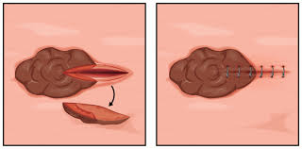

B_ Excisional biopsy:-it is removal of the whole lesion,it is used to confirm chemical diagnosis and it consider as treatment.
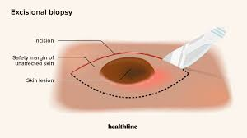

C_ Frozen sections:-allows stained slide to be examined within 10 min of taken the specimen but has some limitation the tissue is sent fresh to the laboratory to be quickly frozen.
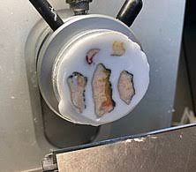

2_Fine Needle Aspiration biopsy(F.N.A): to differentiate between solid and cystic lesion e.g : heamingioma which is benign tumor of blood vessels.
3_Thick needle core biopsy: larger sample than F.N.A

4_ Exfoliate cytology: it is limited to the surface cells provide no information on deeper tissue. Technique:
1_Anesthesia and incision done around the site of the lesion.
2_Biobsy provide tissue lesion and 2mm around from normal tissue.
3_Fix the tissue immediately in 10% formalin.
Indication of biopsy:
1_Any lesion persists for more than 2 week.
2_Any inflammatory lesion that not respond to local treatment.
3_Persist hyperkeratotic changes.
4_Any lesion that has the characteristic of malignancy.
Contraindication for biopsy:
1-uncorrectable bleeding
2-uncontroll sever hypertension
3-active renal infection
4-skin infection at biopsy site
Technique:
1_Anesthesia and incision done around the site of the lesion.
2_Biobsy provide tissue lesion and 2mm around from normal tissue.
3_Fix the tissue immediately in 10% formalin.
Indication of biopsy:
1_Any lesion persists for more than 2 week.
2_Any inflammatory lesion that not respond to local treatment.
3_Persist hyperkeratotic changes.
4_Any lesion that has the characteristic of malignancy.
Contraindication for biopsy:
1-uncorrectable bleeding
2-uncontrolled sever hypertension
3-active renal infection
4-skin infection at biopsy site

