
AL-Mustaqbal university
College of Sciences
Department of Medical Biotechnology
Histology /2rd Stage
Dr. Sarah Kamil
Lec.4\ The Bone
………………………………………………………………………

The Bone:

Bone is a specialized connective tissue composed of intercellular calcified material, the bone matrix, and three cell types: osteocytes, osteoblasts and osteoclasts.

Functions:
- Supports fleshy structures.
- Protects vital organs such as those in the cranial and thoracic cavities.
- Harbors the bone marrow, where blood cells are formed
- It serves as a reservoir of calcium, phosphate, and other ions.
- Bones form a system of levers that multiplies the forces generated during skeletal muscle contraction.
All bones are lined on both internal and external surfaces by layers of connective tissue containing osteogenic cells, endosteum on the internal surface surrounding the marrow cavity and periosteum on the external surface.

The periosteum: Consists of an outer layer of collagen fibers and fibroblasts. Bundles of periosteal collagen fibers, called Sharpey's fibers, penetrate the bone matrix, binding the periosteum to bone. The inner, more cellular layer of the periosteum is composed of fibroblast like cells called osteoprogenitor cells that differentiate into osteoblasts.
The endosteum: lines all internal cavities within the bone and is composed of a single layer of flattened osteoprogenitor cells and a very small amount of connective tissue. The endosteum is therefore considerably thinner than the periosteum.
The principal functions of periosteum and endosteum are nutrition of osseous tissue and provision of a continuous supply of new osteoblasts for repair or growth of bone.

Bone Matrix:
Inorganic matter represents about 50% of the dry weight of bone matrix. Calcium and phosphorus are especially abundant, but bicarbonate, citrate, magnesium, potassium, and sodium are also found.
The bone cells
Osteoblasts: They synthesize the organic components of the matrix. (type I collagen, proteoglycans, and glycoproteins), located at the surfaces of bone tissue, side by side, in a way that resembles simple epithelium, being cuboidal or columnar in the active state, and flattened in the quiescent state. Some osteoblasts are gradually surrounded by newly formed matrix and become osteocytes.

Osteocytes:
Osteocytes which are found in cavities (lacunae) between bone matrix layers (lamellae), with cytoplasmic processes extending into small canaliculi between lamellae. Derive from osteoblasts. Only one osteocyte is found in each lacuna. The thin, cylindrical matrix canaliculi house cytoplasmic processes of osteocytes. Processes of adjacent cells make contact via gap junctions.

Osteoclasts:
Osteoclasts which are multinucleated giant cells involved in the resorption and remodeling of bone tissue. Are very large, branched motile cells, contain from 5 to 50 (or more) nuclei. In areas of bone undergoing resorption, osteoclasts lie within enzymatically etched depressions in the matrix known as Howship's lacunae. The osteoclast secretes collagenase and other enzymes and pumps protons into a subcellular pocket, promoting the localized digestion of collagen and dissolving calcium salt crystals. Osteoclasts have receptors for calcitonin, a thyroid hormone, but not for parathyroid hormone.

Types of Bone:

First: Based on histology
Compact (cortical) bone: Composed of dense bone without cavities. Which represents 80% of the total bone mass and deeper areas with numerous interconnecting cavities? It is also made up of concentric lamellae, and is pervaded by lacunae (containing osteocytes), and by canaliculi. Most of the lamellae are arranged in the form of concentric rings that surround a narrow Haversian canal present at the center of each ring. The Haversian canal is occupied by blood vessels, nerve fibers, and some cells. One Haversian canal and the lamellae around it constitute a Haversian system or osteon. Compact bone consists of several such osteons. Between adjoining osteons there are angular intervals that are occupied by interstitial lamellae. These lamellae are remnants of osteons, the greater parts of which have been destroyed. Near the surface of compact bone the lamellae are arranged parallel to the surface: these are called circumferential lamellae. The canals branch and anastomose with each other. They also communicate with the marrow cavity, and with the external surface of the bone through channels that are called the canals of Volkmann. Blood vessels and nerves pass through all these channels so that compact bone is permeated by a network of blood vessels that provide nutrition to it.

Figure 1: Components of bone and types of bone

Cancellous (trabecular or spongy) bone: Constituting about 20% of total bone mass. Cancellous bone is made up of a meshwork of bony plates or rods called trabeculae. Each trabeculus is made up of a number of lamellae between which there are lacunae containing osteocytes. Canaliculi, containing the processes of osteocytes, radiate from the lacunae. The trabeculae enclose wide spaces that are filled in by bone marrow. They receive nutrition from blood vessels in the bone marrow. The trabeculae are covered externally by vascular endosteum containing osteoblasts, osteoclasts and osteoprogenitor cells.
In long bones the epiphyses are covered by a spongy bone with a thin layer of compact bone, while the diaphysis is composed of compact bone.

Second: Based on maturity

Mature/ lamellar bone: Each lamellus is a thin plate of bone consisting of collagen fibers and mineral salts that are deposited in a gelatinous ground substance. Even the smallest piece of bone is made up of several lamellae placed over one another. Between adjoining lamellae we see small flattened spaces or lacunae. Each lacuna contains one osteocyte. Spreading out from each lacuna there are fine canals or canaliculi that communicate with those from other lacunae. The canaliculi are occupied by delicate cytoplasmic processes of osteocytes. The lamellar appearance of bone depends mainly on the arrangement of collagen fibers. The fibers of one lamellus run parallel to each other; but those of adjoining lamellae run at varying angles to each other. The ground substance of a lamellus is continuous with that of adjoining lamellae.

Immature/woven bone: In contrast to mature bone, newly formed bone does not have a lamellar structure. The collagen fibers are present in bundles that appear to run randomly in different directions, interlacing with each other. Because of the interlacing of fiber bundles this kind of bone is called woven bone. All newly formed bone is woven bone. It is later replaced by lamellar bone.

Third: Based on manner of development
Cartilage bone
Membrane bone

Histogenesis:
Bone can be formed in two ways: by direct mineralization of matrix secreted by osteoblasts (intramembranous ossification) or by deposition of bone matrix on a preexisting cartilage matrix (endochondral ossification). In both processes, the bone tissue that appears first is primary or woven bone. Primary bone is a temporary tissue and is soon replaced by the definitive lamellar, or secondary, bone.
The cartilage:
Cartilage is a tough, flexible form of connective tissue, characterized by an extracellular matrix enriched with glycosaminoglycans and proteoglycans, macromolecules that interact with collagen and elastic fibers. Variations in the composition of these matrix components produce three types of cartilage adapted to local biomechanical needs.
Functions:
- Bear mechanical stresses of the body without permanent distortion.
- Support soft tissues.
- Facilitate joint movement
- Acting as a shock absorber.
- Essential for growth and development of bone.

Cartilage consists of cells called chondrocytes and an extensive extracellular matrix composed of fibers and ground substance. Chondrocytes synthesize and secrete the extracellular matrix, and the cells themselves are located in matrix cavities called lacunae. As a rule the free surfaces of hyaline and elastic cartilage are covered by a fibrous membrane called the perichondrium, but fibrocartilage is not. The perichondrium is a sheath of dense connective tissue that surrounds cartilage in most places, forming an interface between the cartilage and the tissue supported by the cartilage. The perichondrium harbors the vascular supply for the avascular cartilage and also contains nerves and lymphatic vessels. Articular cartilage, which covers the surfaces of the bones of movable joints, is devoid of perichondrium.

Cartilage cells
The cells of cartilage are called chondrocytes. They lie in spaces (or lacunae) present in the matrix. At first the cells are small and show the features of metabolically active cells. The nucleus is euchromatic. Mitochondria, endoplasmic reticulum and golgi complex are prominent. Some authorities use the term chondroblasts for these cells (This term is used mainly for embryonic cartilage producing cells). As the cartilage cells mature they enlarge, often reaching a diameter of 40μm or more. The nuclei become heterochromatic and organelles become less prominent. The cytoplasm of chondrocytes may also contain glycogen and lipids.

Ground substance
The ground substance of cartilage is made up of complex molecules containing proteins and carbohydrates (proteoglycans). The carbohydrates are chemically glycosaminoglycans (GAG). They include chondroitin sulphate, keratin sulphate and hyaluronic acid. The core protein is aggrecan. The proteoglycan molecules are tightly bound. Along with the water content, these molecules form a firm gel that gives cartilage its firm consistency.

Collagen fibers of cartilage
The collagen fibers present in cartilage are (as a rule) chemically distinct from those in most other tissues. They are described as type II collagen. However, fibrocartilage and the perichondrium, contain the normal type I collagen.

Types of cartilage:
1. Hyaline cartilage, the most common form, type II collagen is the principal collagen type. It is located in the articular surfaces of the movable joints. Matrix: Collagen mainly type II. Perichondrium: a layer of dense connective tissue, which is essential for the growth and maintenance of cartilage. It is rich in collagen type I fibers and contains numerous fibroblasts. Chondrocytes: are rounded and may appear in groups of up to eight cells originating from mitotic divisions of a single chondrocyte.

2. Elastic cartilage possesses, in addition to collagen type II, an abundance of elastic fibers within its matrix. Elastic cartilage is found in the external auditory canals. Matrix: It is identical to hyaline cartilage except that it contains an abundant network of fine elastic fibers in addition to collagen type II fibrils. Perichondrium: is present showing an outer fibrous and inner cellular layer. Chondrocytes: Elastic cartilage is characterised by presence of chondrocytes within lacuna surrounded by bundles of elastic fibers

3. Fibrocartilage: It is found in intervertebral disks, is characterized by a matrix containing a dense network of coarse type I collagen fibers. It is a tissue intermediate between dense connective tissue and hyaline cartilage. It contains chondrocytes, usually arranged in long rows separated by coarse collagen type I fibers. The matrix is acidophilic. Perichondrium is absent.
In all three forms, cartilage is avascular and is nourished by the diffusion of nutrients from capillaries in adjacent connective tissue (perichondrium) or by synovial fluid from joint cavities. Chondrocytes exhibit low metabolic activity. Cartilage has no lymphatic vessels or nerves.

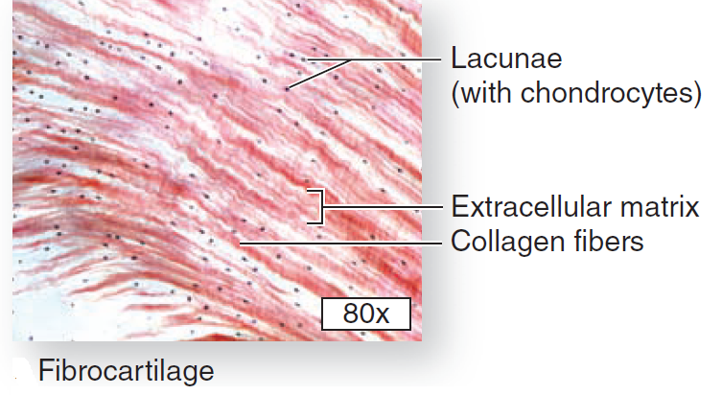
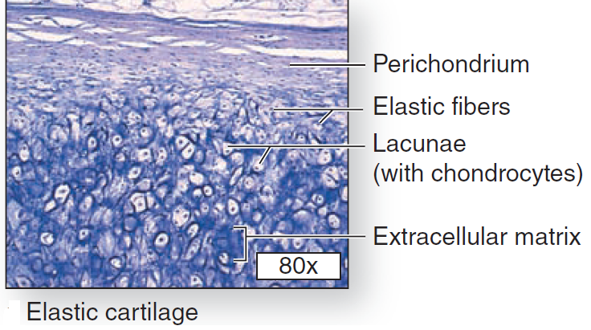
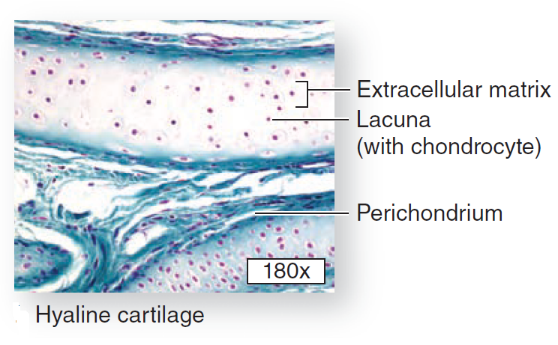

Growth of cartilage:
Newly formed cartilage grows by multiplication of cells throughout its substance. This kind of growth is called interstitial growth. Interstitial growth is possible only as long as the matrix is sufficiently pliable to allow movement of cells through it. As cartilage matures the matrix hardens and the cartilage cells can no longer move widely apart; in other words interstitial growth is no longer possible. At this stage when a cartilage cell divides the daughter cells remain close together forming cell nests. Further growth of cartilage now takes place only by addition of new cartilage over the surface of existing cartilage; this kind of growth is called appositional growth. It is possible because of the presence of cartilage forming cells in the deeper layers of the perichondrium.

