
AL-Mustaqbal university
College of Sciences
Department of Medical Biotechnology
Histology /2rd Stage
Lec.4\ The Nervous Tissue
Dr. Sarah Kamil
………………………………………………………………………

The nervous tissue:

Nerve tissue is distributed throughout the body as an integrated communications network. Anatomically, the general organization of the nervous system has two major divisions:
- Central nervous system, consisting of the brain and the spinal cord, and
- Peripheral nervous system, nerve ganglia, composed of the cranial, spinal, and peripheral nerves conducting impulses to and from the CNS (sensory and motor nerves, respectively) and ganglia that are small groups of nerve cells outside the CNS.
Cells in both central and peripheral nerve tissue are of two kinds: nerve cells, or neurons, which usually show numerous long processes; and various glial cells, which have short processes, support and protect neurons, and participate in many neural activities, neural nutrition, and defense of cells in the CNS.

Neurons:
Most neurons consist of three parts:

The Cell Body (Perikaryon):
A neuron consists of a cell body that gives off a variable number of processes. The cell body is also called the soma or perikaryon. Like a typical cell it consists of a mass of cytoplasm surrounded by a cell membrane. Most nerve cells have a spherical, unusually large, euchromatic (pale-staining) nucleus with a prominent nucleolus. Binuclear nerve cells are seen in sympathetic and sensory ganglia. The chromatin is finely dispersed, reflecting the intense synthetic activity of these cells. On EM it contains RER, Golgi complex, mitochondria (abundant at the axon terminals) and free ribosomes called the Nissl bodies.
The dendrites, which are the numerous elongated processes extending from the perikaryon and specialized to receive stimuli from other neurons at unique sites called synapses. They are irregular in thickness, and Nissl granules extend into them. They bear numerous small spines that are of variable shape. In a dendrite, the nerve impulse travels towards the cell body.
The axon, which is a single long process ending at synapses specialized to generate and conduct nerve impulses to other cells (nerve, muscle, and gland cells). Axons may also receive information from other neurons, information that mainly modifies the transmission of action potentials to those neurons. Most neurons have only one axon, usually very long; a very few have no axon at all. The axon may extend for a considerable distance away from the cell body. All axons originate from a short pyramid-shaped region, the axon hillock, arising from the perikaryon. The plasma membrane of the axon is called the axolemma. Its contents are known as axoplasm.

Neuroglia:
In addition to neurons, the nervous system contains several types of supporting cells called neuroglia.

Types of neuroglia
- Astrocytes are star-shaped cells with multiple radiating processes and most numerous glial cells, present in central nervous system. They bind neurons to capillaries and to the pia mater. Astrocytes with few long processes are called fibrous astrocytes and are located in the white matter; protoplasmic astrocytes, with many short-branched processes, are found in the gray matter. Function: Structural and metabolic support of neurons and repair processes.
- Ependymal cells lining the ventricular system. Function: Aid production and movement of Cerebrospinal Fluid (CSF).
- Schwann cells lemmocytes or peripheral glia forming myelin sheaths around axons of peripheral nerves. It is important to note that both neurilemma and myelin sheaths are components of Schwann cells. Function: Myelin production, electrical insulation.
- Capsular cells (also called satellite cells or capsular gliocytes) that surround neurons in peripheral ganglia. Function: Structural and metabolic support for neuronal cell bodies.
- Oligodendrocytes present in central nervous system. Function: produce the myelin sheath that provides the electrical insulation for neurons in the CNS. They are the predominant glial cell in CNS white matter.
- Microglial Cells: Are small elongated cells with short irregular processes. They are phagocytic cells that engulf foreign materials and involved in the process of inflammation. Function: Defense and immune-related activities.

Types of neurons

First: On the basis of number of processes (figure 1):
- Bipolar neurons: These neurons have only one axon and one dendrite. E.g. Neurons in vestibular and spiral ganglia.
- Multipolar neurons: These neurons have one axon and many dendrites. E.g. Motor neurons
- Unipolar or pseudounipolar neurons, which have a single process that bifurcates close to the perikaryon, with the longer branch extending to a peripheral ending and the other toward the CNS. E.g. Neurons in dorsal root ganglion.
- Anaxonic neurons, with many dendrites but no true axon, do not produce action potentials, but regulate electrical changes of adjacent neurons. They are found in the brain and retina.
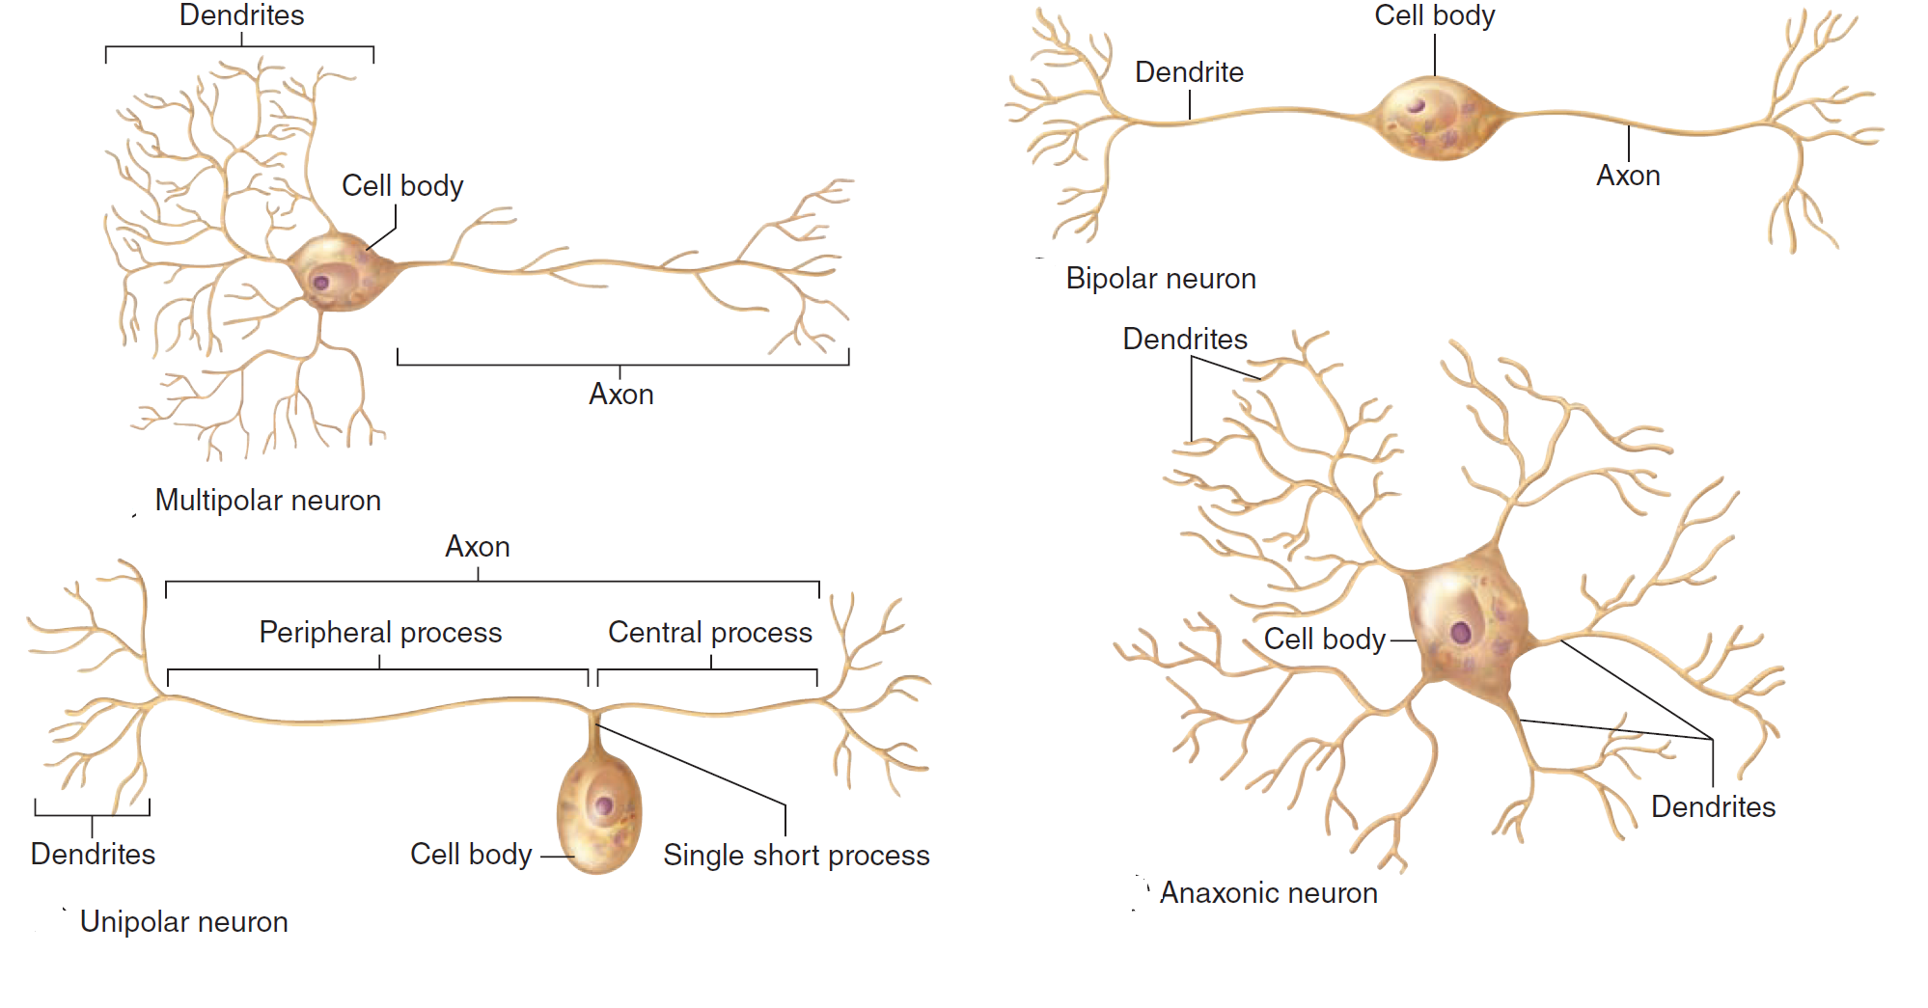

Second: On the basis of function
- Sensory neurons are afferent and receive stimuli from the receptors throughout the body.
- Motor neurons are efferent, sending impulses to effector organs such as muscle fibers and glands.
- Interneurons establish relationships among other neurons, forming complex functional networks or circuits (as in the retina). It is estimated that more than 99.9% of all neurons belong to this integrating network.

Third: On the basis of length of axons
- Golgi type I: These neurons have long axons, and connect remote regions. E.g. pyramidal cells of motor cortex in cerebrum.
- Golgi type II: These neurons have short axons which end near the cell body. E.g. Cerebral and cerebellar cortex.

Synapses:
Synapses are sites of functional contact between neurons or between neurons and other effectors cells (e.g., muscle and gland cells). Its function is to convert an electrical signal (impulse) from the presynaptic cell into a chemical signal that acts on the postsynaptic cell, by releasing neurotransmitters. The synapse is formed by an axon terminal (presynaptic terminal), a region on the surface of another cell (postsynaptic terminal), and a thin intercellular space called the synaptic cleft. Morphologically, various types of synapses are seen between neurons (Figure 2). If an axon forms a synapse with a cell body, it is called an axosomatic synapse; with a dendrite, axodendritic; or with another axon, axoaxonic. Axoaxonic synapses modulate activity of the other two types.

Synapses can be broadly classified into:
Chemical synapses.
Electrical synapses.
Synapses involving the release of neurotransmitters are referred to as chemical synapses. At some sites one cell may excite another without the release of a transmitter. At such sites adjacent cells have direct channels of communication through which ions can pass from one cell to another altering their electrical status. Such synapses are called electrical synapses. At the site of an electrical synapse plasma membranes (of the two elements taking part) are closely applied, the gap between them being about 4nm. Proteins called connexins project into this gap from the membrane on either side of the synapse. The proteins are so arranged that small open channels are created between the two synaptic elements.

The Central Nervous System:
The CNS consists of cerebrum, cerebellum and spinal cord. It has almost no connective tissue and is therefore a relatively soft, gel-like organ. It can be divided into the white and the grey matter. The main component of white matter is myelinated axons with no neuronal cell bodies. Gray matter contains neuronal cell bodies, dendrites, and the initial unmyelinated portions of axons and glial cells prevalent in the cerebral and cerebellar cortices.
In the cerebral cortex, the gray matter has six layers of cells with different forms and sizes.
The cerebellar cortex has three layers: an outer molecular layer, a central layer of large Purkinje cells, and an inner granular layer. The Purkinje cells have a large cell body and their dendrites are highly developed distributed within the molecular layer. The granular layer is formed by very small neurons (the smallest in the body), which are packed together densely, in contrast to the neuronal cell bodies in the molecular layer which are spars. In cross sections of the spinal cord (figure 3), white matter is peripheral and gray matter is central, assuming the shape of an H. The central canal lies in the horizontal bar of this "H", lined with ependymal cells. Gray matter of the legs of the H forms the anterior horns, which contain motor neurons. The posterior horns (the arms of the H), receive sensory fibers from neurons in the spinal ganglia.

-

The Meninges:
The skull and the vertebral column protect the CNS, but between the bone and nervous tissue are membranes of connective tissue called the meninges. Three meningeal layers are distinguished: the dura, arachnoid, and pia maters.
Dura Mater: Is the external layer and is composed of dense connective tissue continuous with the periosteum of the skull. The dura mater is always separated from the arachnoid by the thin subdural space. The internal surface and the external surface in the spinal cord, is covered by simple squamous epithelium.
Arachnoid: The arachnoid has two components: (1) a sheet of connective tissue in contact with the dura mater and (2) a system of loosely arranged trabeculae composed of collagen and fibroblasts, continuous with the underlying pia mater layer. The arachnoid is composed of connective tissue devoid of blood vessels, covered by simple squamous epithelium. Arachnoid villi are protrusions of the arachnoid through the dura mater covered by endothelial cells; its function is to reabsorb the CSF.
Pia Mater: Is a loose connective tissue containing many blood vessels. It follows all the irregularities of the surface of the central nervous system and penetrates it to some extent along with the blood vessels. It is not in contact with nerve cells or fibers, glial cell processes separate them.

Blood-Brain Barrier (BBB):
Is a functional barrier results from the reduced permeability that is characteristic of blood capillaries of nerve tissue. The endothelial cells are not fenestrated, connected by tight junctions, and covered by expansions of glial cells. The BBB protects neurons and glia from bacterial toxins, infectious agents, and other exogenous substances, and helps maintain the stable composition and constant balance of ions in the interstitial fluid that is required for normal neuronal function.

The Peripheral Nervous System:
The main components of the peripheral nervous system (PNS) are the nerves, ganglia, and nerve endings.
Nerve Fibers: Consist of axons enveloped by a special sheath (the myelin sheath). In peripheral nerve fibers, the sheath cell is the Schwann cell, and in central nerve fibers it is the oligodendrocyte. Axons of small diameter are usually unmyelinated. Schwann cells wrap and wind around the axons, the cell membrane layers unite to form the myelin; a whitish lipoprotein complex. The myelin sheath shows gaps along its path called the nodes of Ranvier, is the space between adjacent Schwann cells. In the peripheral system, all unmyelinated axons are enveloped within simple clefts of the Schwann cells, with no presence of nodes of Ranvier.
Nerve fibers are grouped in bundles to form nerves, which have a whitish, homogeneous, glistening appearance because of their myelin and collagen content. The external fibrous coat of dense connective tissue called epineurium, each bundle is surrounded by the perineurium, formed by layers of flattened cells. The enveloping connective tissue of Schwann cells is called the endoneurium.

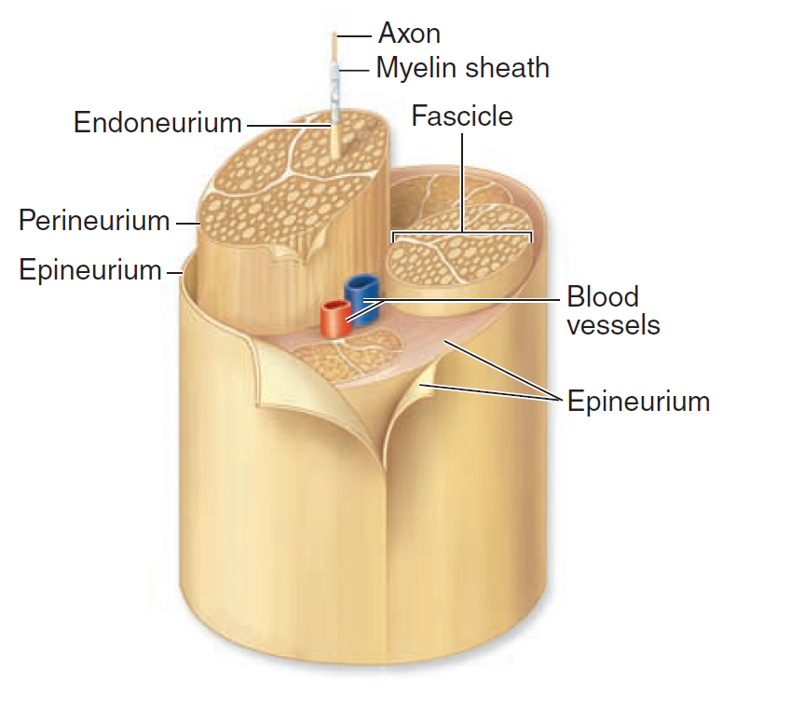

Ganglia: Ganglia are ovoid structures containing neuronal cell bodies and glial cells supported by connective tissue, they act as relay stations to transmit the nerve impulses, and they may be sensory or autonomic ganglia.

