Lecture 4 Dental Equipment Technologies Dr.Muna Merza

Electric and Induction Centrifuge Casting Machine

Electric and Induction Centrifuge Casting Machine:
It is a modem centrifuge specially designed for centrifuge molding small metal parts for the dental prosthesis sector.
Parts:
- Arm: parts of arm:
1- Balance arm: - it is the arm that is faced with the crucible arm; connect with the base from one side and the other side stabilizes on its heavy bodies "contour weight". These heavy bodies increase according to the weight of the pouring ring in the other side. The importance of this
arm to protect 2 arms in a balancing way.
2- Crucible arm: its high strength arm connects with a base from one side and with perpendicular support wall from the other side and anterior to the support wall there are 3 parts which are:
a. Cradle: is locating downward of the ring the advantage of the cradle is to surround melting ring &the importance of melting crucible metal is to pour the metal that inside it.
b. Melting crucible metal: to locate the molten metal it should be made from the ceramic because no carbon contains the metal.
c. Locks: are important to stabilities melting crucible metal and melting ring in their place and making sure that they are not moving.

B. Lid.
C. On switch.
D. Control panel.

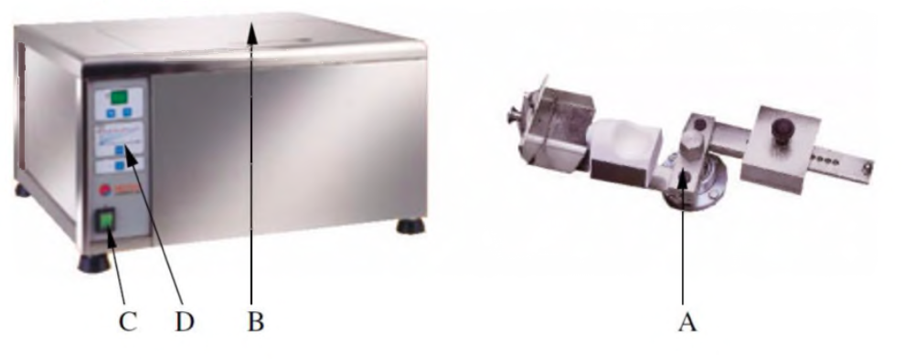

Vestacast Centrifuge casting machine:

Vestacast is a compact, easy to operate induction casting machine for melting and casting all dental alloys except titanium and titanium alloys.
This is the machine that uses the argon gas in the cycle electrical or the magnetic field bends the brow electrically.
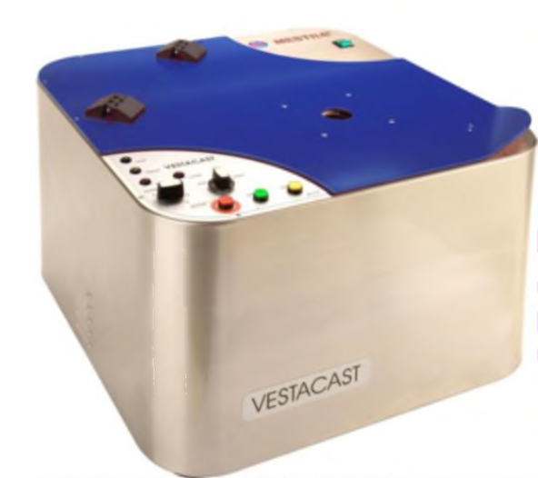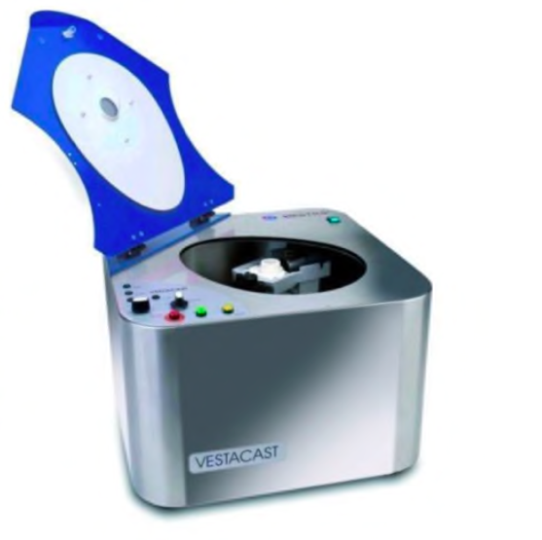

Parts:

