Lecture 9 Dental Equipment Technologies Dr.Muna Merza
Dental Biostar Machine

Dental Biostar Machine

The work of this adapter is to heat some ready-made base plate above gypsum cast, after it become soft, applied air pressure on it and on the gypsum cast, so the base plate disk takes the other shape of gypsum cast, then cutting according to need.
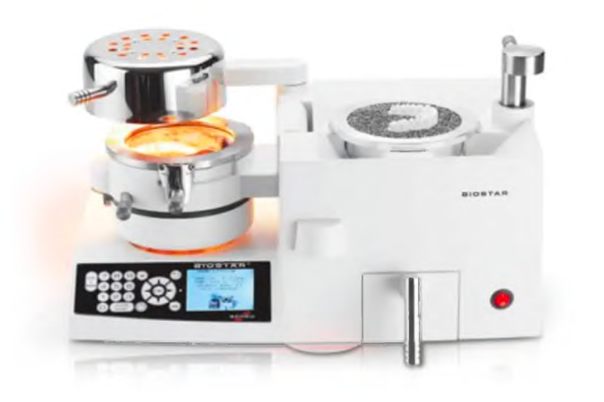
The device composed from:
1. Infrared heater Immediately after setting the code the infrared heater reaches the working temperature and the foils can be plasticized. Short-wave thermostatically controlled infrared heater reaching working temperature within 1 second without waiting time.
2. vacuum pressure to empty the air and to adapter disc materials on model (Working pressure 6 bar).
3. Heightened model cup allows embedding of mounted models.
4. Stainless Steel Pellets materials the surface temperature of this side of the material is up to 60°C higher, a thickness of 4-5 mm.
5. Disc materials (rubber, soft and hard plastic resin) with different thickness.
6. Display With the modern control panel, all working parameters can be programmed and controlled. Program code, heating time or temperature is controlled by means of the panel, after closing the pressure chamber, the programmed cooling time runs automatically.
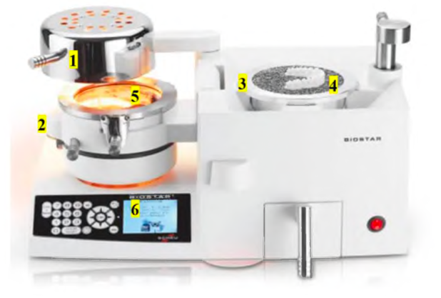
Applications

1. Model Duplication
2. Functional and Custom Trays
3. Denture Base, Periodontal Splints
4. Copings
5. Partial Dentures
6. Mask for Temporary Crowns and Bridges
7. Mouth Guards
8. Chin Cups
9. Positioners.
10. Orthodontic Plates
Lecture 10 Dental-Arch Trimmer
Dental-Arch Trimmer Machine
This dental-arch trimmer optimizes the model-making process improving quality and reliability during the fabrication of sectioned models. Saving more than 60% in time.
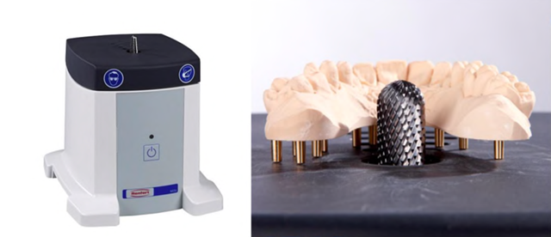
Used: Only use the unit for trimming dental stone or resin dental arches. And used in the crown and bridge lab.
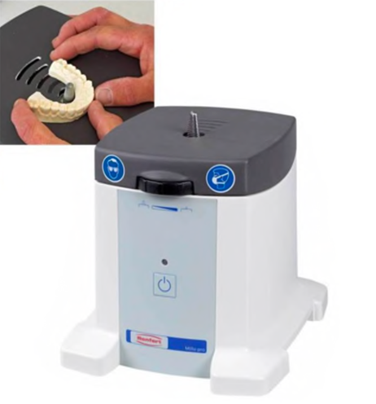
Parts:
A. ON/OFF button
B. ON/OFF LED display
C. Height adjustment.
D. Connector for extractor
E. Plug-in socket for connecting an extractor.
F. Safety cut-out
G. Cuter bur.
H. Mains cable I. Work table
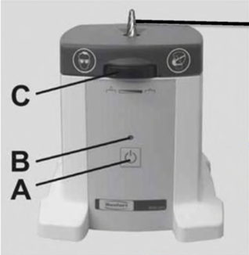 G 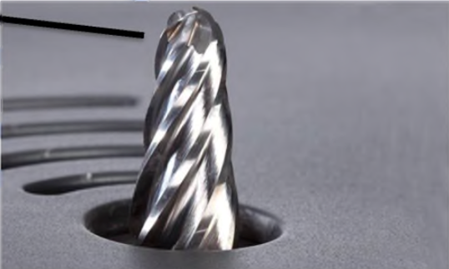
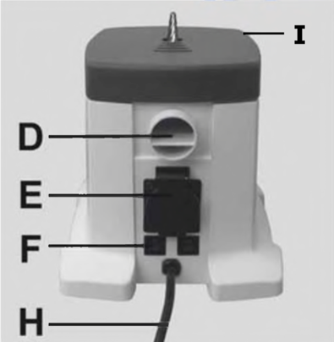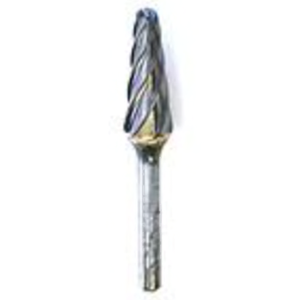
Lecture 11 Dental Pindex Machine

Dental Pindex Machine
In the pindex system, a reverse drill press is used to create a master cast with dies that can be removed & replaced repeatedly with great precision .The impression is poured without positioning & attaching dowel pins before hand. It's used in the crown and bridge lab. The machine accurately drills parallel holes from the underside of the trimmed cast.[

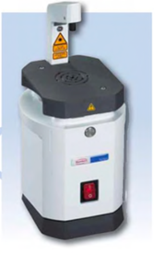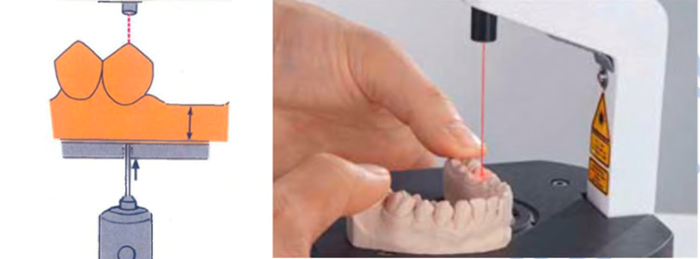

Parts:
A. ON/OFF button
B. Focus the laser beam.
C. worktable
D. Motor
E. Base
F. dust bucket
G. drill spindle
H. drill bit
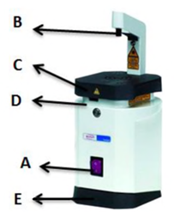 G H
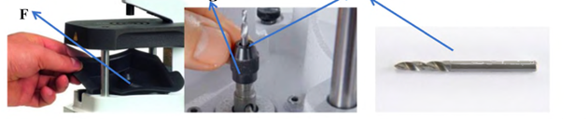
Dental Hammer Device:
Essential tool for a quick cleaning off of models. It has airflow regulation; ergonomic shape; made in corrosion-free materials; small dimensions. It has been designed to reduce to the maximum vibrations and sound level. Three chisel heads with different sizes and shapes are included. Used for the deflasking in the acrylic lab and for cutting investment after casting procedure in the crown & bridge lab and the chrome cobalt lab.
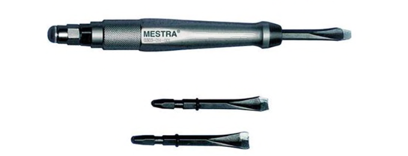
Parts:
1) On / Off controls
2) Air pressure connection
3) Chisel head

