Lecture 5 Dental Equipment Technologies Dr.Muna Merza

Ultrasonic Cleaning Machine and Mechanical Mixer (vacuum)

Ultrasonic Cleaning Machine:
It is a device used to clean the metal by ultrasonic pulls with a cleaning solution that is either hot or cold, the machine consists of:
- On-Off switch
- Display
- Up-Down keys
- Heater resistor key
- Lid
- Waste pipe
- Stainless steel basket
- Glass vessel
- Glass vessel support

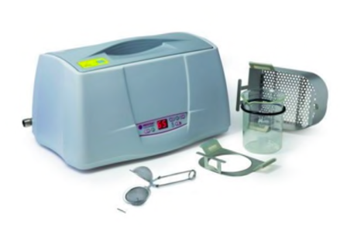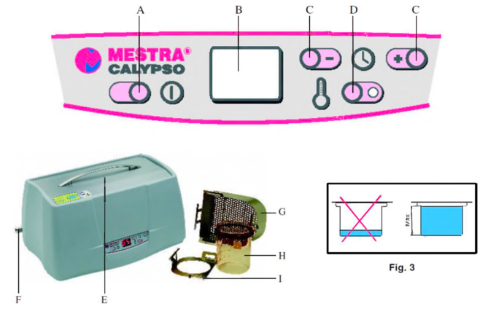

**” Liquid solution": is used in ultrasonic cleaners to dissolve or disperse the material to be removed from the dental restoration.
* There is special liquid for each type of alloy.

Mechanical mixer device (vacuum-auto-mixing device):

This device is used in the laboratory of the crown, bridge, and chromium cobalt for mixing gypsum product materials (plaster, stone, die stone, and investment material.)
With this equipment, the powder and liquid (water or special liquid) are mixed in a vacuum. The amount of air usually is reduced enough to obtain a smooth adaptation of the investment to the pattern vacuum investing often yield casting with the improved surface when compared with casting procedure from hand investment pattern.
It consists of:
- Vacuum display.
- Program display.
- Up key
- Down key
- Parameter selection key.
- Start/stop key.
- No vacuum key.
- Function display:
a. function key.
b. mixer only.
c. vacuum and mixer.
d. vacuum only.
9. Main switch.
10. The high-performance vacuum pump.
1. Mixing bowls in three sizes (small, medium, large bowl).
12. Led with mixing spatula.

