AL-Mustaqbal University College  Department of Medical Physics  The Second Stage  Thermodynamics and Heat  Dr. Rusul Abdul Ameer  MCs. Noor Raed Hadi |  | كلية المستقبل الجامعة  قسم الفيزياء الطبية  المرحلة الثانية  الديناميكيا الحرارية
Lecture .1
INTRODUCTION AND BASIC CONCEPTS IN THERMODYDNAMICS

*Thermodynamics can be defined as the since of energy
* The word thermodynamics stems from the Greek words therm (heat) and dynamics (force).
* Thermodynamics is a science that is based on experimental findings.
* The study of thermodynamics is concerned with the ways energy is stored within a body and how energy (heat, work) interactions takes place.
*One of the most fundamental laws of nature is the conservation of energy principle. i.e., energy can neither be created nor destroyed, it can only be transformed from one form to another.
Or is the branch of chemistry that deals with the quantitative relations between heat and various forms of energy (Chemical, Nuclear, Movement, ...) and is interested in describing the material in terms of physical properties ( V, T, P) , Or is the science of thermodynamics is an experimental science interested in studying everything that is related to temperature, Thermal energy or thermal flow associated with changes in chemical or physical systems.

Application Areas of Thermodynamics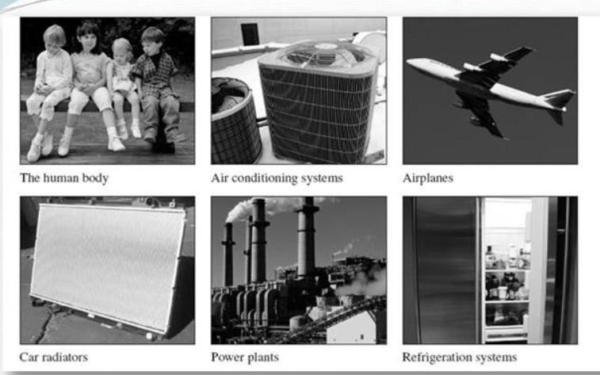

Thermodynamics Applications:
- Engineering applications: This engineering science is used in the design of engines and generators of electric energy and Refrigeration and air conditioning systems.
2. Chemical Applications: There are several applications for the science of dynamics, including:
* Changes in energy that accompany chemical or physical change.
* Change in energy between the system and its surroundings.
* Study the possibility of chemical reaction automatically
Basic concepts in thermodynamics
System: is part of the universe in which a chemical or physical change occurs, or is the specific part of the material to which the study is directed.
Surrounding : is the part that surrounds the system and follows the energy in The shape of heat or work can be real or imaginary.
System boundaries: is the envelope that surrounds the system and separates it from the surrounding medium and represents the container walls of the system.
For example, when adding a hydrochloric acid solution to a sodium hydroxide solution in a glass cup,
(The system is acid solution and base * System boundaries are the walls of the cup * The Surrounding is the rest)
The universe is about the system based on the way the system shares energy and matter with the ocean

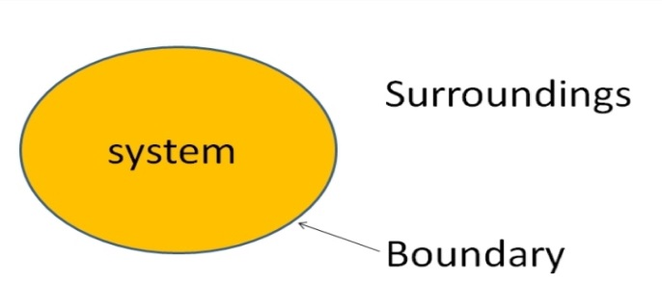

Types of systems in thermodynamics Systems are divided To several types:
1-Open System: A system that allows the exchange of both material and energy between the system And the surrounding medium.
2-Closed System: Allows only energy exchange between the system and the surrounding medium as heat or work .
3-Isolated System: Is not allowed to transfer any energy and material between the system and the surrounding medium
4- Alkazima System : is not able to exchange material and heat with the surrounding environment in any way or in other words it is other types of energy can be exchanged except heat.

The system is said to be homogenous: if it contains a single phase and is said to be heterogeneous if it contains more than one phase,
The gas phase is always homogenous because the gases are combustible with gas ,In the case of liquids, the system is either homogenous or heterogeneous depending on the viability of the liquids.
Properties of a System
The natural properties of the system can be divided into two groups:
1-Extensive Properties (Extended or External): are the properties that depend on the amount of material in the system such as mass, volume, thermal capacity,
Internal energy, entropy, free energy, surface area and total value for these properties are equal the sum of discrete values.
2-Intensified Properties: are properties that do not depend on the amount of material in the system such as pressure, temperature, density, Surface tension, electric force and voltage. All of these properties are characteristic of the material but do not rely on quantity.
Thermodynamic Equilibrium
It can be divided into three types:
A) Mechanical Equilibrium: This type of equilibrium occurs when none occurs
Microscopic change of system with time.
B) Chemical Equilibrium: This type of equilibrium occurs when it does not occur change in the concentration of matter with time.
C) Thermal Equilibrium: This type of equilibrium occurs when equal the temperature of the system with the surrounding medium this equilibrium represent the zero law of thermodynamics ,Which states that( if two systems are in equilibrium with a third system, the two systems are in a state balance with each other).
Thermodynamic processes:
It is the process of moving a system from one state of equilibrium to another state of equilibrium over a period of time as well Means the change in the thermodynamic properties of the system. So it is said that the system is undergoing a process
Thermodynamic when any of the properties of the system variables change
The system state also changes. Example: If the pressure exerted on a confined invading entity increased, then it would
This is accompanied by a change in other properties such as volume, density, and temperature ... and when it stabilizes ,These properties bring the system to a new equilibrium state. It can be during the thermodynamic process Install one or more system properties and let the rest of the properties change to take new values,
For example, there are processes during which the size of the system remains constant and others are under constant and under pressure
Constant temperature and so on , these process summarized in the following:

1-Adiabatic Process: It is the process that occurs without any heat entering or leaving the system or q = 0. i.e. remaining during which the amount of heat in the entity is constant. The process is known as adiabatic when it occurs to a system.
Encased with a good insulation that prevents heat leakage from the system's roots and there are processes that take place ,So quickly that the system does not have enough time for heat to leak in and out. Examples of operations Adiabatic: sudden burst of a bicycle wheel, a piston stroke inside a cylinder The internal combustion,compression, and rarefaction associated with the passage of sound waves through the air.

2-Isothermal Process: It is the process that occurs to an entity without changing its temperature. Here should be a cover ,The system is a good conductor of heat, allowing heat to escape or enter when it gets in an increase or decrease in the system temperature during the process. i.e ∆E = 0.

3-Isobaric Process: is the process that occurs when a constant is compressed.
4-Isochoric Process: is the process that occurs at a fixed volume.
5-Cyclic Process: It is the process by which the system goes through a number of processes and then returns to its initial state .This system is said to have gone through a complete Cycle. And in periodic processes it absorbs .The system usually has heat in each cycle and performs work on the ocean, and in the case of cycles
Large The resulting workload was large and could be employed and utilized as well as machinery Steam, internal combustion machines .

6-Irreversible Process
It is a one-way process that cannot be reversed without leaving permanent changes ocean. An example is the heat that is transferred from a hot body to a cold body, and the wind that is it blows from the high pressure area to the low pressure area and the objects fall from top to bottom.

