Lecture 8 Dental Equipment Technologies Dr.Muna Merza
Packing & Duplication tools
These tools are used in the acrylic and metal prosthesis lab, and they must be chosen for the good type of them.
Types of Packing and Duplicating Tools-:
1. Metal flask for acrylic (Complete denture flask):
it is used for a complete and partial denture, acrylic material need certain heating to gain complete solid, so this flask is made from thick copper because copper is a good material to reach the heat equivalently to all types of acrylic .There are many shapes and sizes of these flasks.
Complete denture flask is divided into two types:
1. Flaskforamaxillarycompletedenture.
2. Flaskforamandibularcompletedenture.

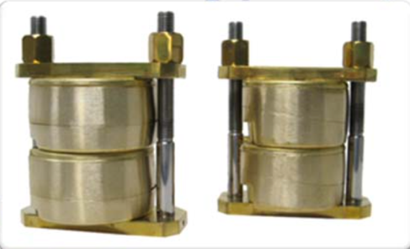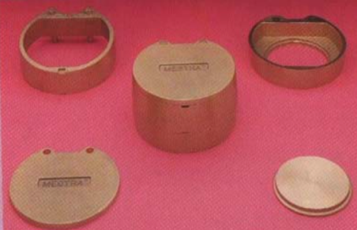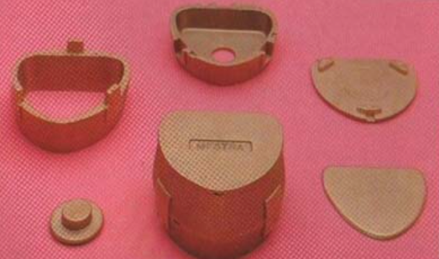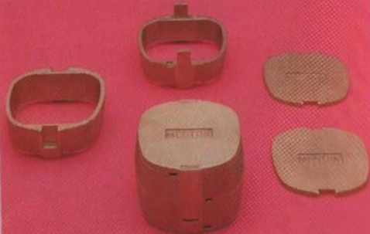

Parts of Flask-:
Lower half :it equivalent in the height from anterior and from posterior "from all parts "In maxillary denture, but the height from anterior is less than that of posterior parts in a flask of the mandibular denture.
Ejectingdisc: It covers the circle hole in the lower half forde‐flasking.
Upper half: this half lies above the lower half, these are 2 projections to make the occlusion accuracy, the anterior part and posterior part of the flask are the same in the height for the maxillary denture .But in the flask of the mandibular denture, the height of the anterior part is more than the posterior part of the flask.
Cover: used to completely cover the flask, have a hole to exit the excess. There are many types of it {Cylinder, Cubic, rectangular}.
Clamp: used with a metal flask for keeping it close in an occluded manner, it made from copper, like the flask material and there are many types:
hold 3 flasks
hold 2 flasks
hold 1 flask .
Note- : the flask must be closed well edge to edge and not be used if the edges are not occluded well
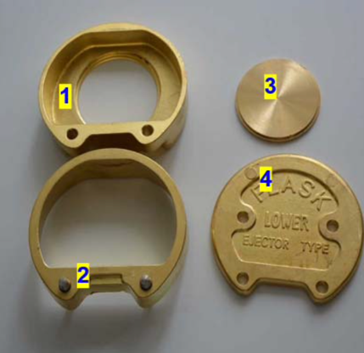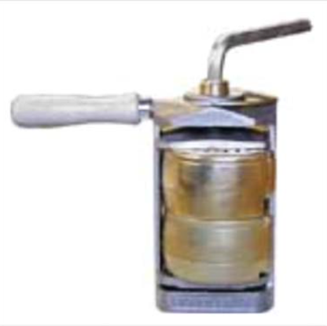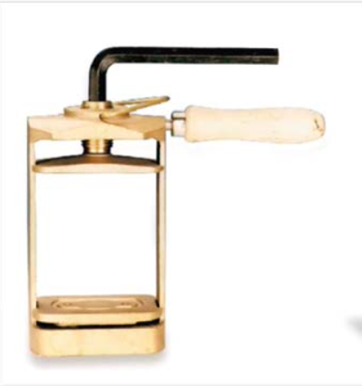
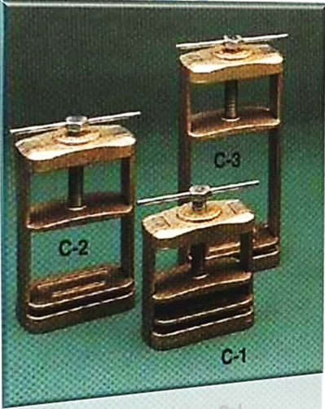
2 .Bridge Flask: this flask is made from copper material, they are like a complete denture flask, but the size is smaller, it's used in crown & bridge lab.
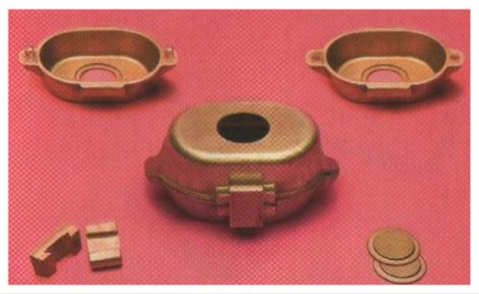
3 .Crown Flask :it is small in size and divided into an upper half and lower half (small size) and there is one hole in the base of each half with entered projections to sure the contact "to make the contact accuracy .It's used in the crown & bridge lab.
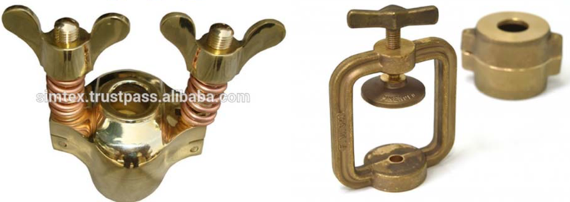
4 .Giant Flask: it is the largest picture complete upper denture used for working complete denture in case of large jaw "abnormal "and the maxillofacial prosthesis.
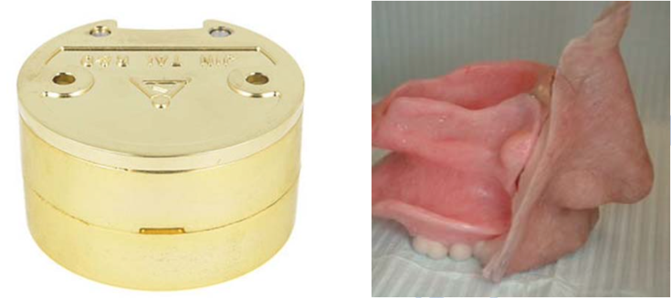
5 .Duplicating Flask: it is consists of the base and upper part, there is a different type of duplicating flask as a lightweight brass flask, and also there is a plastic flask. It is used in the chrome cobalt lab .
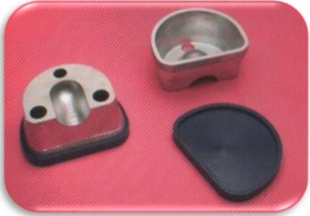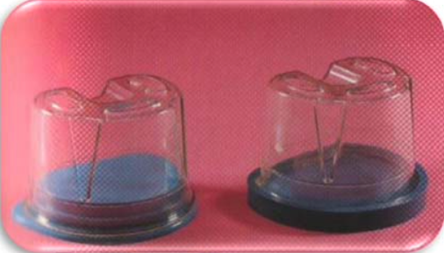
6 .Fiber Reinforce Plastic Flask: it is made from Fiber Reinforced Plastic, there is like complete denture flask "copper material", and disadvantages of this flask are needed very carefully to avoid fracture of the flask, it is used in the acrylic lab and crown & bridge lab .
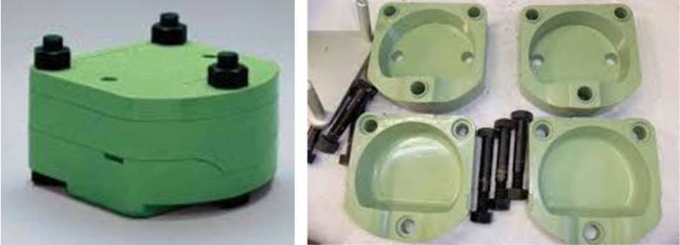
Dental Press:
It is made from stainless steel, used to obtain pressure on the flask to make the pressure equally on acrylic material found in the flask space
They are two types:
1. SimplePress:
Like the clamp and it always stabilized on the bench.
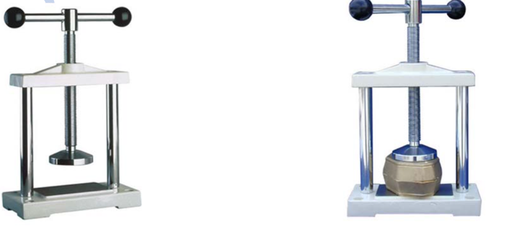
2. HydraulicPress:
It is best than the simple press because it gives the wanted pressure and it has a pointer for pressure amount .
Parts of the Hydraulic Press:
1. Base.
2. Oilchamber.
3. Pump piston.
4. Pressure meter
5. Pressure arm.
6. Hydrauliccylinder.
7. Screw.
