Lecture 9 Dental Equipment Technologies Dr.Muna Merza
Dental Trimmer
It,s an electric device used to trimming the model that is made from gypsum products (stone, stone, plaster,.......)
Use for:
1‐ Making a model with a suitable width.
2‐ To match the model together (upper and lower model).
3‐ To determine the occlusal view of the model.

There are two types of trimmer:
A‐One wheel model trimmer.
B‐ Double wheel model trimmer.
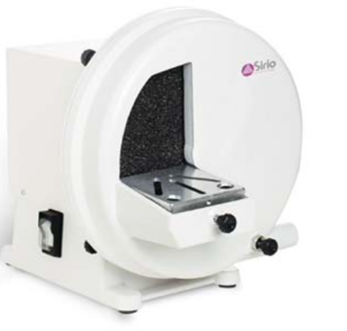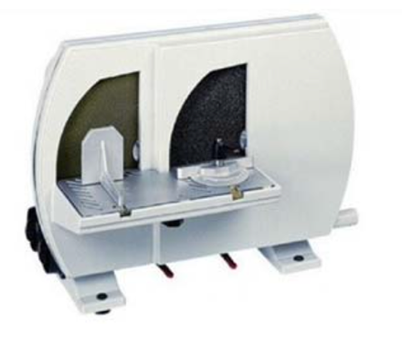
In general, the trimmer consists of:
1‐ Coarse or /and fine corundum grinding wheels.
2‐ Control motor switch.
3‐ Motor.
4‐ Individual control water supply
5‐ Work area with squaring and angulation device.
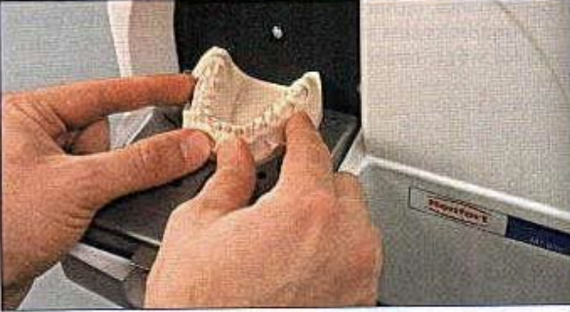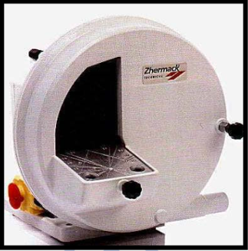

Dental Vibrator:
Its electric device used in all dental laboratory, it aid in mixing gypsum product (plaster, stone, die stone.......) & escape the air from it & avoid air bubbles to obtain homogenous mixing during pouring the impression (to produce the casts) & during flasking procedure.

It consists of:
1. theswitchtoopen&closetheequipment
2. motortovibrate
3. rubbersurface.
NOTE: Rubber surface is easily removable for cleaning.
