Lecture 1 Dental Devices Technology Dr.Muna Merza

Dental Laboratories

Types of Dental Laboratories:
1. General Dental Laboratories:-
They make all wanted prostheses in dentistry
ex: complete denture, partial denture, oral structure missing, orthodontic and other missed structure in the face.
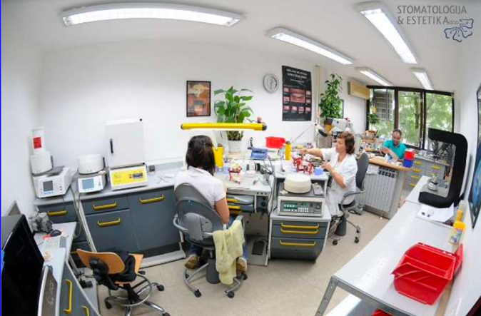
2. Specialized Dental Laboratories:-
They make only one type of work in fields of
dentistry ex: ceramic bridge or acrylic prostheses.
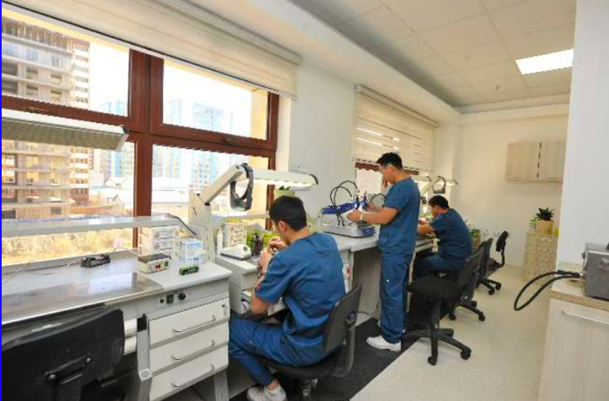
3. Private Dental Laboratories:-
small laboratories. مختبرات صغيرة ملحقة بعيادة طب الاسنان
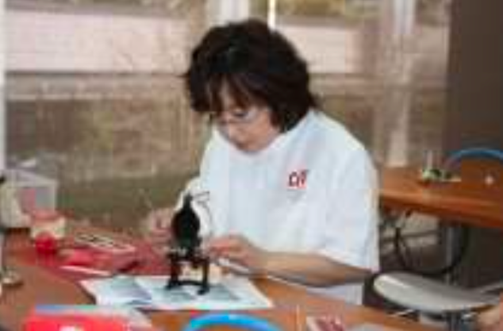

The Work in Dental Laboratories: -
- One step specialization: ex: making base plates, occlusal rim, pouring gypsum casts, pour the cast articulators, or the setting of artificial teeth.
- One-line specialization: Make a complete product line يختص بخط انتاج كامل
- General work: small laboratories and in sometimes in private dental laboratories have general work, they make all types of work that wanted.

Advantages & Disadvantages of the Work in Dental Laboratories:
- Inthecaseofspecialists,whoseworkonesteptheyforgetothersteps.
- Inthecaseofworkingonestep,ahighdegreeofaccuracywillbefound.
- Thebenefitismoreincaseofgeneralwork.
- Income case of specialist laboratories is more than income case of working all step laboratories (general laboratories).

The principle of ideal laboratories:-
1) The money.
2) The plans.
3) Manpower.

Points which are considered in the planning of penetration of the market:
- Planed area of the lab.
- Location of the lab.
- The amount of production.
- A number of technicians & workers.
- Future expansion.

