Lecture 1 Dental Devices Technology Dr.Muna Merza

Hand Instruments

In dentistry, hand instrument is very important especially in the prosthetic department to make good work and there is no choice to replace it. We have many instruments with a different names, sizes, and others that vectored in a different shapes.
The benefit from these instruments and their uses, they make us choose the good type instruments in prosthesis dental lab.
Types of Hand Instruments:
1. Cutting Hand Instruments
Types of the Cutting Hand Instruments:-
1) Wax knife. 2) Plaster knife. 3) Manual saw.
4) Scissors. 5) Wirecutter or pliers.

1) Wax knife:-
It is a hand instrument used mostly in a dental lab and in work with wax, it is not used for cutting gypsum products. This hand instrument is made from stainless steel and has two ends and a wood handle, one end is sharp like a small knife and another end like a spoon (plate).
The sharp end is used to cut wax and other working & shaping with wax, another end "like spoon end" is used to push melted wax.
The handle must be made from wood so that it separates the heat.
There are three types of a wax knife according to the shapes and uses:-
- Small. 2. Medium. 3. Large.

Don't heat the knife to redness degree, this procedure makes a change in the properties of the metal and makes it soft, also it leaves some carbon position. In special cases that the knife needs to be heated, the degree should not exceed 50oC.
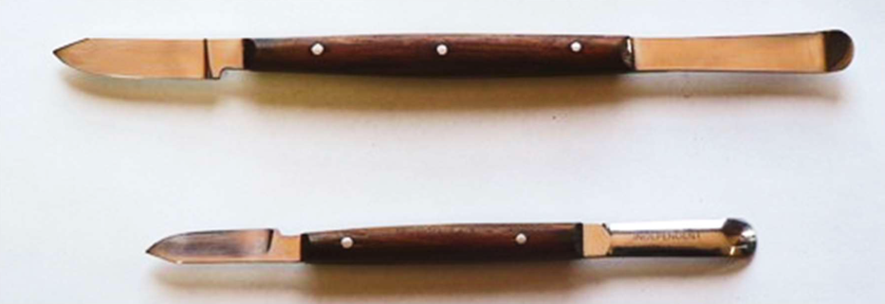

2) Plaster knife: -
This instrument is used for gypsum work ex: cutting excess gypsum product.
There are many types of plaster knife, the morally used type has a sharp metal end "stainless steel" with one side or two sides and there is plastic or wood handle between them, also some types have a metal end for opening metallic flasks.
Note: It is important not to use this type of knife for working with wax.
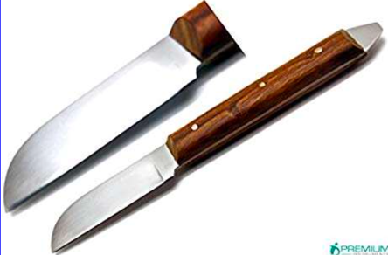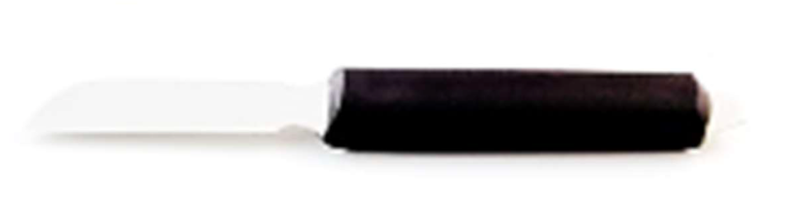
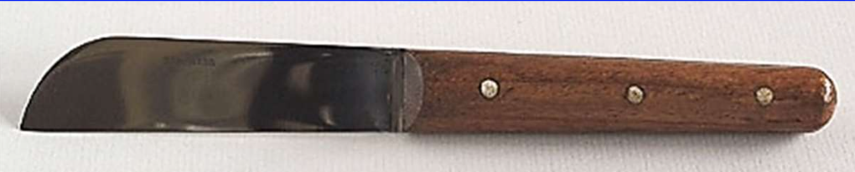

3) Manual saw: -
This saw is used for gypsum product cutting and has two types:
1. Conventional manual saw: used in the acrylic lab for deflasking.
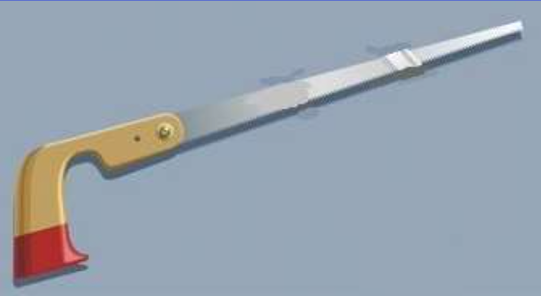
- Mini-manual saw: used in crown and bridge lab for cutting dies.
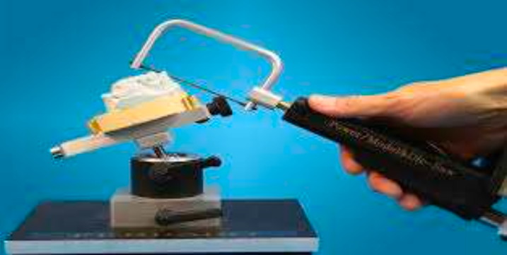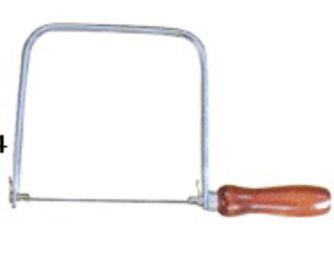

4) Scissors: -
Scissors are classified into many types:
1. Straight head scissors: this type of scissors isused in:
- Crown & bridge.
- Chrome cobalt.
- Asbestos paper. (also used in special papers within rings casting)
- Thin wax plates: used with the thin wax plate.
We have two shapes of these scissors:
- Long head. 2. Short head
They are made from stainless steel.
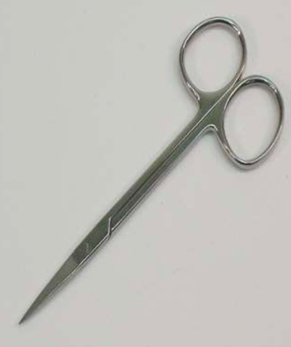
- Curved head scissors: These scissors have a curved end, used for cut copper rings and metal bridge, sometimes are called crown scissors.
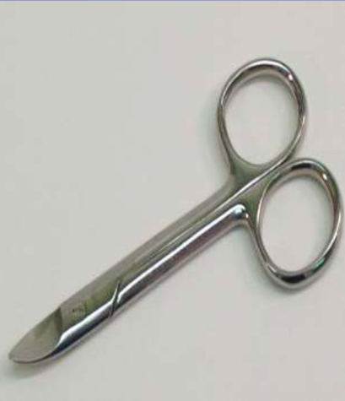
- Plaster scissors: used for cutting gypsum products, also have spring lever to make the handle always divergent. The cutting end has two shapes either sickle or like a small saw.
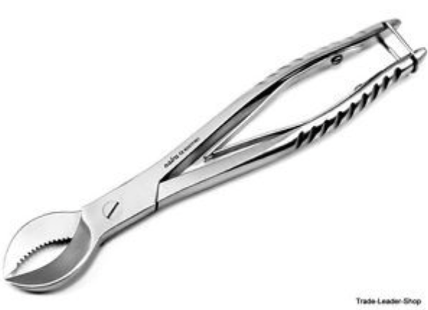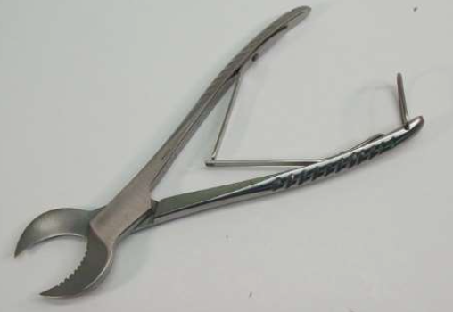
4) Wirecutter plier: -
This instrument is very important and it is used in the acrylic lab for construction acrylic prosthesis, also used in orthodontics. The use of this instrument is for metallic wire cutting, this instrument is made from stainless steel. The ends of the handles are covered by thin rubber.
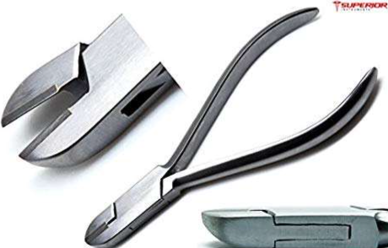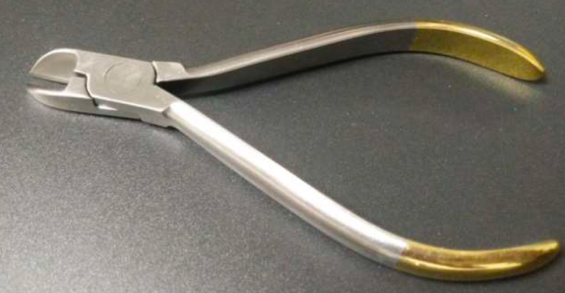

2. Filings Hand Instruments
The filings: are used in the acrylic lab and experimental base plates for complete and partial denture. The shape of a filing instrument could be:
  - Round section.
  - 2) Half-round section.
  - Square section.
  - Triangle section.
  - Oval section.
  - Flat section.
  - Half oval section.
These instruments have a different degree of roughness and made up from stainless steel and the handle made up either from plastic or wood.
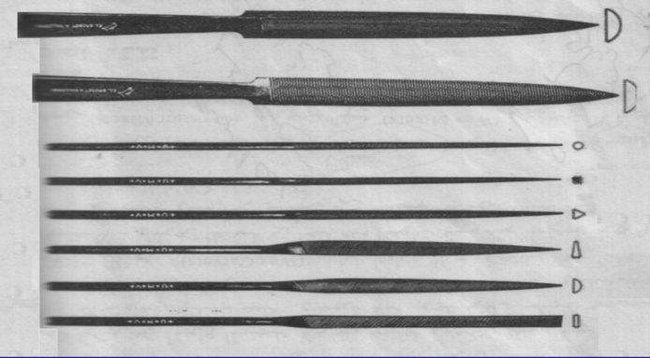

3. Carving Hand Instruments
Carving instrument: is a very important instrument in prosthesis lab, it is used for shaping and making wax skeleton and for working crown & bridge, complete & partial denture.
Types of carving instrument: - these types of instrument are called by naming which made it with many types:
- Lacron carver.
- Word carver.
- Roach carver.
- Hylin carver.
- Riagner carver.
- Zahi carver.
Lacron carver:- is made from stainless steel and has two ends, one end is sharp like a fine knife, the other end is like a small spoon. The sharp end is used for carving & shaping with wax, the other end "like small spoon end" is used for fine carving wax. They are used in complete & partial denture and crown & bridge lab.

4. Mixing Hand Instruments
Classified into: -
- Wax mixers.
- Cement mixers.
- Acrylic mixers.
- Plaster mixers.

1. Wax mixers: -
Instruments used for mixing solute wax in a special flask, then the wax is poured into gypsum cast or wax cast in complete and partial denture by one end of this instrument, don't heat the instrument.

We have two types:
a. Grittman wax spatula: this spatula is made up from stainless steel and the its shape is like a flat arrow with handle. One end is large in size, the other is curved. The length of these instruments is 15-20cm.
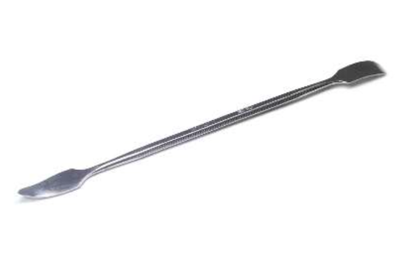
b. Beal wax spatula: this spatula is made up from stainless steel, it is smaller in size than the Grittman wax spatula and have 2 ends, one is curved, the other is straight and flat.
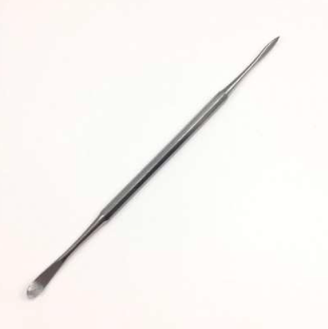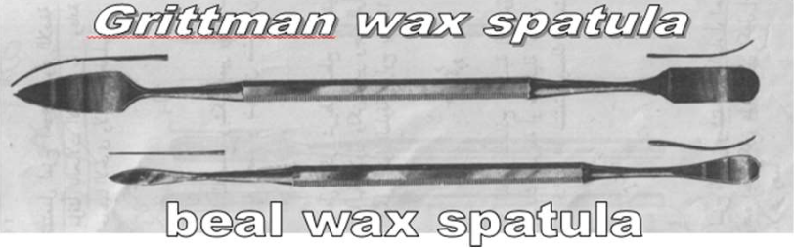

- Cement mixers:-
Consists of two parts:
a. Cement spatula: it has two similar ends or two different ends one of these ends is flat with pin head, the other end is the flat end, but it is smaller in size. The length of this instrument 15-20cm.
b. Mixing glass slap: it is made from glass, its thickness is 1cm, and has a rectangular shape with different sizes.
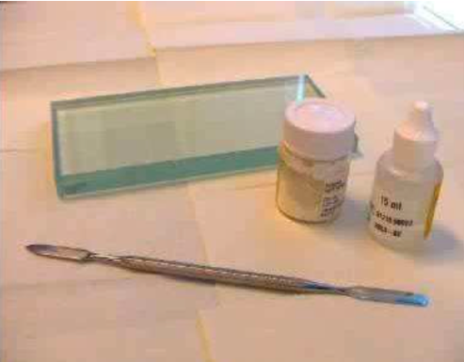
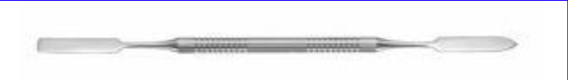

- Acrylic mixers:
Consists of two parts:
- Acrylic spatula: made from stainless steel with one end, sometimes made from hard plastic with one end.
- Acrylic container: made from colour glass or porcelain.
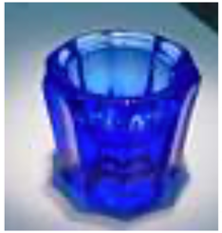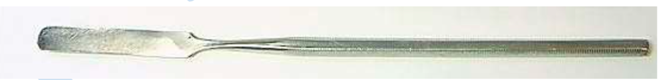

- Plaster mixers:
It consists of:
Plaster spatula: made from hard plastic or stainless steel with plastic or wood handle, with one ends either the straight or curve end. The straight end is used for mixing impression materials while the curve end is used for mixing gypsum product.
Rubber bowl: made from rubber used for mixing gypsum product or impression materials.

Rubber bowl may be two types:
a. Small: used for mixing impression materials by the straight end of plaster spatula.
b. Standard: used for mixing gypsum product by the curved end of plaster spatula.
