Lecture 3 Dental Equipment Technologies Dr.Muna Merza

Impression Tray

It is an instrument used for carrying the impression material into the mouth for maintaining it in position during setting or hardening and supporting it during removal from the mouth and when pouring the model.

Parts of the tray:

1. Body: which consists of:
  - floor.
  - flanges.
2. Handle.
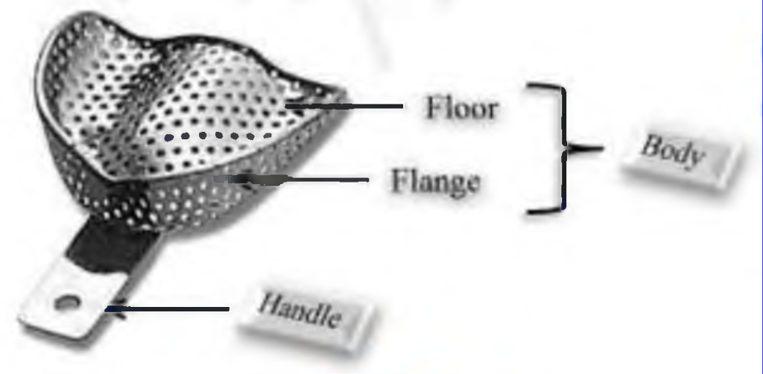

*The difference between the upper and lower tray is that the upper has a palatal portion while the lower has lingual flanges.
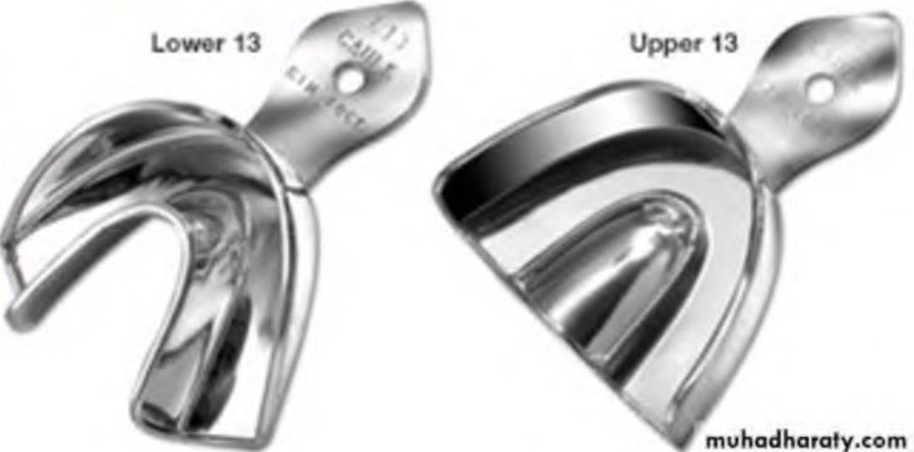

Types of Impression Tray:
- For the primary impression, we use a stock tray and for the final impression, we use the special or custom tray.
- In general, there are two types of impression trays: -

1. Stock tray primary impression diagnostic or study cast
2. Special or custom tray final impression master cast

- Stock tray
- Are ready-made trays, supplied in various shapes and sizes, and are designed to fit most mouths (a full arch or anterior or posterior or side less or quadrant trays).
- It's used for more than one patient.
- Trays are usually made from nickel silver, stainless steel, aluminum, or plastics.
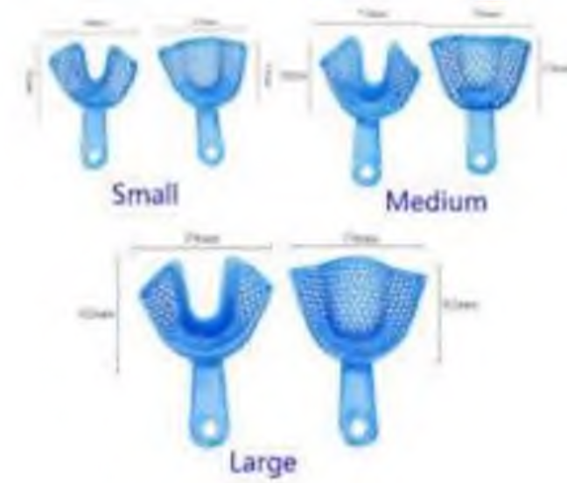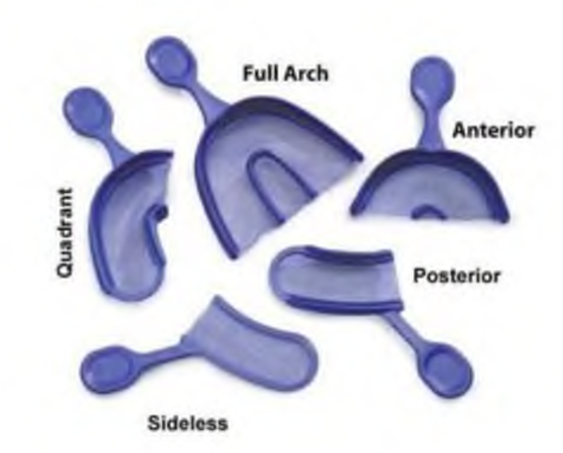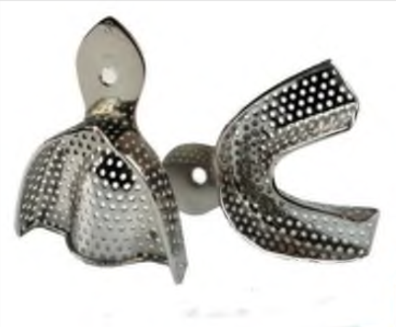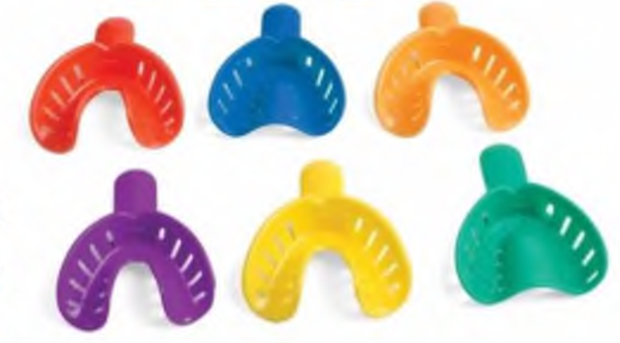

Types of Stock trays: -
- Perforated stock tray: - used with alginate impression material in partial denture, crown, and bridge.
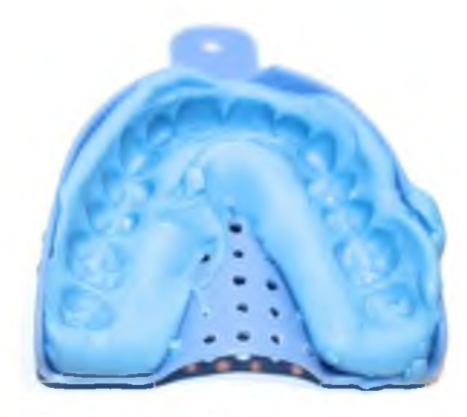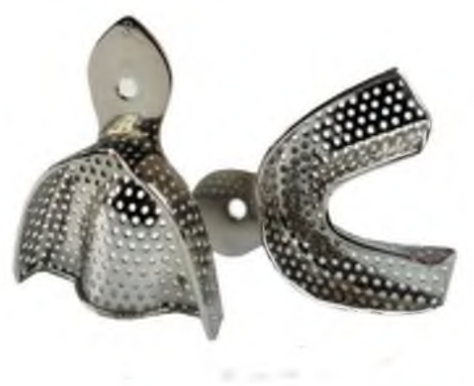

- Non-perforated stock tray: -
Used with impression compound material in complete denture (in edentulous cases).

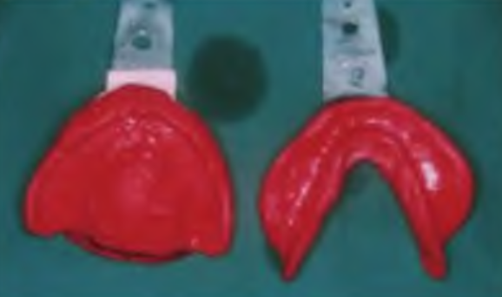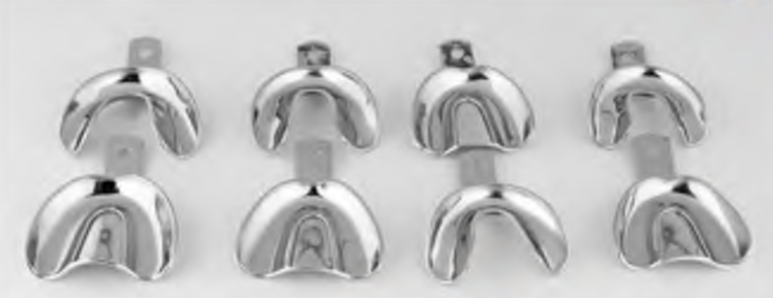
- Rim lock: -
- Has a rim of metal around the border.
- This type can be used with impression compound and with alginate impression material in complete denture (in edentulous cases).

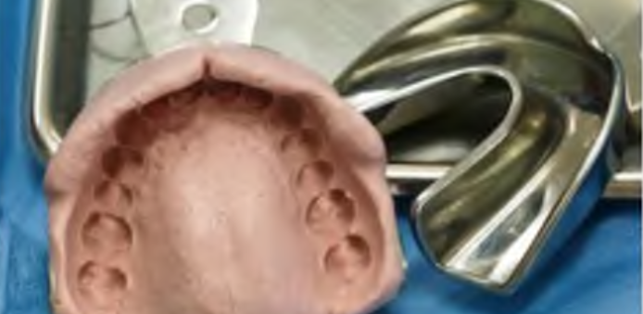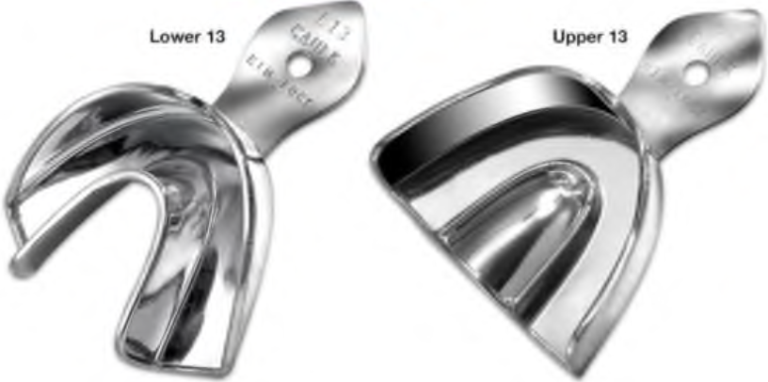

- Custom tray (individual or special tray)
- It is an impression tray made on the diagnostic cast and is designed to make a more accurate and detailed impression.
- It is fabricated for a specific impression procedure for the patient and is discarded after use.

Materials used for construction of special tray:
1. Shellac tray: - It is constructed in the same method of constructing a shellac base plate with the addition of a handle.
2. Self or heat cure acrylic resin: - Are the most widely used materials.
3. The use of impression compound.
4. Old denture

