Lecture 6 Dental Equipment Technologies Dr.Muna Merza
ARTICULATOR

An articulator: is a mechanical device to which maxillary and mandibular casts may be attached, representing the tempro-mandibular joints and jaw members, and it is used to hold the casts in one or more position of diagnosis, the arrangement of teeth (artificial teeth) and the development of the occlusal surfaces of fixed restoration.

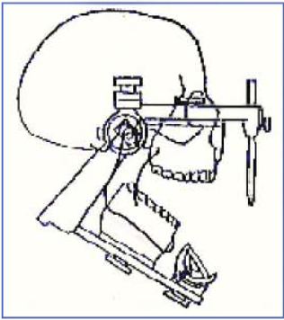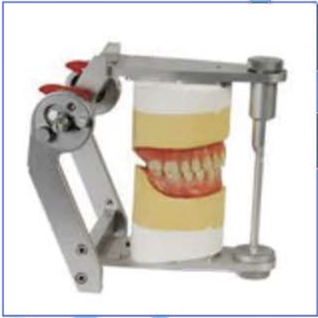

Articulators can be divided into three types:

1. Simple hinge or Small non adjustable articulators:
It's the simplest type, consist of two members (arm) upper and lower, they are joined by a nonadjustable hinge, it can hold the casts in the centric relation and can be opened & closed only.

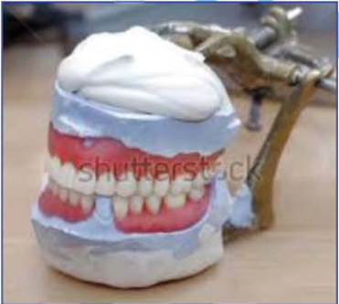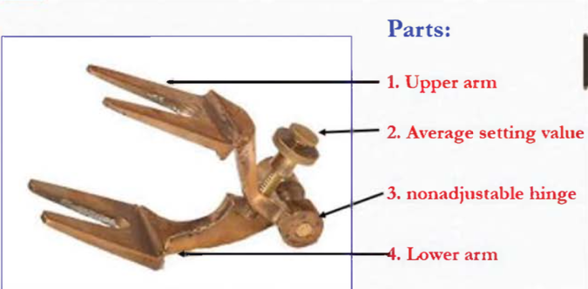

Advantages:
1. Low cost.
2. Easy to use
3. Average setting value.

2. Semi-adiustable articulators:
It consists of two members (upper & lower), these articulators have adjustable horizontal condylar guides and incisal pin and accept both centric relation and protrusive
maxillomandibular relation records, for example, Hanau articulator.
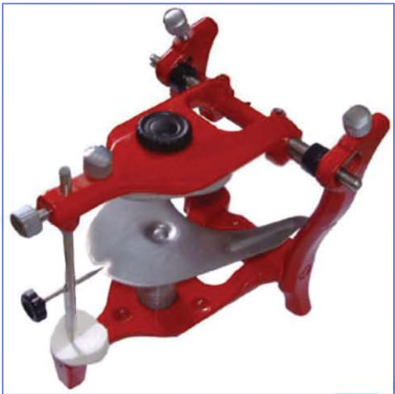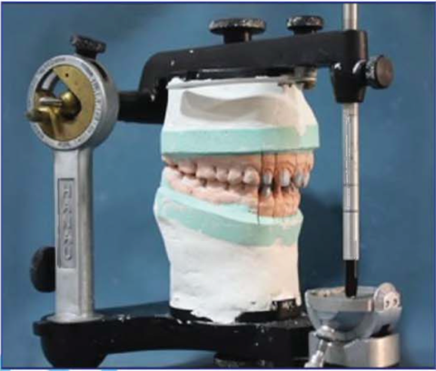

Disadvantages:
1. Moderate cost.
2. Not all its type represents the Bennett shaft.
3. Required more time and procedure.

Types of Semi-adjustable articulators:
They are generally divided into 2 types:
1. ARCON: condylar elements are on the lower member ofthe articulator.
2. NON-ARCON: condylar elements are placed on the upper portion of the articulator.
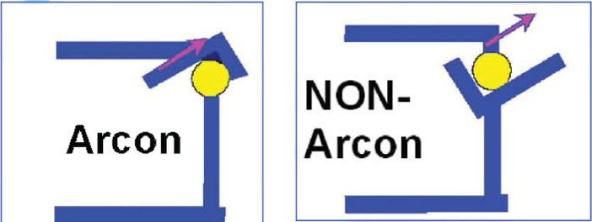

3. Fully adjustable articulators:
These accept not only centric relation maxillomandibular relation records, but also protrusive and right & lift lateral maxillomandibular relation. Fully adjustable articulators horizontal and lateral condylar path inclination can be obtained from the patient mouth in addition to face bow transfer. It facilitates the mounting of the cast on the articulator.
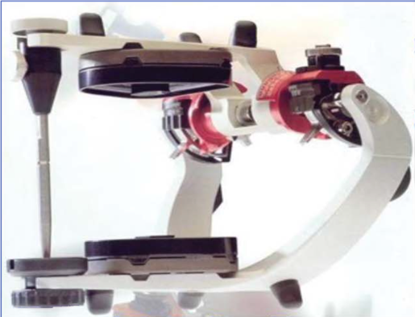
Advantages:
Allow view close representation of the T.M.J. with a more accurate reproduction of
condylar path and Bennett shaft.

Disadvantages:
1. Time-consuming to use and adjustable.
2. Require a high level of skill and understanding from both dentists and technicians.
3. Expensive instrument.

Parts of an articulator:
1) Maxilla or upper frame
2) Mandible or lower frame
3) Frame uprights
4) Incisive table.
5) Incisive pin.
6) Incisive rod.
7) Model mounting plates.
8) Screws for Model mounting plates.
9) Screws for Incisive rod.
10) Condylar rod (TMJ).
11) Anti-tipping rod.
12) Table for upper cast

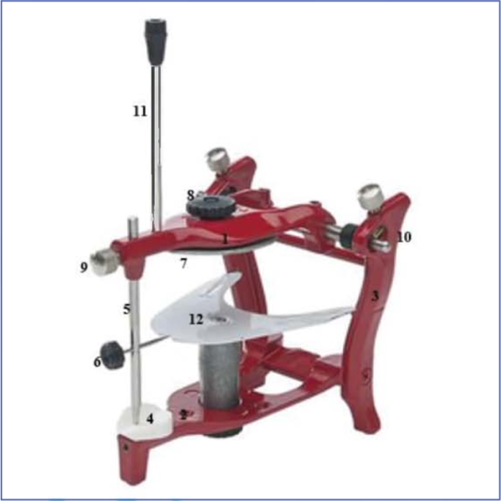

Face - bow:
It is a caliper like a device used to record the relationship ofthe maxilla to T.M.J or it's an instrument used to record the relationship of the maxillary arch and then transfer this relationship to an articulator.
Uses o f the face-bow:
1) Relate the maxillary cast to the terminal hinge axis of the condylar.
2) Facilitate the mounting of the cast on the articulator.

Parts of Face - bow:-
1- U- shaped frame.
2- The part that contacts the skin over the T.M.J. is the condyle rods.
3- The part that attached to the occlusal rims is the fork.
4- The other parts are the orbital point.

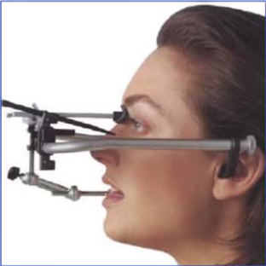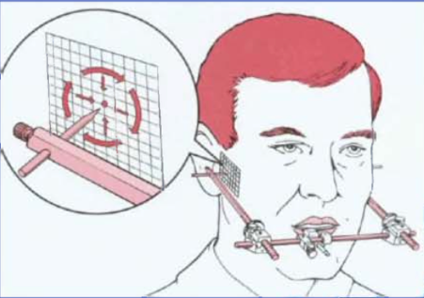

Die -lock tray:
This tray used in crown and bridge for working cast & dies, this tray with internal grooves and notches.
