___________________________________________________Lecture 8: Blood Film Preparation
Principle:
- Blood film enables us to evaluate WBC, RBC, and PLT morphology,
- Also, to perform differential WBC count,
- Estimation of WBC and platelets counts.
- Blood films are made on glass microscopic slides.

Sample: EDTA anticoagulated venous whole blood

Procedure:
1- Use clean standard size glass slides (3 inch x 1 inch = 7.5 cm x
2.5 cm), wiped from dust just immediately before use.
2- Place a small drop of well mixed anticoagulated whole blood, in
the center line of the slide, about 1.5 to 2 cm from one end, with
the aid of a capillary tube.
3- Immediately, without delay, with the aid of a second clean slide
with uniform smooth edges (spreader slide), with a 30 –40 degrees angle, move back so blood drop will spread along the edge of the spreader slide.
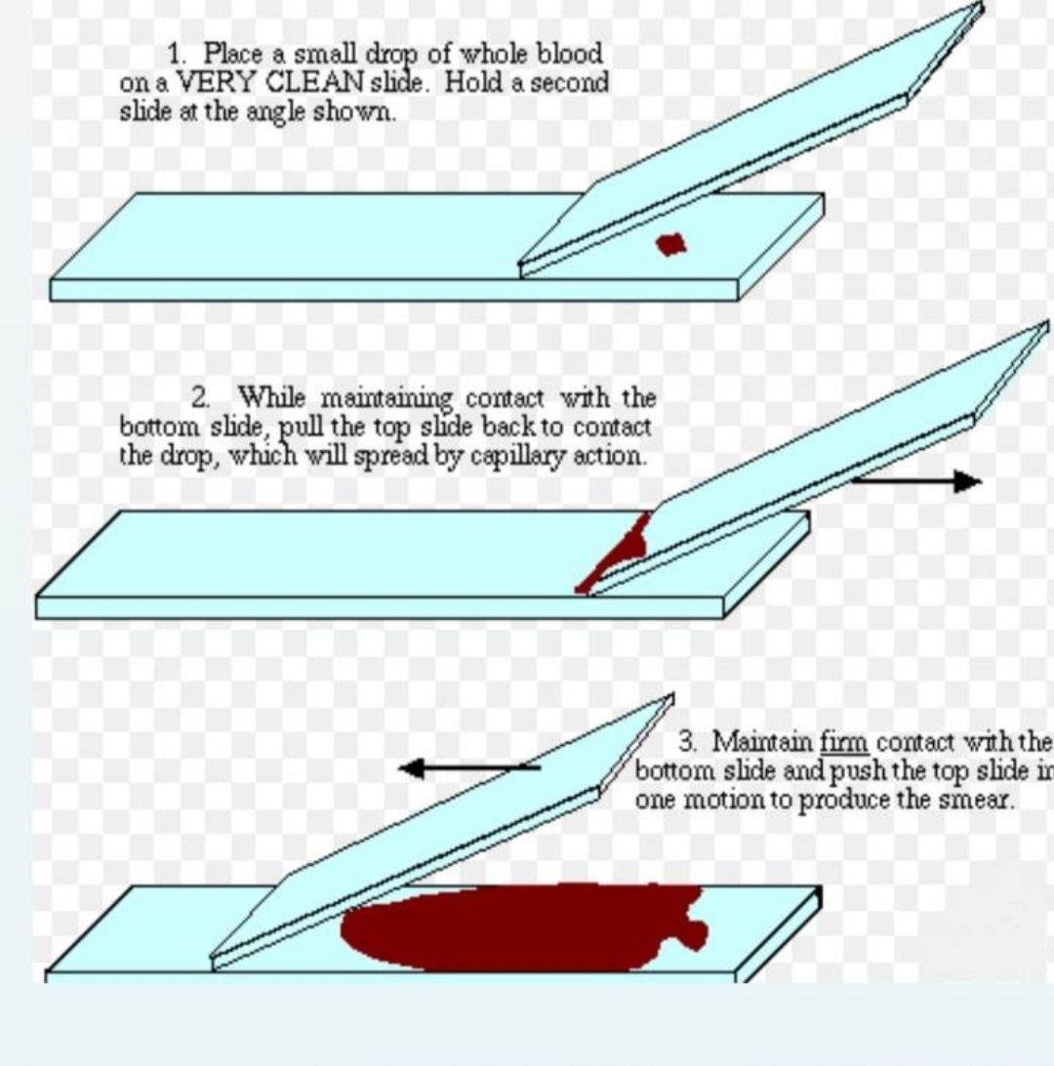
(Figure 1 blood smear preparation)
Blood films are stained with one of the Romanovsky stains, which are universally used for staining blood films
Romanovsky stains dependent on two staining components:
- Azure B (the basic dye) and
- Eosin Y (the acidic dye).
Other factors which affects the staining results include :
1) Staining time , 2) Ratio of Azure B to Eosin Y, 3) pH of the staining solution
Romanovsky stains include:
 Giemsa Stain
 Wright’s Stain
 Leishman Stain
 May-Grünwald Stain
The widly used and popular Romanovsky stains :

➢Leishman Stain
➢Wright’s Stain

Leishman Stain Procedure:

1- Cover the blood film with 8-10 drops of Leishman’s stain for 1-2 min.
2- Dilute the stain with an equal volume of distilled water (DW) and mix by gentle rocking then leave it for 10 min.
3- Wash with (DW).
4- Drain and dry in the air at room temperature.
5- Clean the back of the slide and examine it microscopically.
A well spread blood film should have the following characteristics (Fig.2):
1. Lateral edges 2. An adequate zone of morphology 3. Straight feature-edge. 4. Adequate length.
The zone of morphology is the area of the film where the RBCs barely touch each other (Fig.3), this is appropriate area for carrying out blood film examination.
Preparing a good quality smear depends on three main factors:
1- The size of the drop of blood.
2- The angle applied to spreader.
3. The speed and steadiness in pushing the spreader.
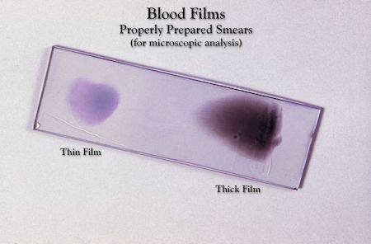
(Figure 2 well spread blood smear)
A B
Figure (3): a: Zone of morphology. The RBCs are well separated from each other. b: Thick film with no zone of morphology (RBCc are crowded).
Notes ON This Technique :

- Before preparing the films, you must check that blood samples are free from clots
- Films can be labeled with patient’s name and /or Lab. No. on the thick end of the film itself, after being dried, by using a pencil.
- With anemia (low Hct, reduced viscosity), the spreading angle
should be greater, to avoid running off the slide.
- With polycythemia (high Hct, increased viscosity), the spreading
angle should be less, to avoid short, too thick films.
- With large blood drops, increase the spreading angle.
- With small blood drops, decrease the spreading angle.

Sources Of Errors In Staining:

- Stain Precipitate: May obscure cell details .Filter the stain before use.
- pH of the buffer or water:
- Too acidic pH causes too pinkish slides.
- Too basic pH causes too bluish slides
- Improper stain timing may result in faded staining or altered colors:
- Too long staining time causes too blue slides (overstaining).
- Too short staining time causes too red slides.
- Forced drying may alter color intensities and/or distort cell
morphology.
- Non-stain related errors:
- EDTA causes crenation of the cells after blood collection.
- Severely anemic blood samples causes slower drying
(before staining) due to excessive plasma.

