Intraoral radiographic techniques
Intraoral radiographic techniques are used in routine dental practice. It is divided into three categories
.Periapcal projection.1
. Bitewing projection.2
. Occlusal projection.3
Periapical projections
Periapical radiographs are intended to evaluate the periapical region of the tooth and surrounding bone. It is often helpful in determining the cause of pain in specific tooth or area.
Indication:
.Detection of caries, pulp disease and apical infections.1
. Assessment of periodontal status.2
. Assessment of the presence and position of unerupted teeth.3
. Assessment of root morphology.4
. During endodontic treatment.5
. Implant imaging before and after placement.6
7.To study developmental defects such as dense in dente, dilacerations ….etc.
There are two periapical radiographic technique:
.Bisecting technique.1
. Parallel technique.2
The paralleling technique provides a less distorted view for the dentition but it’s more difficult to apply than the bisecting technique.
.**Bisecting technique:
1.The receptor is positioned as close as possible to the lingual surface of the teeth, resting on the palate or on the floor of the mouth.
2.The operator envision an imaginary bisector of the angle formed by the long axis of the tooth and the long axis of the film.
3.Operator direct the central ray of the beam through the apex of the tooth so it strikes the bisector at 90 degree
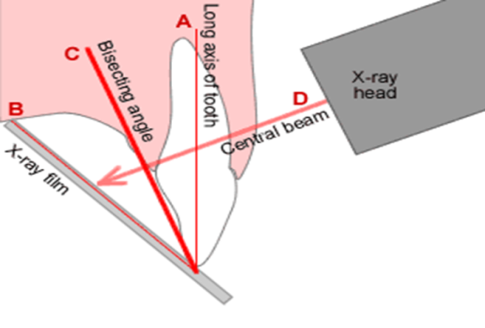
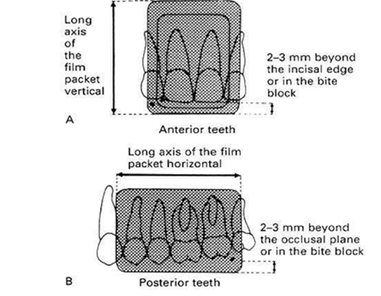
Film positioning:
* A small, raised dot known as the identification dot is located in one corner of the intraoral X-ray film. This raised dot is used to distinguish between the left and right sides of the patient after the film is processed; it should be oriented toward the occlusal or the incisal edge of the tooth facing the source of radiation
*In anterior teeth the film must positioned vertically , while the film is positioned horizontally in posterior teeth. The edge of the film is about 2-3 mm away from the incisal or occlusal surface
*if necessary for the patient comfort, the film can be softened by bending it before placing it against the tooth.
*The film is held in position by the patient himself with his thumb or index finger.
Angulations of the x ray tube head:
*Horizontal angulation: It refers to the x ray beam direction in horizontal plane
The tube head is pointed in a way that the central ray is directed through the contact area to avoid overlapping of the teeth. It determined by the shape of the arch.
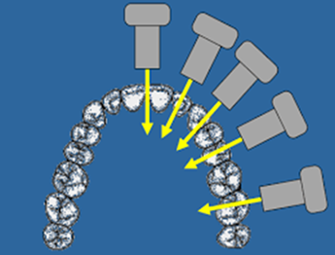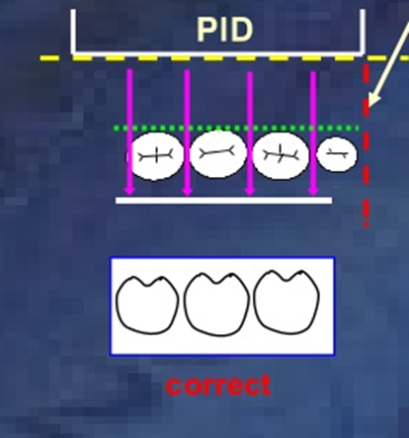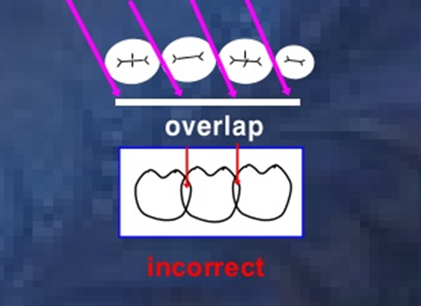
*Vertical angulation: Refers to the x ray beam direction in vertical plane.
Positive (plus) vertical angulation: the beam is tipped downward as in maxilla.
Negative (minus) vertical angulation: the beam is tipped upward as in the mandible.
**Paralleling technique:
It is called so because the film and the tooth must be parallel to each other
The requirement of this technique:
.It requires the target object distance as long as possible.1
2.It requires the x ray strike the tooth and the film at right angle (90 degree)
3. It requires the film to be placed in a position parallel with the plane passing through the long axis of all teeth being examined.
The last requirement causes a wide separation of the tooth and the film, which produce considerable distortion ( magnification) if a short target – object distance was employed, therefore a long cone (16 inch) should be used to increase the target – object distance and compensate for the distortion and un sharpness caused by increased object – film distance.
In the parallel technique, the film and the tooth should be parallel to each other so a paralleling instrument with an aiming ring (receptor holding device) is used to orient the film and the teeth in a parallel relationship.
When the aiming ring is aligned, the x ray beam will be perpendicular ( at right angle ) to the teeth and the film.
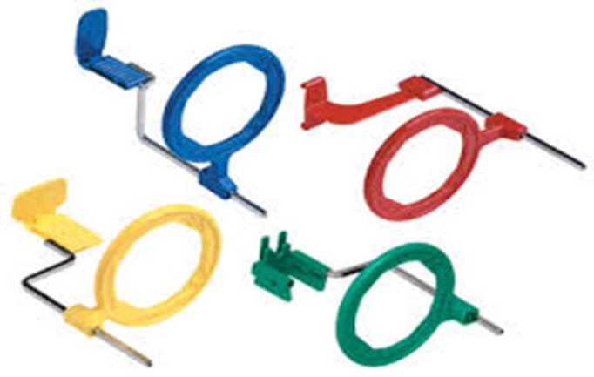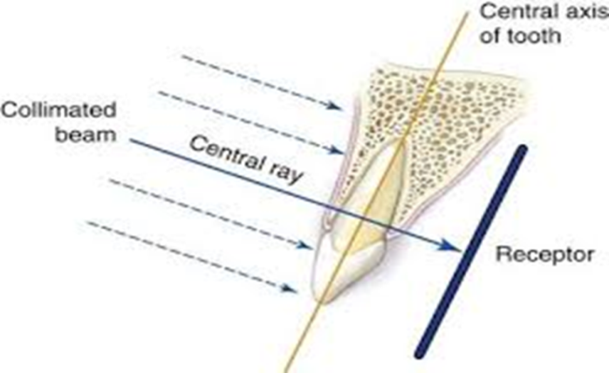
Bitewing projection:
It shows the interproximal caries and visualizes the periodontal condition between two adjacent teeth.
In adult we need 2 bitewing films on each side of the jaw at premolar and molar area while in children of 12 years old or less we need one film on each side. In a single film, the crowns of 6-8 teeth can be seen.
Patient is positioned with the occlusal plane horizontal and the tab of the film is placed on the occlusal surface of lower teeth. Ask the patient to close the teeth firmly together on the tab , the beam is aimed directly through the contact area at right angle in horizontal plane and at approximately 5˚ - 8˚ downward in vertical plane.
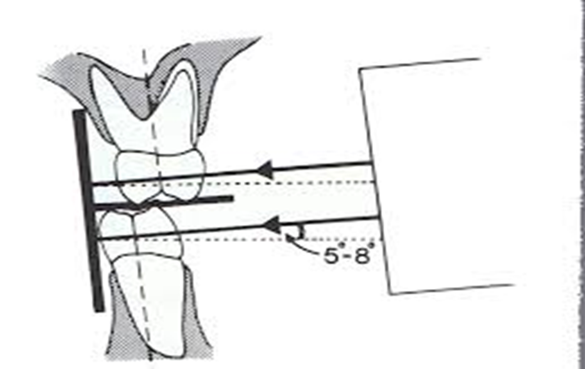
Occlusal projections:
Occlusal film is an intraoral radiograph where the x ray film is placed on the occlusal surface of the lower teeth; It shows an area which is larger than that shown in periapical or bitewing radiograph.
Indications:
1. To locate supernumerary, unerupted and impacted teeth.
2. To localize foreign bodies in the jaws and floor of the mouth.
3. To determine the full extent of disease ( e.g., cyst, malignancies) in the jaws, palate and floor of the mouth.
4.Imaging patients with trismus that have limited mouth opening.
5. Stone in submandibular and sublingual gland duct.
Occlusal film projections:
**Maxillary occlusal projection which include :
A- upper standard occlusal
B- upper oblique occlusal
C- vertex occlusal
Mandibular occlsal projections which include:**
A- lower 90 occlusal ( true occlusal )
B- lower standard occlusal.
C- lower oblique occlusal.
Maxillary occlusal projections:
A- Upper standard occlusal:
it shows the anterior part of maxilla and upper anterior teeth.
The technique involves:
1. Patient positioned with the occlusal plane horizontal and parallel to the floor
2. Film placed on the occlusal surface of the lower teeth and the patient is asked to bite gently. The long axis of the film is crossways.
3. X ray tube positioned above the patient in the midline directed through the nose bridge at angle 65–70 degree
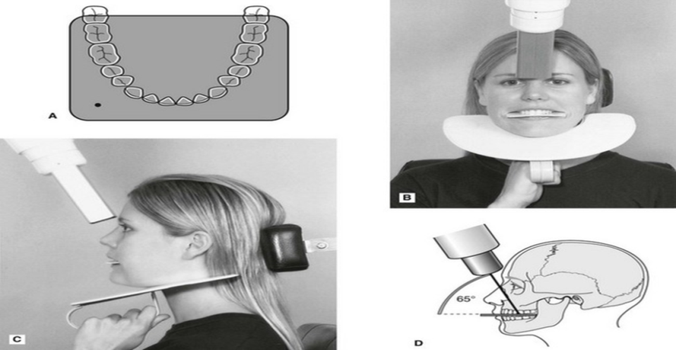
B- Upper oblique occlusal:
This projection shows the posterior part of maxilla and upper posterior teeth.
The technique involves:
1. Patient positioned with the occlusal plane horizontal and parallel to the floor.
2. Film placed on the occlusal surface of the lower teeth and the patient is asked to bite gently. The long axis of the film is anteroposteriorly placed to the side of the mouth under examination.
3. X ray tube positioned at the side of the patients face directed downward through the cheek at 65-75 degree.
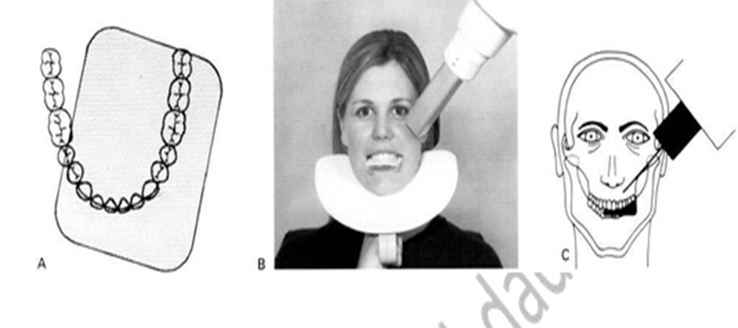
C- Vertex occlusal:
This view shows a plan view of teeth bearing area of maxilla from above to assess the bucco palatal position of unerupted canine.
The technique involves:
1. Patient positioned with the occlusal plane horizontal and parallel to the floor.
2. Film placed on the occlusal surface of the lower teeth and the patient is asked to bite gently. The long axis of the film is anteroposteriorly in the mid line.
3. X ray tube is positioned above the patient in the midline directed through the vertex of the skull downward
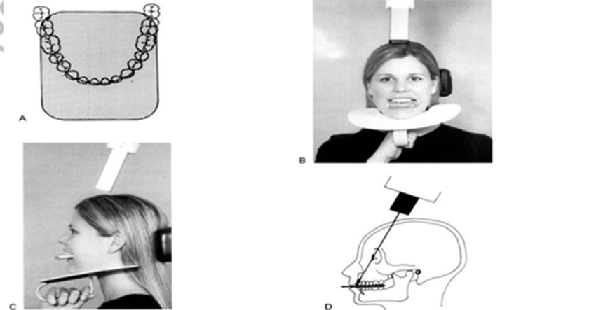

Mandibular occlusal projections:
A- Lower 90 occlusal (true occlusal):
This projection used to show the floor of the mouth and the teeth bearing area of the mandible from second molar to the other second molar.
The technique:
1. Patient tips his head backward as far as comfortable, where it is supported
2. The film placed centrally to the mouth on the occlusal surface of the lower teeth with long axis crossways and the patient bite gently on the film.
3. The x ray tube placed below the patient’s chin in midline centering on an imaginary line joining the first molar at 90 degree to the film.
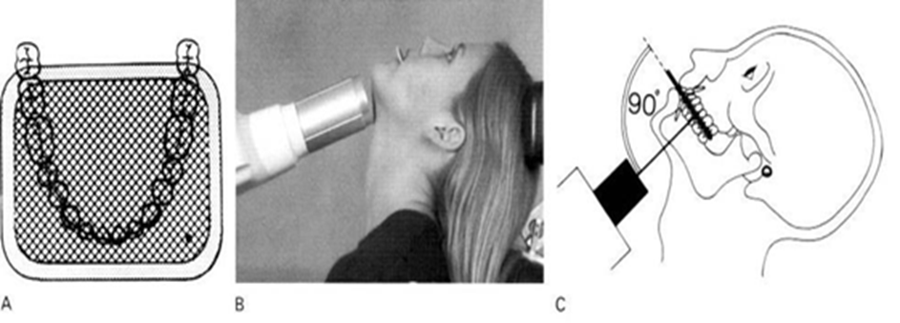
B- Lower standered occlusal:
This projection is taken to show lower anterior teeth, anterior part of mandible and the inferior border of the mandible.
The technique:
1. Patient is seated with the occlusal plane horizontal and parallel to the floor.
2. Film placed centrally into the mouth with the long axis anteroposterior and asked him to bite on the film gently.
3. X ray tube is positioned in the midline centering through the chin point at 45 degree to the film
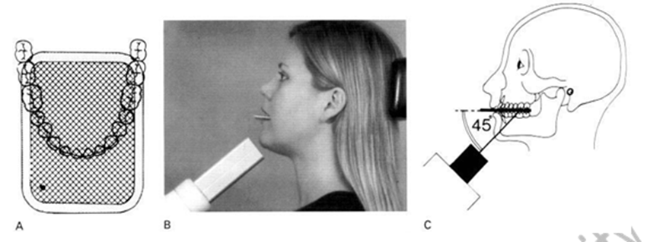
C- Lower oblique occlusal:
This projection shows the submandibular salivary gland on the side of interest.
The technique:
1. Patient head is supported and rotated away from the side under investigation and the head is raised.
2. The film placed on the occlusal surface of lower teeth over the side under investigation with long axis anteroposteriorly then he bite on the film gently.
3. The x ray tube directed upward and forward toward the film from below and behind the angle of mandible and parallel to the lingual surface of the mandible.

