


Al-Mustaqbal University
College of Health and Medical Technologies
Radiological Techniques Department

Magnetic Resonance Imaging

First Semester
Lecture 9,10 : Artifacts and their compensation

By

Dr. Mohanad Ahmed Sahib
MSc. Ph.D. Radiology technology

Assistant lecturer
M. A. Mohammed
MS.C. Theoretical Nuclear Physics

2023/2024

Scientific Content:
Artifacts may be defined as the false features in the image produced during the imaging process. The random fluctuation of intensity due to noise can be considered separately from artifacts. Artifacts can be rectified easily when the causes are known. It is necessary to be familiar with specific artifacts since they can conceal pathological elements or simulate pathology that does not exists.
Artifacts can be classified into different categories, viz.
- Aliasing
- Chemical shift
- Gibbs/truncation
- Magic angle
- Motion
- Point
- Slice overlap
- Susceptibility
- Zipper
- Array processing
- Coil selection

1- Wrap Around/Aliasing
Wrap around or aliasing appears when the diameter of the scanned area is greater than the dimensions of the field of view used a part of the image is ‘folded’ on itself.

Fold over artifacts also known as:
i. Back folding
ii. Aliasing
iii. Wrap around artifact
Phase of the signal just outside of the field of view, increase FOV, changes preparation direction increased phase encoding.

Remedies
1. Increase FOV
2. Filtering the frequency encoded direction
3. Oversampling in the phase encoded direction

2- Chemical Shift Artifacts
Chemical shift artifacts appear at the interfaces between water and fat because the precessional frequency of protons is slightly different in these two substances. This leads to misregistration of the signals. They are displayed by the equipment as dark region of signal void on one side of water containing tissue and a region of bright signal at the other end of the water fat interface due to super imposition of fat and water signals on the frequency encoding direction.
The chemical shift artifacts is commonly noticed in the abdomen, spine and orbits where fat and other tissues from boarders.

This artifact is greater at higher field strengths and can be reduced by increasing the bandwidth. The only way to eliminate this artifact is to use a fat suppression technique.

3- Gibbs or Truncation Artifacts
Gibbs or Truncation artifacts are bright and dark lines that are seen parallel and adjacent to boarders of abrupt intensity change, as many be seen at CSF, spinal cord, fat and muscle. These artifacts are commonly seen in phase encoding direction. They can be reduced by
a. Increasing the matrix
b. Using a filter
c. Change the direction of phase and frequency.

4- Magic Angle Artifacts
Magic angle artifact is seen mostly in tendons and ligaments of knee-joint that are oriented at a magic angle, i.e. 55° to the main magnetic field. This artifact is seen commonly in the rotator cuff and occasionally in the patellar tendon region and elsewhere

5- Motion Artifact
Motion artifacts appear as repeating densities oriented in the phase direction occurring as the results of motion during acquisition of a sequence. These artifacts may be seen from arterial pulsations, swallowing, breathing, peristalsis and physical movement of a patient. This type of artifact is caused by the motion of the patient voluntarily on involuntarily during the scanning. The various types of motion artifacts are as follows:
A- Patient motion Since all the images in one sequence are taken at the same time, it is important not to use excessively long sequences, as movement for a brief period spoils all the images.

Remedy: Make patient lie comfortably, stabilize, with straps and cushions.
B- Cardiac motion This type of artifact is caused by the contraction and relaxation of heart (chest) while the scanning is going on.
Remedy: To avoid this type of artifact, cardiac gating is mandatory during the procedure.

C- Respiratory motion This type of artifact is caused by respiration during the scanning.

Remedy: This can be avoided by respiratory gating and respiratory compensation.
It can be avoided by placing bellows (pressure transducers) around the patient’s chest or abdomen.
D- Blood flow motion This type of artifact is caused by the flow of blood throughout the cardiac cycle. The artifact are prominent in axial images.
Remedy: An effective remedy for blood flow motion artifact is ‘Spatial
Presaturation (SAT)’.
E- CSF pulsation The remedy for CSF pulsation ghosting is ‘Gating’ to the cardiac cycle, e.g. plethysmograph (peripheral gating). However, combination of ‘Gating’ and flow compensation (flow comp) is optimal for cervical and thoracic imaging.

6- Point Artifact
Point artifact is seen as a bright spot of increased signal intensity in the center of the image. This is caused due to constant offset of DC voltage in the receiver coil which after Fourier transformation appear as a bright spot in the center of the image.

7- Slice Overlap Artifact
The slice overlap artifact is a name given to the loss of signal seen in an image from a multi-angle, multi-slice acquisitions, as is obtained commonly in the lumbar spine. If the slices obtained at different disk spaces are not parallel, then the slices may overlap.

If two levels are done at the same time, e.g. L4/L5 and L5/S1 then the level acquired second will include spins that have already been saturated. This causes a band of signal loss crossing horizontally or vertically in our image, usually prominent posteriorly.

8- Susceptibility Artifacts
The susceptibility of a tissue fells us how easily it can be magnetized. Normally most of the tissues have susceptibility values which fall in a fairly narrow range. However, presence of paramagnetic material like hemoglobin degradation products or tissue-air interphases lead to local variations in the susceptibility. This is turn results in reduction in the quality of the local field.
Tissue air interphases related artifacts are commonly seen around the para nasal sinuses and the lungs. These susceptibility artifacts can be removed by using spin echo sequences.

9- Zipper Artifacts
This artifact is caused by external RF entering the room at a certain frequency and interfering with inherently weak signal coming from the patient. There are various causes for zipper artifacts in images. Most of them are related to hardware or software problems. The zipper artifacts that can be controlled easily are those due to RF entering the scanning room when the door is open during acquisition of images. RF from radio transmitters will cause zipper artifact that are oriented perpendicular to the frequency axis of the image. Frequently there is more than one artifact line on an image from this cause.
Remedy: System generated artifacts should be reported service engineer.
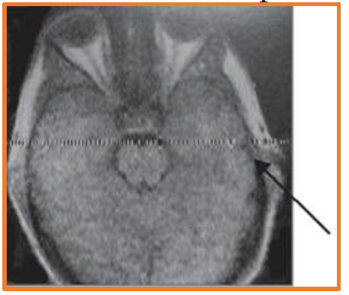

Figure :Effect of right interface causing streak artifacts. This can be caused by a leaking RF, causing pick-up of external RF signals

Posttest:
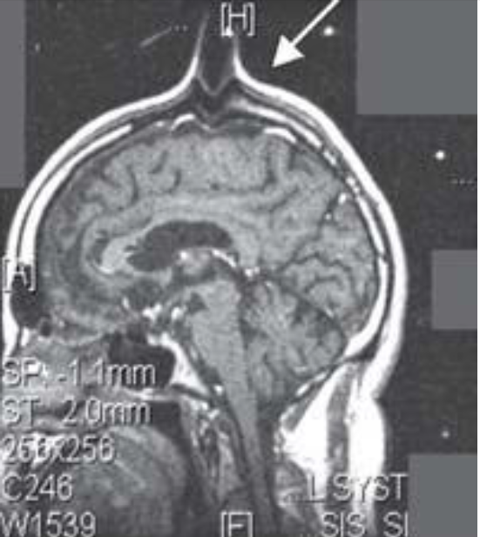

Q: As MRI technician detect the type of this artifact and suggest the remedies you could do to fix the image?

