Factors controlling the production of radiograph
*Radiation Quantity: the number of x ray photon in the useful beam.
*Radiation Quality: is the penetrating power of the x ray beam which is quantified by HVL.

factors controlling the radiographic production can be subdivided into:

1.factors related to the radiation beam.
2. factors related to the object.
3. factors related to the x ray film

1. Factors related to the radiation beam:

A. Exposure time: Changing the exposure time (measured in fractions of a second) modifies the number of photons generated. When the exposure time is doubled, the number of photons generated is doubled too but the photon's energy is unchanged.
B. Tube current: The number of photons that reach the patient and the film (quantity) is directly proportional to the tube current (mA).
As the milli amperage is increased more power is applied to the filament, which heat up and releases more electrons that collide with the target producing more photons.
C. Kilovoltage: Increasing the kVp increases the potential difference between the cathode and the anode, increasing the energy of each electron when it strikes the target. The greater the energy of the electron, the greater the probability it will be converted into the X ray photons .
Increasing the kVp of X ray machine will increase:
1.The number of photons generated. (beam quantity).
2.The energy of photons (beam quality).

D. Filtration: Although the x ray beam consists of X ray photons with different energies, only photons with sufficient energy to penetrate the tissue and reach the image receptor (film or digital) are useful for diagnostic radiology. Low energy photons (photons with longer wavelength) cannot reach the receptor and only increase patient exposure so its desirable to remove these low energy photons from the X ray beam. This removal can be accomplished by placing a metallic disc (filter) in the path of the X ray beam. The result of filtration of X- ray beam is hardened beam (more short wave-length photon with high penetration power)
E. Collimation: collimator used to control the size and shape of the beam.
Effect of collimation:
- Reduce the amount of tissue irradiated
- Minimize the production of secondary radiation fog.
* Fog: - is the unwanted film density (blackening) and thus reduce radiographic contrast.

F. Distance: The intensity of the x ray beam at a given point ( number of x ray photons per cross sectional area per unit exposure time) is inversely proportional to the square of the distance from the source of radiation and this is called (inverse square law). The reason for this decrease in intensity is that the X ray beam spread out as it moves from the source.

2. Factors related to the object:
As the object is an absorbing x ray medium; it plays an important role through its:
A. Thickness: thickness must be considered when we talk about radiographic image production; body parts that have greater thickness absorb more x ray photons resulting in a lighter (more radiopaque)image.
Thick object required more radiation to make a radiographic image so it's often advisable to increase kV or mA and /or exposure time in order to increase the amount of X- ray photons
B. Density: density refers to weight per unit volume of the object . In dental radiography enamel of the tooth has highest density of all body tissues. increase the density of the object increase its ability to absorb X- radiation. So hard tissue like enamel absorb great amount of radiation when compared with absorption of soft tissue like pulp because of object density
3.Factors related to the film:
A. Reduction of secondary (scattered) radiation: scattered radiation is undesirable because in addition to that it increases radiation to the staff and patient; scattered radiation reach all parts of the film and producing film fog (unwanted film density).
Depending on the type of the film ; we can minimize scattered radiation for the intraoral film through the presence of lead foil behind the film. In case of extraoral film ; a grid is an effective device for reducing the amount of scattered radiation.
The grid is composed of alternating strips of radiopaque material (lead) and strips of radiolucent material(plastic); so the grid transmitted only the x rays that are on straight line from the source and absorb the remnant scattered radiation.
B. Film storage: the film should be stored away from heat and humidity and in a lead lined boxes to prevent stray radiation from fogging the film. Objects should not be placed on the top of the stored film because pressure can cause film artifacts and of course films should be used before the expiration.
C. Intensifying screens: the screens should be routinely checked and cleaned because any debris or scratches may cause spots on the resultant radiograph.
D. Film processing: correct processing of exposed x ray film is an essential step in obtaining an artifacts free radiograph.

Ideal radiographic projection
Ideal radiograph demonstrates certain image qualities include:
A – Radiographic image that is sharp.

B – Radiographic image that is shaped like the object.

C – Radiographic image that is the same size as the object.

- Sharpness: is the ability of a radiograph to define an edge precisely (e.g. the dentino-enamel junction, a thin trabecular plate)
- Image Size Distortion (magnification) is the increase in size of the image on the radiograph compared with the actual size of the object.
- Image shape distortion is the result of unequal magnification of different parts of the same object ( Is the change in the shape of image as compared to the object due to improper alignment of the tube ,film or the object).
- Penumbra: Is the amount of un sharpness of the image so penumbra is the area of partial shadow.
- Umbra: Is the area of total shadow and its exist only when the object absorb all of X – rays.
Penumbra is created by the size of focal spot (source of radiation), the larger the spot size the greater is the penumbra (the amount of un sharpness). penumbra not only affected by focal spot size but also affected by tube – object distance and object – film distance so the closer tube – object distance the greater is the penumbra while the closer object – film distance the lesser is the size of penumbra.

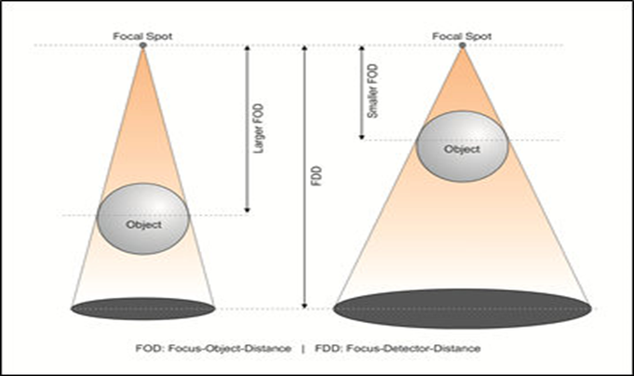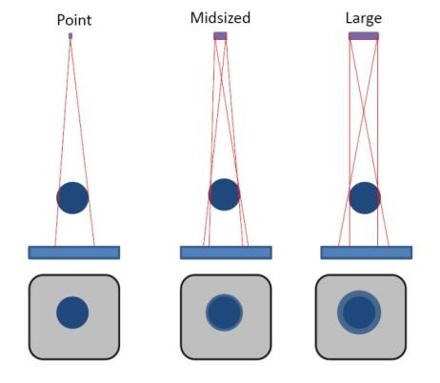
effect of focal spot size on penumbra & umbra effect of tube – object distance on umbra & penumbra

Basic Principles of Projection Geometry for Radiography ( Principles of shadow casting)
- Source of radiation should as small as possible.
- Tube – object distance should be as great as possible.
- Object – film distance should be as small as possible.
- Film should be parallel to the object.
- Central ray of the beam should be perpendicular to the film.
The first 3 principles deal with the image sharpness while the last 2 principles required during exposure as a technique.

Radiographic errors and Artifacts:

Classified into three categories:
  - Technique and projection errors
  - Exposure errors
  - Processing errors

Cone cut: is clear unexposed area results from positioning fault when the x ray beam doesn’t completely cover the film during exposure.

Back side exposure: when the film placed in wrong position making the non-exposure side facing the beam, the result is the image with the pattern of lead foil is evident.

Undeveloped area (developer cut off): this appear as clear area caused by incomplete immersion of the film in the developer or sticking the film in the developer to the side of the tank.

Double exposure: the same film exposed twice to x ray this results in two images appear superimposed onto each other.

Elongated image: vertical angulation of x ray tube head was too shallow

Shortened image: vertical angulation was too steep (excessive).

Overlapping of adjacent structures: when horizontal angulation was incorrect; the proximal surfaces of adjacent teeth appear overlapped and this prevent the examination of interproximal area

Distorted image: the image appear stretched and distorted due to excessive bending of the film during placement or heavy pressure by patient's finger

Fingernail marks: black crescent shaped marks appears on the film. The cause is the damaging of the emulsion by operator’s or patient’s finger during rough handling of the film

Pale x ray film: this is due to under exposure or under developing

Dark x ray film: this is due to over exposure or over development
Bend marks ( black line marks): it appears on the film due to excessive film bending
A completely clear film: The causes are we put the film in fixer before developer, the film didn't receive radiation, malfunction of the machine or defect in the film itself

Reticulation: it mean crack of emulsion when subjected to great change in temperature between different processing solutions

Scratched film: it is a white lines appeared on the film. when the film is processed, the soft emulsion is easily scratched by sharp object such as holder, tank or nails; so handle the film gently during processing.

Blurred film: movement of the patient or the x ray tube head during exposure. The operator should remind the patient to remain motionless during exposure.

Developer spot: dark spot on the film caused by drops of developer solution that was accidently spilled on the film before it was developed.

Fixer drop: white dots or light spots on the film caused by drops of fixer solution that was accidently spilled on the film before it was developed.
Static electricity: it is a black "lightening" marks result when the film is forcibly unwrapped or due to excessive flexing of the film.
Brown film: with time the film will go brown if not left in fixer solution or water bath (final wash) for the required amount of time with manual processing or the fixer solution may be exhausted.
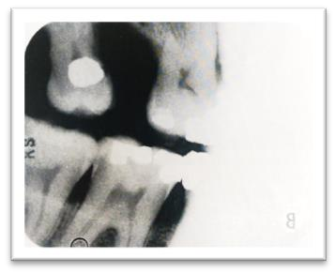
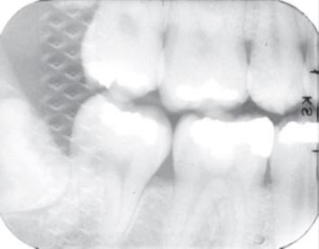
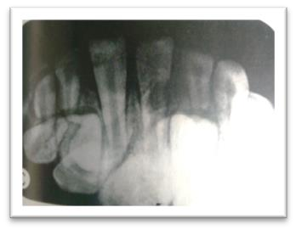
Cone cut reverse side exposure double exposure
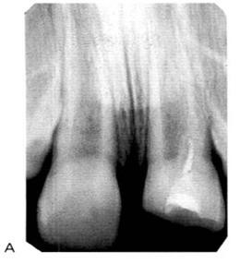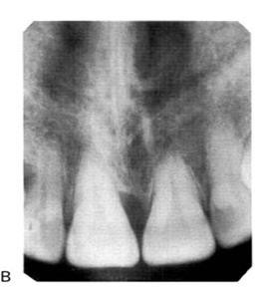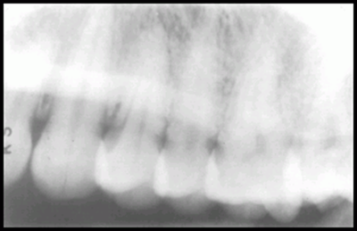
Elongation shortening overlapping
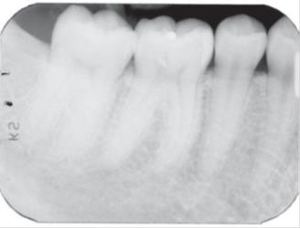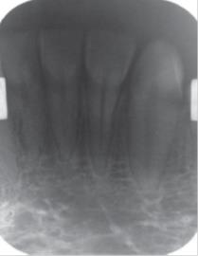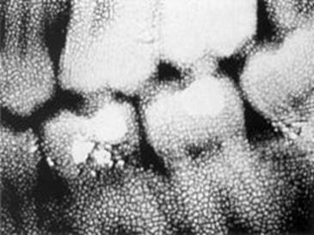
Pale film dark film reticulation
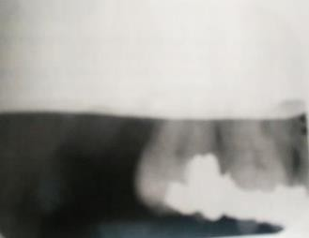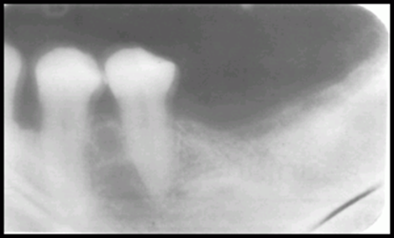
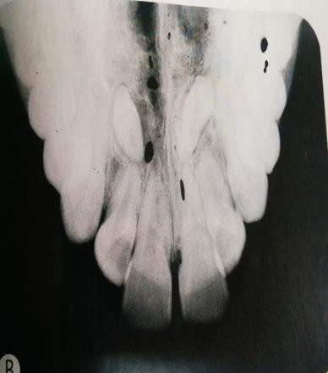
undeveloped area blurred image
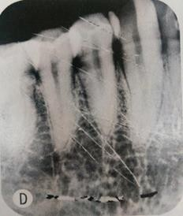
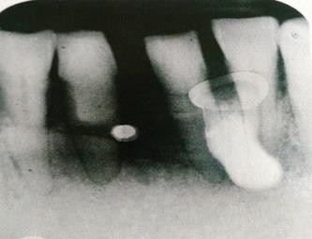

fixer spot Developer spot (occlusal film) scratched film

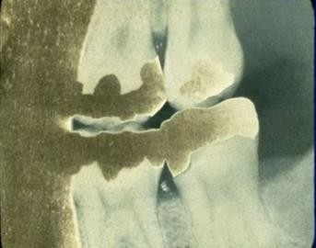
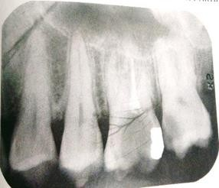
yellow or brown discoloration static electricity complete clear film

