Ministry of Higher Education and Scientific Research Al- Mustaqbal University College Department of Chemical Engineering and petroleum Industrials

Mathematics II

2nd Stage

Lecturer: Rusul A. Hashim

Multiple Integrals

Integration of functions of one variable
We start by recalling the basics of integration with respect to a single variable. We have results such as:
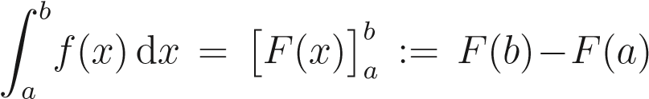
where F is an “antiderivative” or indefinite integral of f. (f = dF/dx.)
Z λf(x)dx = λZ f(x)dx,
Z (f(x) + g(x))dx = Z f(x)dx + Z g(x)dx.
Useful techniques include:
- Integration by parts.
- Integration by substitution.
- Use of partial fractions.
Some specific integrals can be found on the formula sheet.

Question 1. Calculate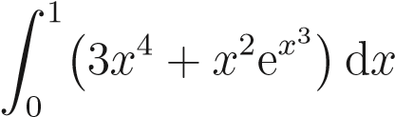.
Solution. This integral is designed to use a few different techniques! Firstly we can split the integral as
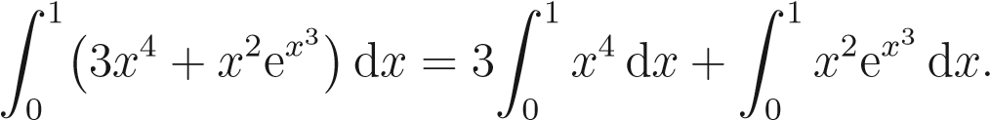
The first integral on the right-hand side is straightforward:
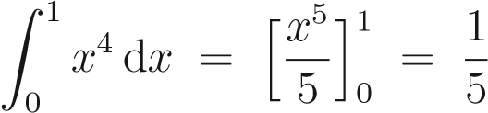.
To calculate the second integral on the right hand side we use integration by substitution; taking u = x³ we have d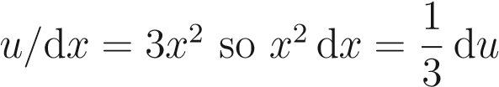. Therefore
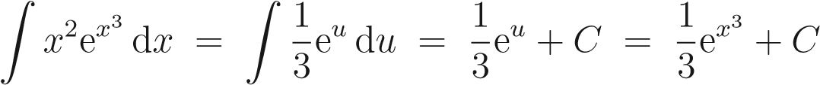.
The definite integral can then be computed as
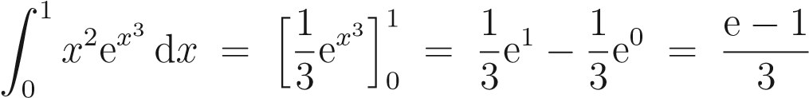.
Combining the above calculations we finally get
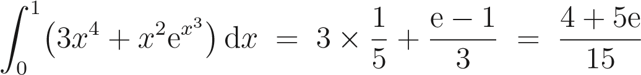.

One interpretation of an integral like this is the area under a graph: assuming that f is positive, the area of a strip of width dx and length f is f dx and then A = Ra^{b} f(x)dx is the total area between the x axis and the curve y = f(x) for a < x < b.
y = f(x)
x
a
b
A
More generally, if f represents the density of some quantity, i.e. it is the amount per unit length, f dx is the amount in a short length dx and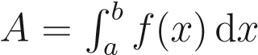 is the total amount between x = a and x = b.

Integration of functions of two variables
Thinking of a single integral as giving an area, we might ask: what is the volume under a surface z = f(x,y) lying above a rectangle in the x - y plane, a < x < b, c < y < d? (We again take f > 0 for simplicity.)
First look at a small rectangle of length dx and width dy. Its area is dA = dx dy. Then the volume between that small rectangle and the surface is the height of the enclosed (aproximately) cuboidal region times the area: f dA = f dx dy.
z = f(x,y)
d
y
d
x
f
The volume between the x - y plane and the surface in the slab of width dx between y = c and y = d is then given by integrating with respect to 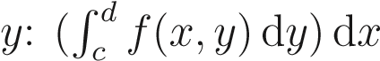. (In doing this integral, x is held fixed.) Finally, to get the total volume, we must integrate with respect to x from a to b:
volume =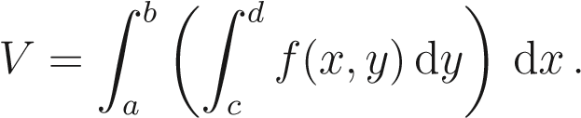 (7.1)
We usually abbreviate this double integral as

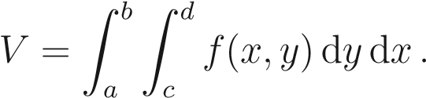 (7.2)
Noting that, for cases we’ll be considering at least, we could have integrated with respect to x first and then y, we also have
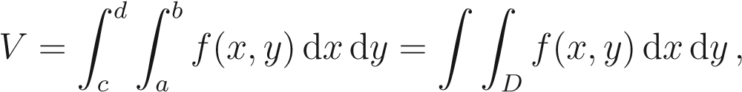 (7.3)
where D is our region of integration, here D is the rectangle a < x < b, c < y < d.

More generally if f once again represents some sort of density, e.g. mass per unit area in a sheet of metal, the double integral R RD f(x,y)dxdy is the total amount in the region D.
Question 2. CalculateZ (xy² + y)dy dx. 4 3
2 1
Solution. Calculating the inner integral first gives
Z
.
Therefore
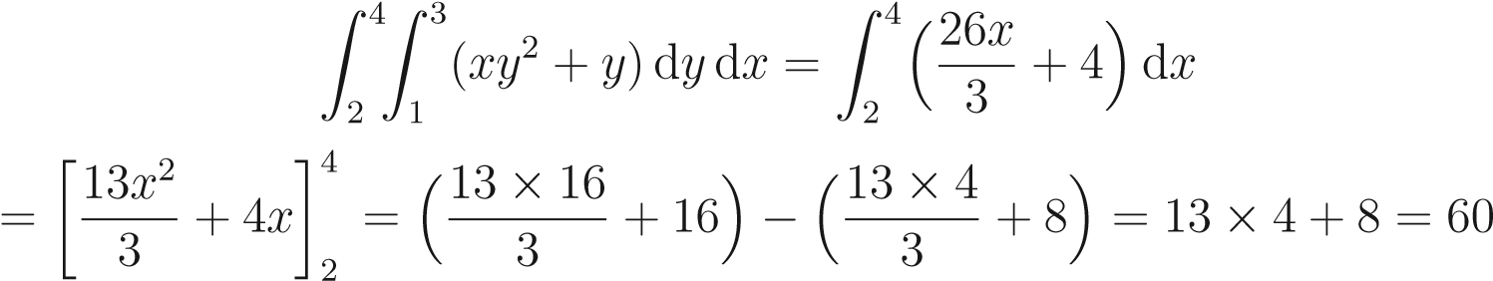.

Question 3. CalculateZ 2xy dxdy. 1 3
0 2
Solution. Calculating the inner integral first gives
Z
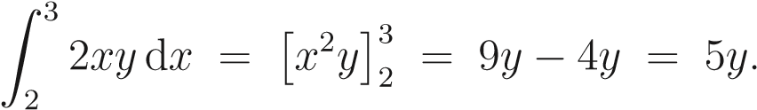
Therefore
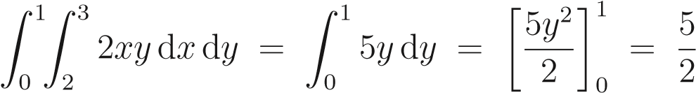.

3 1
question 4 . For the double integral Z Z 2xye^{xy2} dy dx the region of integration D is
2 0 the rectangle given by
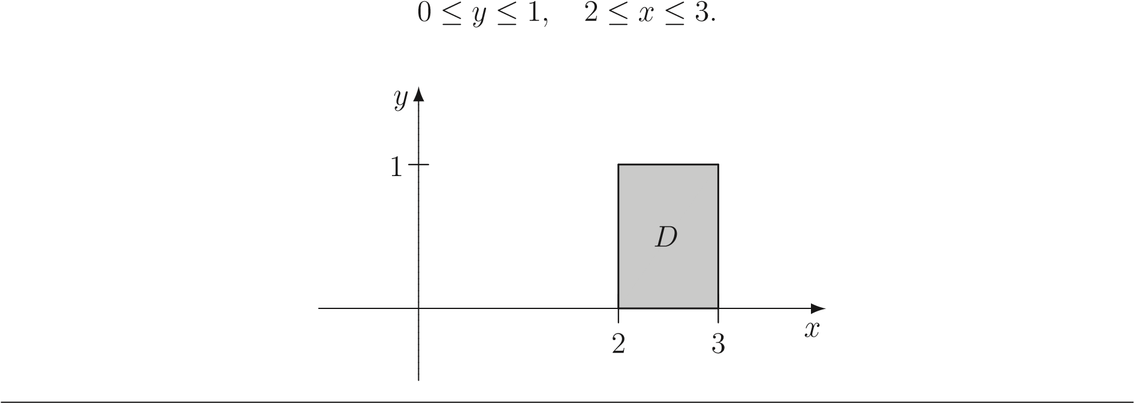

Question 5 . CalculateZ 2xye^{xy2} dy dx. 3 1
2 0
Solution. Firstly consider the inner integral
Z
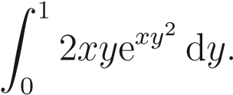
We will use integration by substitution for this integral; taking u = xy² we have 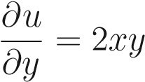so du = 2xy dy and hence
Z 2xye^{xy2} dy = Z e^{u} du = e^{u} + C = e^{xy2} + C.
Thus
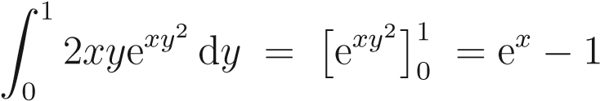.
It follows that
.

Question 6 . Let D be the rectangle given by
−1 ≤ y ≤ 0, 1 ≤ x ≤ 3.
Calculate ZZ (x² + y)dy dx.
D
Solution. The region of integration is the following:
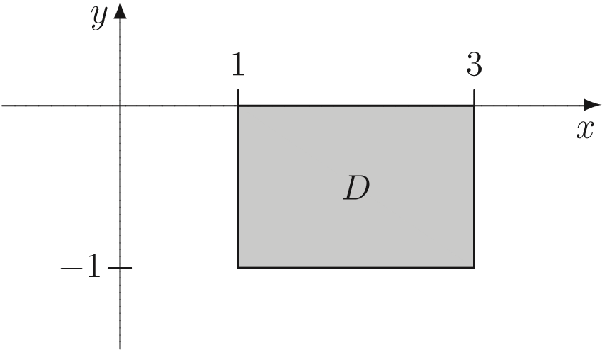
Now
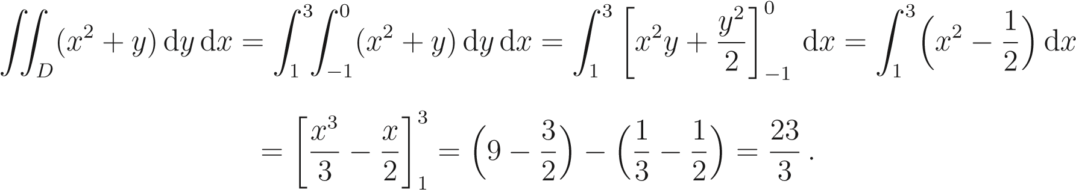

Of course a region of integration need not be rectangular. If D can be described by g(x) < y < h(x) for a < x < b, the (double) integral of f(x,y) over D will be
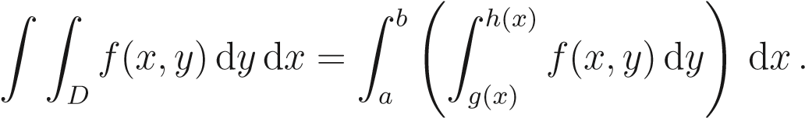
We can drop the brackets and simply write this as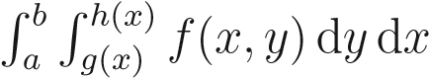.

question 7 . Consider the region given by
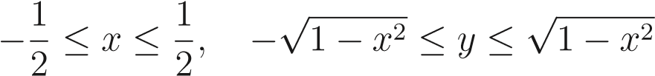.
This region is part of a disc.
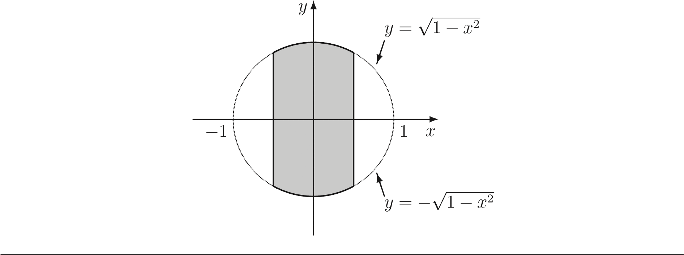

question 8. Consider the region D:
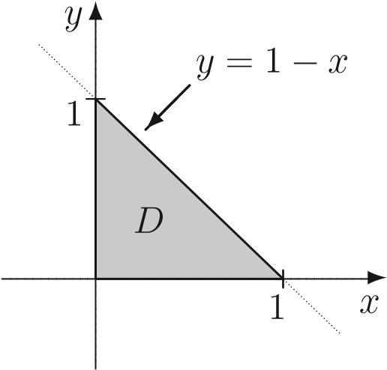
In this region we have 0 ≤ x ≤ 1 whilst, for a given x, 0 ≤ y ≤ 1 − x. Thus the region D _{is described by}
0 ≤ x ≤ 1, 0 ≤ y ≤ 1 − x.

Question 9 . Calculate Z ZD y dA over the region D below:
Solution. In this region we have 0 ≤ x ≤ 1, whilst, for a given x, we have
√x ≤ y ≤ 1.
1
y
=
√
x
x
y
D
0 1
Therefore
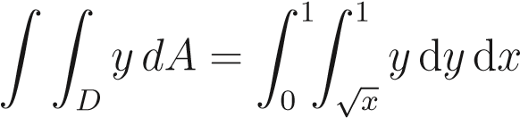.
Calculating the inner integral first gives
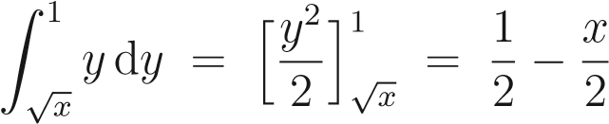.
Hence
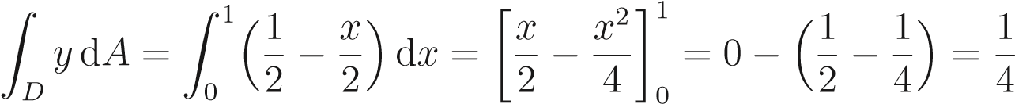 .

question 10. Consider the region D:
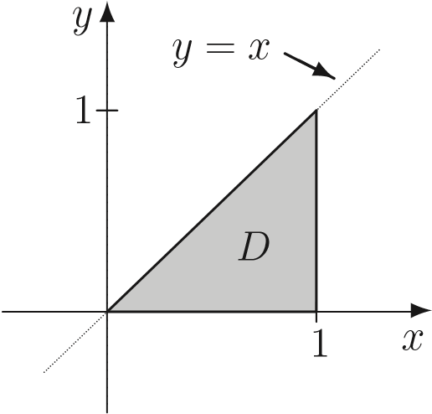
In this region we have 0 ≤ y ≤ 1, whilst, for a given y, y ≤ x ≤ 1.

Question 1 1 Calculate. ZZD(3 − x − y)dA where D is the region described in the previous question.
Solution. Recall that D is described by
0 ≤ y ≤ 1, y ≤ x ≤ 1.
Therefore ₁ ₁
ZZ (3 − x − y)dA = Z0 Zy (3 − x − y)dxdy.
Now
.
It follows that
.

Interchanging the order of integration
As noted before, we can swap the order in which the order in which the integrals are carried out : R R_{D} f dy dx = R RD f dA = R RD f dxdy. It is sometimes easier to calculate the value of a double integral doing the integrations in one order than the other.

Example 7.6. Consider the region D which lies between the line y = x and the parabola y = x²:
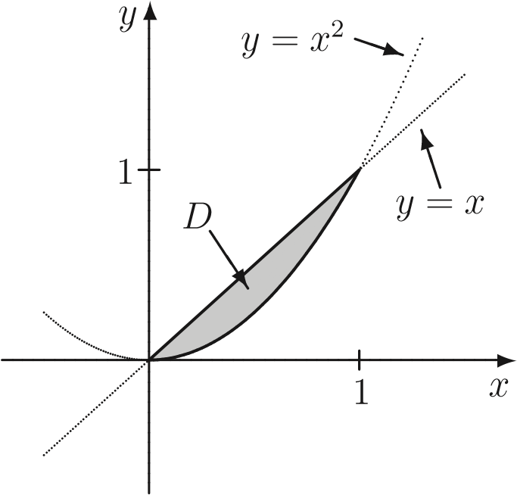
This region can be described by
0 ≤ x ≤ 1, x² ≤ y ≤ x.
On the other hand, the parabola is also given by the equation x = √y so the region D can also be described by
0 ≤ y ≤ 1, y ≤ x ≤√y.
It follows that we have

Question 1 . Calculate ZZ e^{y2} dA where T is the triangular region with vertices (0,0),
(0,1) and (1,1): ^{T}
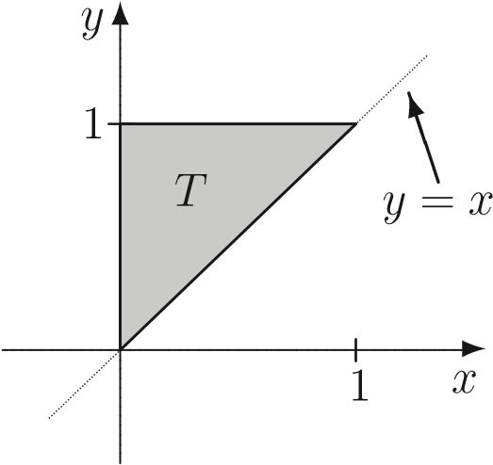
Solution. As a first attempt we may describe T by
0 ≤ x ≤ 1, x ≤ y ≤ 1.
It follows that
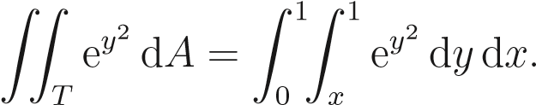
The inner integral is then
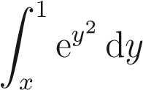
which can’t be evaluated very easily! We’ve got stuck!
As a second attempt let us describe T the other way; that is
0 ≤ y ≤ 1, 0 ≤ x ≤ y.
Then ZZ e^{y2} dA = Z Z e^{y2} dxdy. 1 y
T 0 0
Evaluating the inner integral first gives
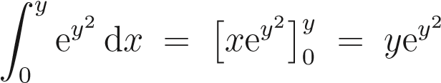.
It follows that
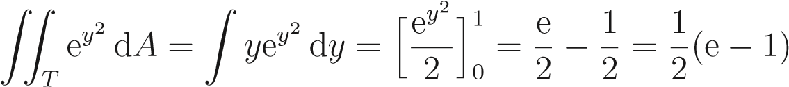,
where we used the substitution u = y² to evaluate the integral.

Note. On evaluating a double integral I = R RD f(x,y)dA by doing the y integral first, i.e. taking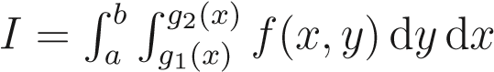, we integrate along vertical strips between the lower boundary, say y = g₁(x), and the upper boundary, say y = g₂(x) (this gives a result which generally depends upon x, but definitely does not depend on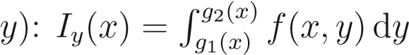.
We then total up the contributions of strips by integrating I_{y} from the lowest value of x taken in D, say a, to the largest, say b (see Fig. 7.1(i)): 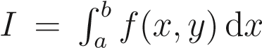. On the other hand, doing the y integral first, we take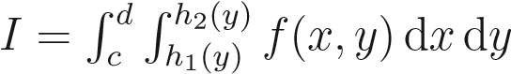, we integrate along horizontal strips between the left-hand boundary, say x = h₁(y), and the right-hand boundary, say x = h₂(y) (this gives a result which generally depends upon y, but definitely does not depend on 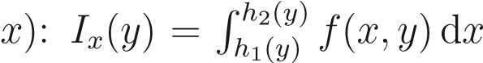. We then total up the contributions of strips by integrating I_{x} from the lowest value of y taken in D, say c, to the largest, say d
(see Fig. 7.1(ii)). (Either way, the final result does not depend on either x or y!)
(i) (ii)
2
D
D
y
y
c
d
y
=
g
1
(
x
)
y
=
g
2
(
x
)
x
=
h
(
y
)
x
=
h
2
(
y
)
a b x x
Figure 1: Different orders of integration over D.

