Lecture 1 Dental Equipment Technologies Dr.Muna Merza

Laboratory Engines and Handpiece

Laboratory Engines: is an electrical instrument that is used in all dental laboratory that placed either on or underwork table and always used in dry parts or wax working from laboratory and used specially in direct manual apparatus for cutting, grinding and polishing all prosthesis replacement, it is divided into two types:

A. Macro engines: It composed of 3 parts: -
1. Generator; it is the principle of the laboratory; it has 2 types; the first type rotates 24.000
rotation in each minute, and the second type rotate 6.000 rotation in each minute. It holds on the holder part on the table.
2. Rotated connection: it has 2 shapes, first by rotated silk or cable start from generator and end to the straight handpiece. But the second by cord procedure that constricted into several joints, connected by an entered tube, we can control the distance between handpiece and generator.
3. Speed control: it controls the speed of the generator and same time it will be movement
sarong, it has two types:
1st. Foot speed control: it is placed on the floor; we control the amount of pressure by a foot lever.
2nd. Knee speed control: stabilized on the table it contains rotation speed control and rotation "movement" switch.
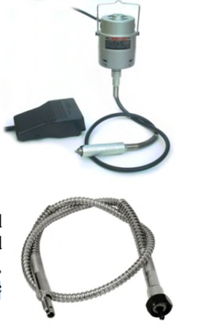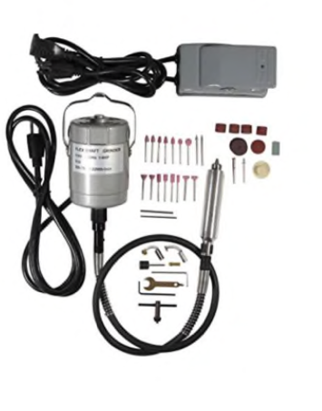

B. Micro engines: it consists of two parts:
1) Small generator: possible to be inside the handpiece, the rotation speed of the generator reaches more than 25.000 rotation in each minute.
2) Speed control: it is same the macro engine, but it has 3 types:
1. Table speed control: have silk connect it with the footswitch.
2. Foot speed control.
3. Knee speed control.
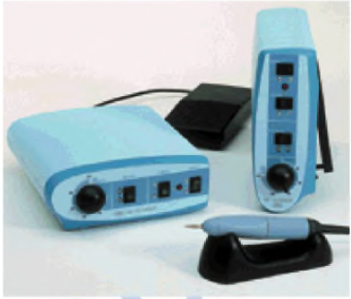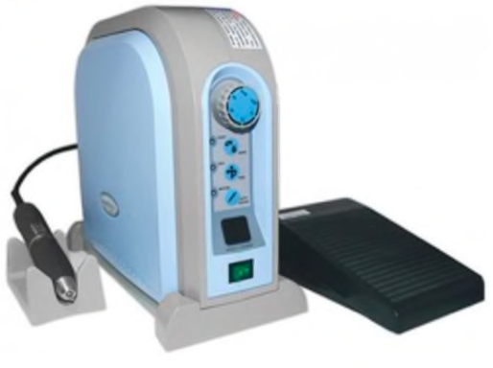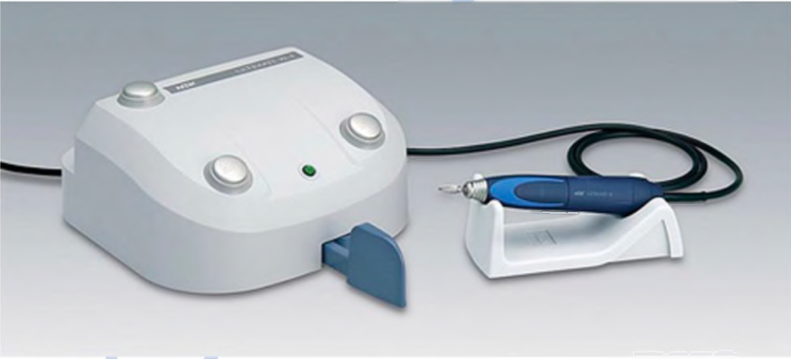

Handpieces
Types of handpieces:
1. Straight handpiece.
2. Right angle handpiece.

1. STRAIGHT HANDPIECE:
They are very important tools used in the prosthesis lab, have many types that differ in design, and each type has certain use.
The principal design for the straight handpiece is groups of rotated levers inside the tube, the base of the tube connects with the part that rotates it and the other end entering on it the cutting burs.
1. TYPES OF THE STRAIGHT HANDPIECE:
1.Ordinary handpiece: (mostly used)
Tools used in the lab and private clinic to grind the tooth, the speed of rotation must not exceed 15.000 rotations in each minute and for a period does not exceed 3 minutes.
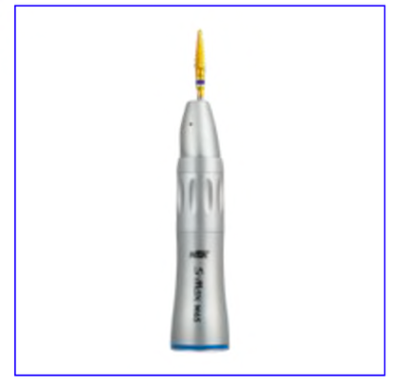

2. Doriot handpiece:
Like the ordinary handpiece, but the design differs, the speed of rotation must not exceed 20.000 rotation in each minute and for a period does not exceed 5 minutes.
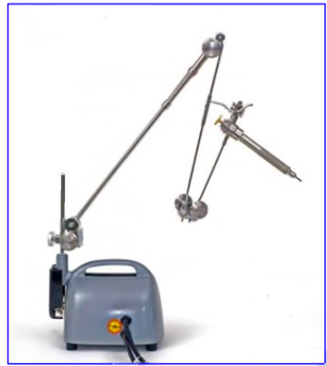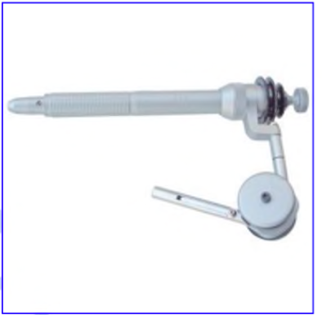

3. Laboratory handpiece:
Like the ordinary handpiece, but it is stronger, the speed of rotation reaches more than 25.000 rotation in each minute and for a period more than 5 minutes. Used with cable-driven lab macro engine.
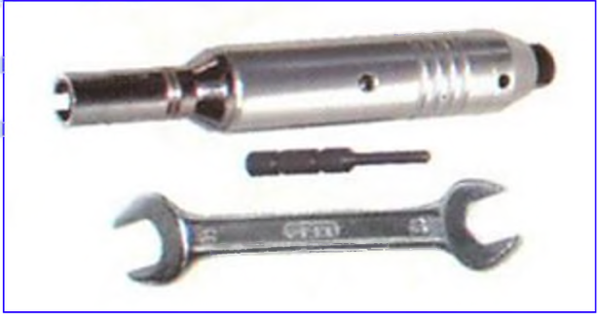

4. High torque lab handpiece:
Used in the chrome-cobalt lab, the speed of rotation reaches more than 50.000 rotations in each minute and withstand high pressure.

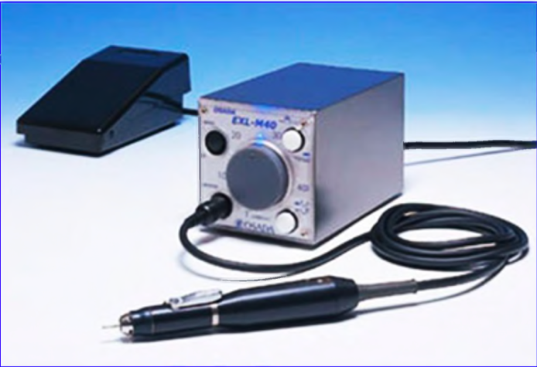

5. Micro-Straight handpiece:
This tool rotates when connected with a driven motor, the speed of rotation must not exceed 50.000 rotations in each minute. Note: 4 and 5 are the most developed handpiece types.
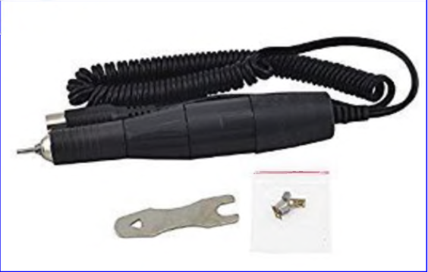

6. Air-driven handpiece:
It is the most recent type, rotates by pressured air only, the speed of rotation reach more than 60.000 rotation in each minute.

