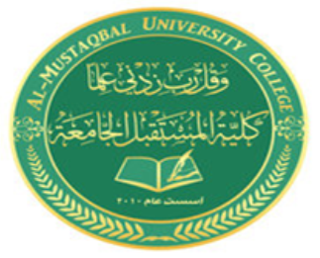

AL- Mustaqbal University College
Optometry Department
Lec.10
Part of the eye ball
Teaching assistant
Ali Hadi Alhussainy
2021-2022

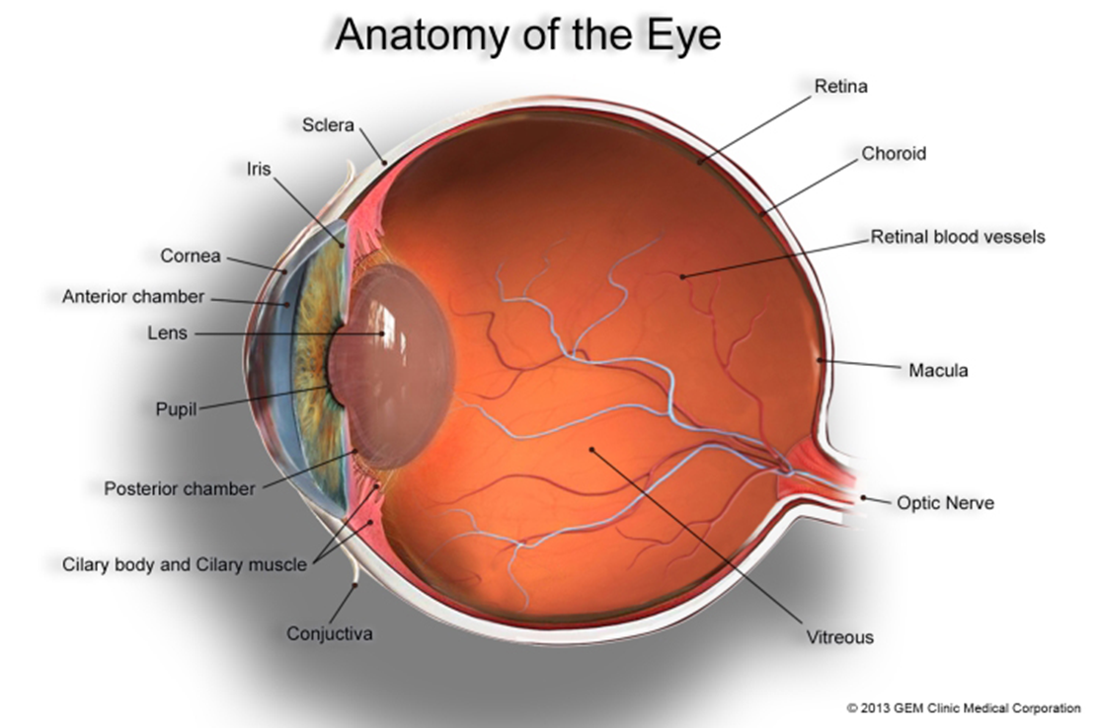

THANK YOU

