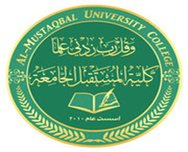
AL- Mustaqbal University College
Optometry Department Lec.1
Anatomical Terminology
Teaching assistant Ali Hadi Al-Husseini
2021-2022

Cavities

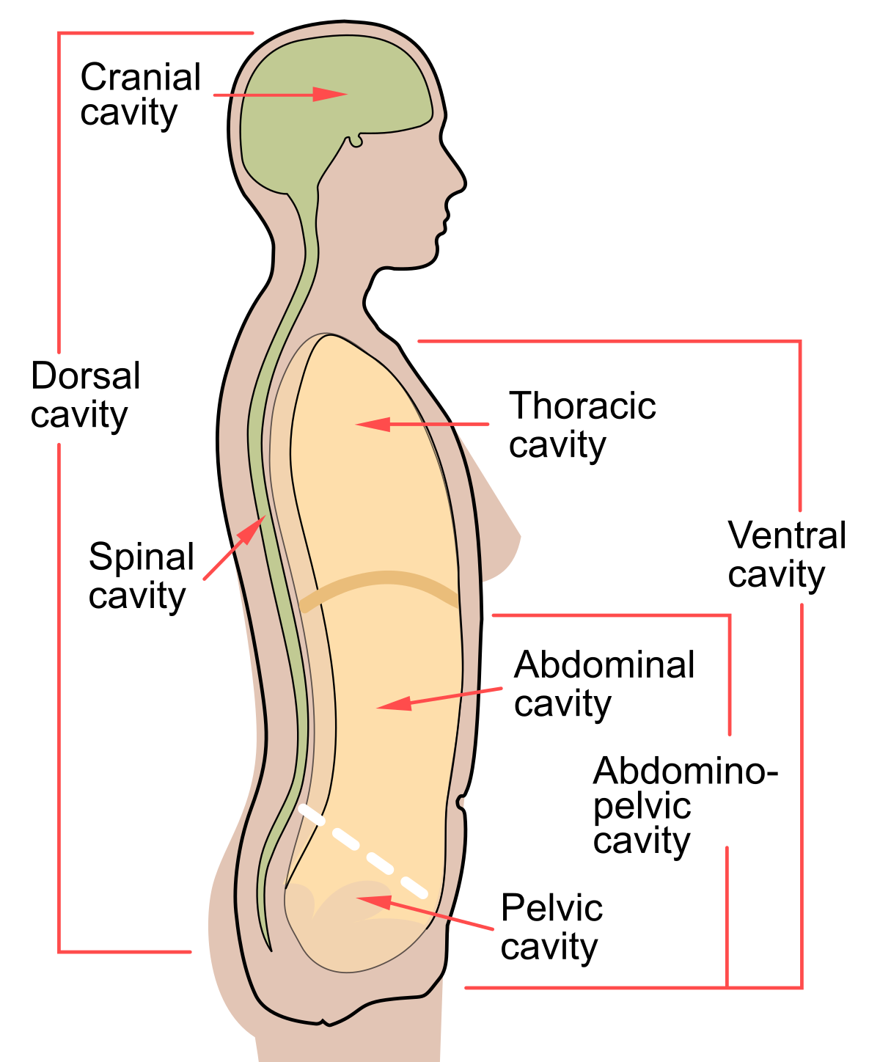

Thoracic cavity

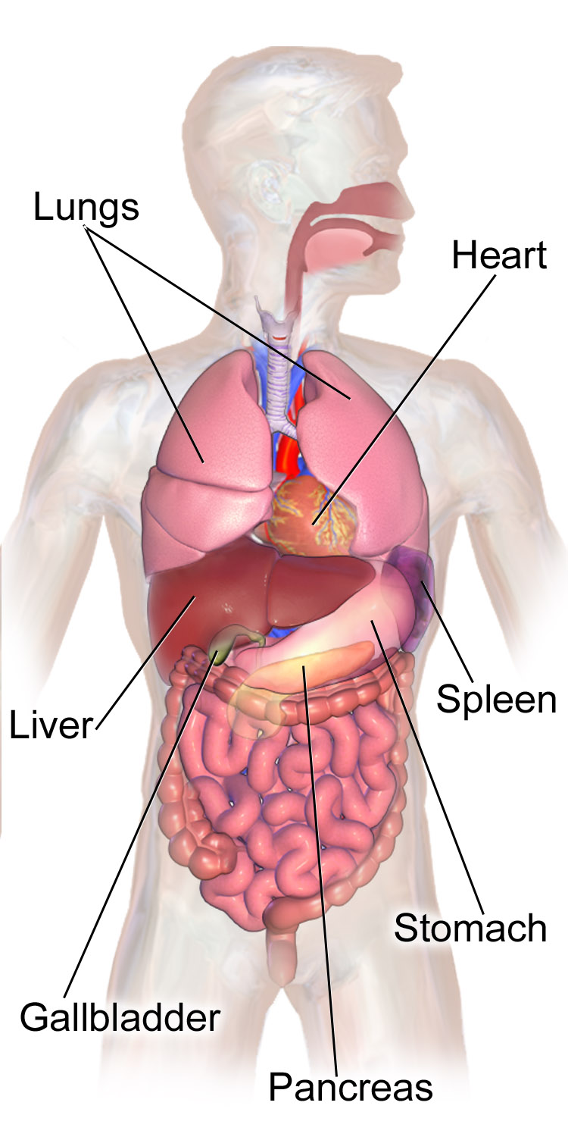
cranial cavity
