

Practical Pharmacognosy
2nd Stage
2nd semester

Dr. Hayder Ridha
Lab.3
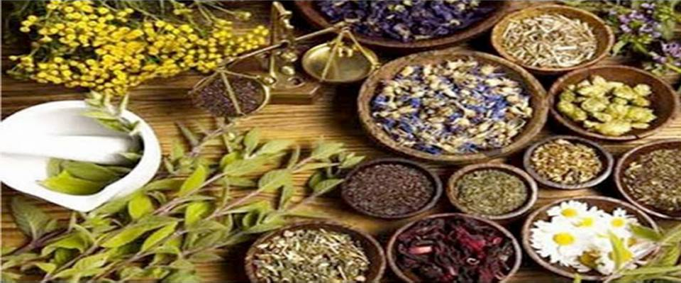



Cell Contents
- Cell contents which concerned in pharmacognosy are those which can be identified in vegetable drugs by microscopic examination or by chemical and physical tests.
- These cell contents represent either food storage products
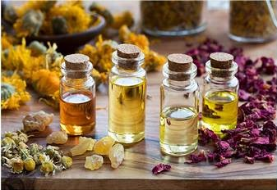
e.g. starch or by products of metabolism and these include carbohydrates, proteins, fixed oils, fats, alkaloids, purines, glycosides, V.O., gums, mucilage resins, tannins, calcium oxalate, calcium carbonate, and silica.

Starch:
- Starch occurs in granules of varying sizes in almost all organs of plants, found in roots, rhizomes, fruits, and seeds.
- Starch granules may be simple or compound.
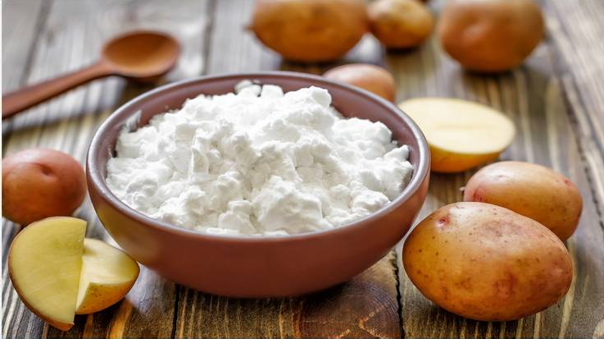

- Compound granules formed by aggregations of a large numbers of simple granules e.g. rice starch.

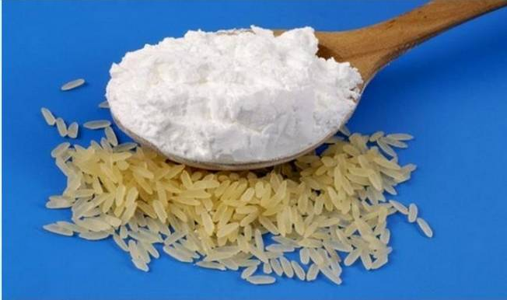

- Hilum is the starting point of formation of starch granules, the position of the hilum either central or eccentric.
- There are different shapes of hilum (dot, curved, multiple clefts).
- Concentric rings or striations (deposition of successive layers around the hilum) also appear in starch granules.

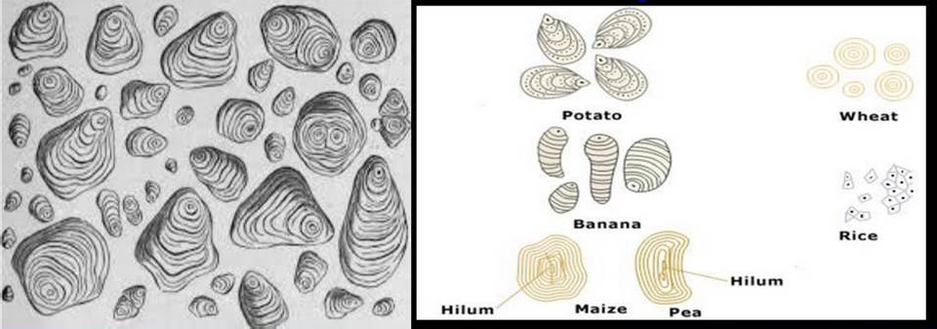

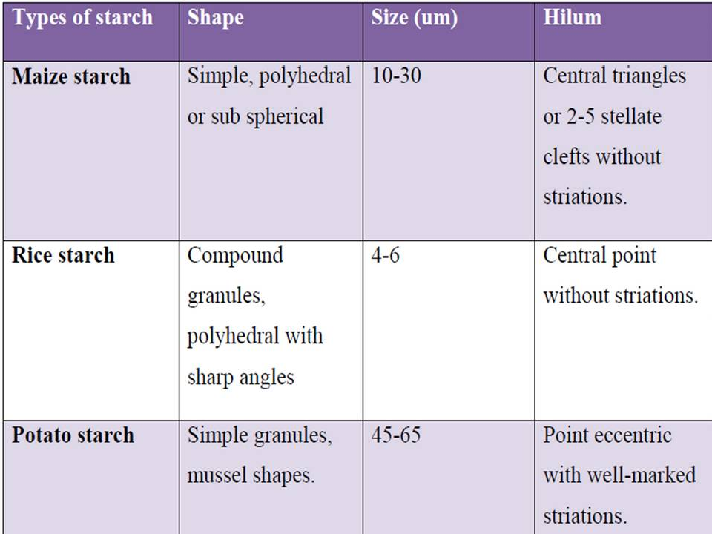

Calcium Oxalate:
- Calcium oxalate is a dimorphous salt and both types occur in plants, these are tetragonal or monoclinic systems, these both types differ in the amount of water of crystallization.
- Tetragonal system ( CaC2O4. 3H2O)
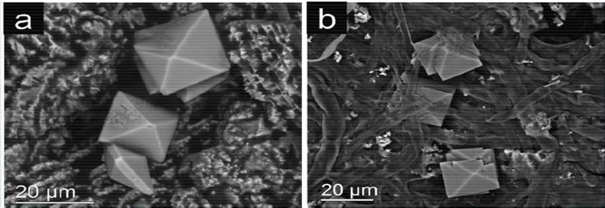
e.g. Prism (Senna, Hyoscymus), Rosset (Rhubarb, Strmonium).

- Monoclinic system ( CaC2O4. H2O). Excess oxalic acid shine in polarized light.
e.g. Raphide (Squill), Single needle crystal , Monoclinic prism.

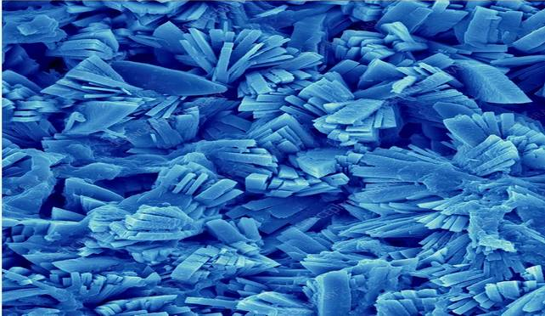

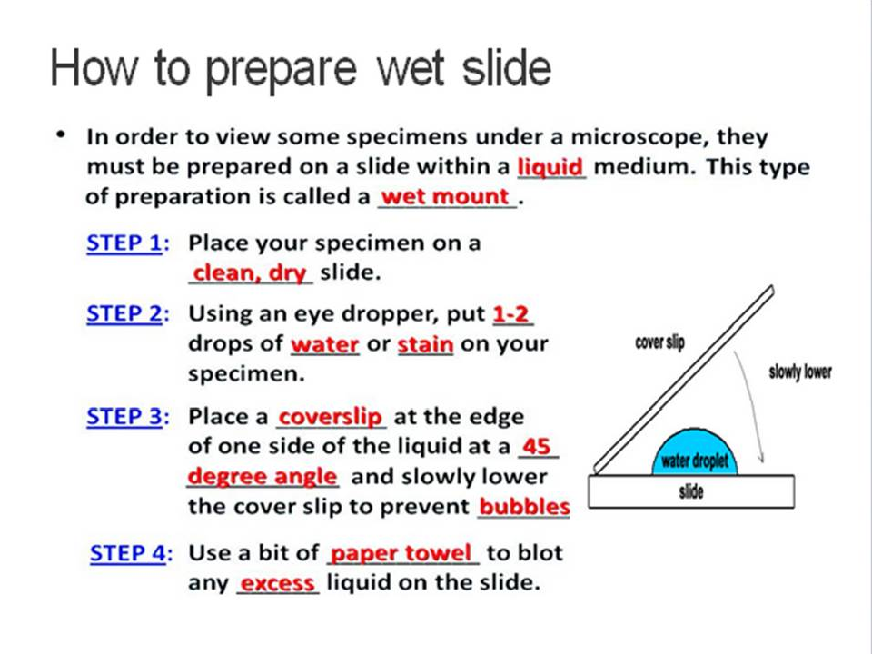

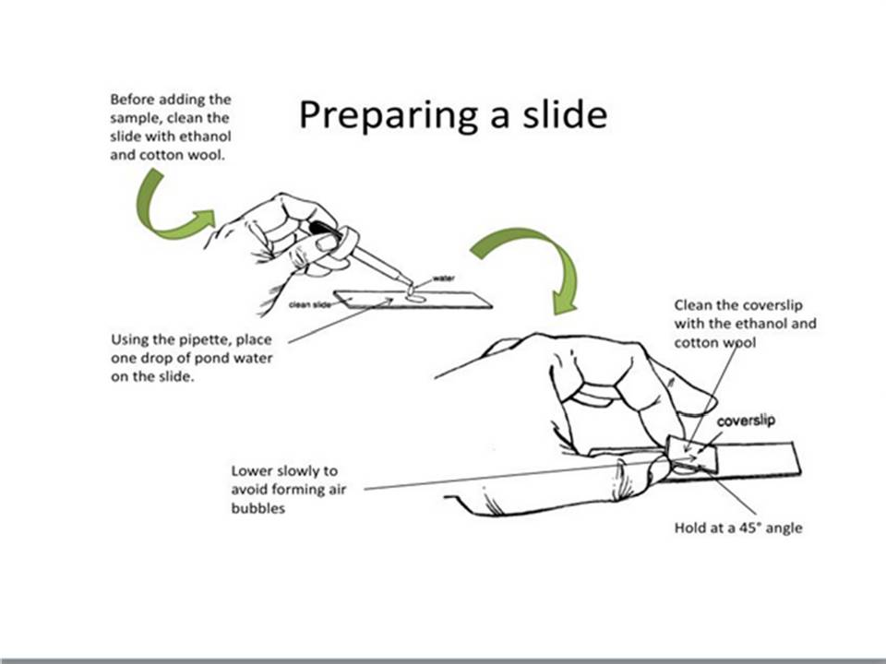

Observing Potato Starch Grains under microscope Materials: a potato, knife, slides, cover slips, water, iodine Procedure:
  - Cut the potato in half and scrape a little of the potato onto the
microscope glass slide. by use knife There should not be any large potato pieces on the glass.
  - Place a small drop of water on the “potato juice” and then place the glass cover slip on top.
  - Observe using the microscope.
  - repeat experiment but Place a drop of the dilute iodine instead of water on potato juice and then place cover glass.
  - You should be able to see how the starch grains change color. The iodine will react with the starch and turn it blue-black.

EXTRACTION OF STARCH FROM POTATO
Aim: 1) To isolate the starch from the given potato sample .
2)Calculate the yield of starch.

Principle:
    - Starch is an important polysaccharide found in plant sources.
    - The microscopic appearance of starch is in the form of granules.
    - Starch is insoluble in water and rapidly.

Materials Required: Potato, Muslin Cloth, Watch Glass, Mortar and Pestle, Distilled water.

Procedure:
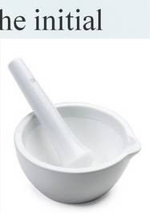
- Take the weight of potato sample
- Cut raw potato into small pieces, and record the initial weight.
- Grind them in a motor and pestle with sufficient water.
- Collect the potato homogenate into a beaker and add enough water.
- Then filter the homogenate through a muslin cloth to remove the particles.
- Allow the filtrate to settle. Starch rapidly settles at the bottom. Decant the starch free supernatant carefully
- Wash 3-4 times and decant the supernatant. Collect the compact mass of starch and allow it to dry.

Calculation

- The weight of potato sample = ( ) g
- The weight of filter paper = ( ) g
- The weight of filter paper with starch = ( ) g
3) The yield of starch = ( ) g



