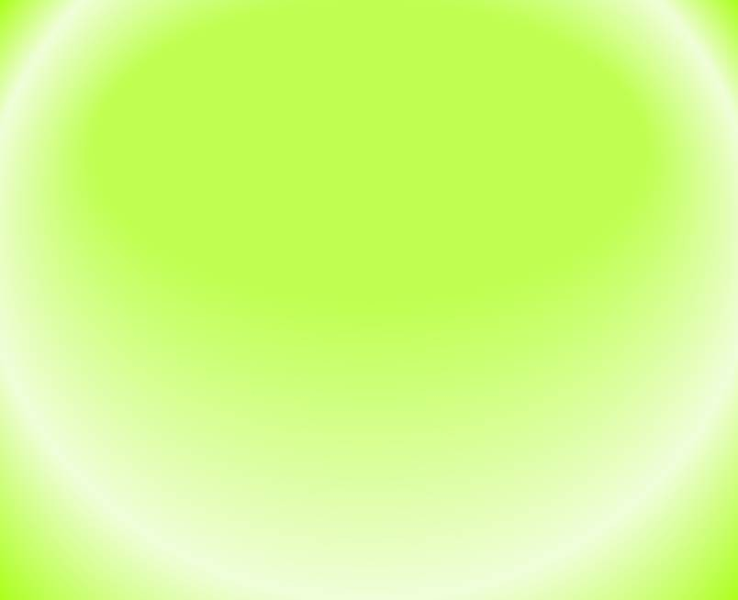

Practical Pharmacognosy
2nd Stage
2nd semester
Dr. Hayder Ridha

Lab.2
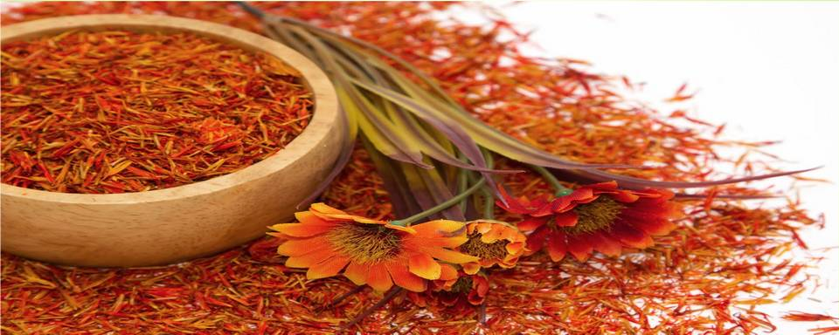


Morphological and microscopically examination of crude drugs and cell inclusions
- For convenience of study, drugs may be arranged not only according to families and chemical constituents, but also into such morphological groups as barks, roots, leaves, seeds, etc. in another word drugs can be arranged into :

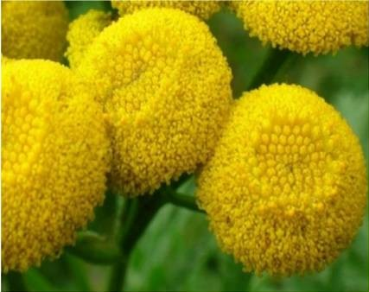
Organized.
- Non-organized drugs.

Organized drugs:

Leaves and tops (herbs)
These consist of stems and leaves often associated with flowers and young fruits.

Barks
Barks consist of all tissues outside the cambium.

Woods
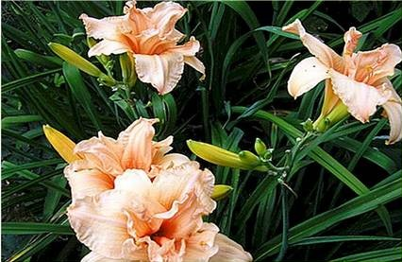
Wood consists of the secondary tissues produced by the cambium or its inner surface.

Leaves or leaflets.
- Inflorescences and flowers. 6- Fruits.
7- Seeds.

Unorganized drugs:
These include:
fixed oils, fats and waxes; volatile oils; resins, oleoresins, oleo-gum-resins, balsams and gums, dried juices, extracts.

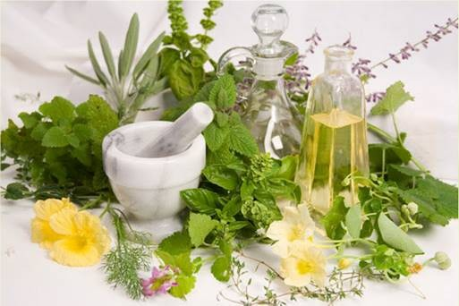

Cell differentiation:
- The cell wall
- Parenchymatous tissue
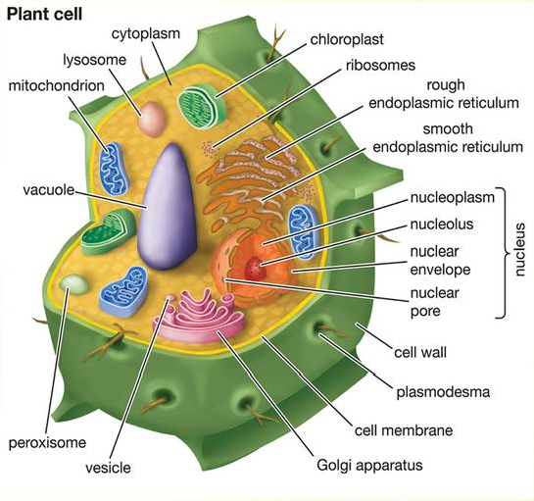
- The epidermis
- Epidermal trichomes
- The endodermis
- Cork tissue
- Collenchyma
- Sclereids
- Fibers
- Xylem
- Secretory tissue

1-The cell wall
There are different types of cell wall:
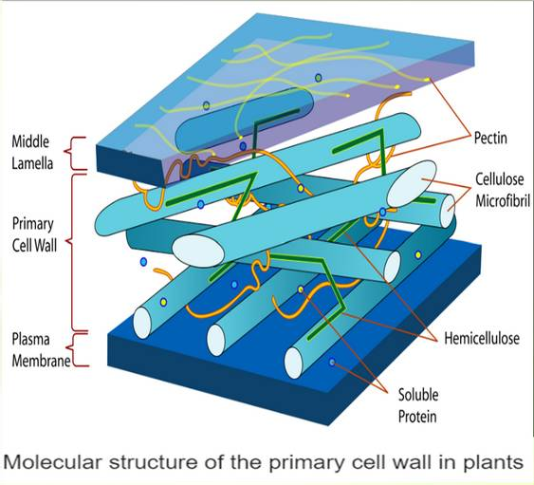
- Cellulose wall
- Lignified wall
- Chitinom wall
- Cutinized wall
- Mucillaginum wall

2) Paranchymatous tissue
- In plants, "parenchyma" is one of the three main types of ground tissue, and the most common.
- It can be distinguished through their thin cell wall
as compared to other cells.
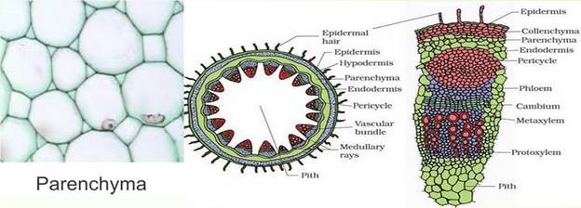
- Parenchyma cells make up the bulk of the soft parts of plants, including the insides of leaves, flowers and fruits (but not the epidermis or veins of these structures).

The epidermis
Single layer of cells covering the whole plant, the structure of the epidermis and stomata are of first important in the microscopically identification of leaves.
e.g. Strait – walled epidermis in Senna leaves, waxy walled in Belladonna leaves and beaded wall in digitalis.

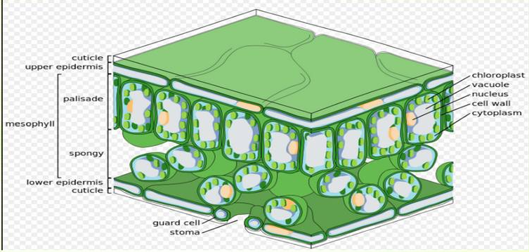

Types of Stomata:
  - Anomocytic stomata: Cells resembling the other epidermal cells may surround stomata.
e.g. Digitalis purpurea leaves.
▪ Anisocytic stomata: With the stomata surrounded by 3 or 4 subsidiary cells, one of which is markedly smaller than other.
e.g. Hyoscymus niger and Atropa belladonna leaves.
  - Paracytic stomata: With two subsidiary cells with their long axis parallel to the pore. e.g. Cassia acutifolea ( Senna leaves).
  - Diacytic stomata: With two subsidary cells with their long axis at right angles to the pore of the stomata.
e.g. Mentha piperita ( Pepperment).
  - Actinocytic stomata: Subsidary cells are arranged along the radii of the circle. e.g. Pilocarpus jaborandi.

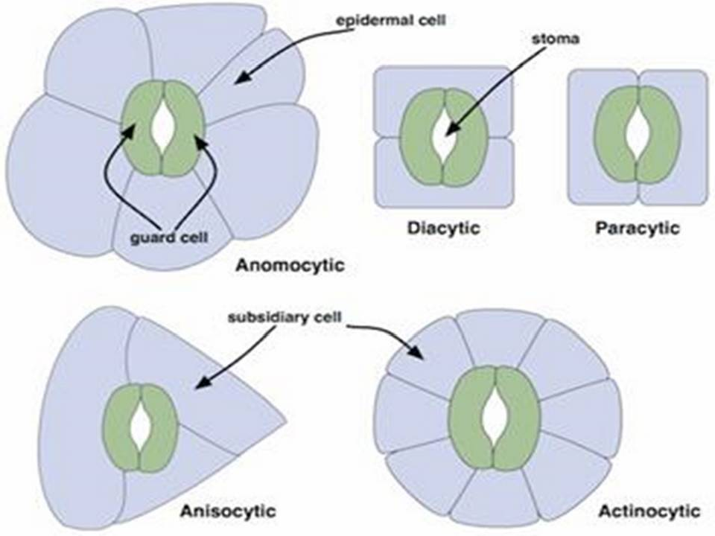

- Epidermal Trichomes:
Most leaves, stems , flowers ,fruit and seeds possess hairs or trichomes one kind or another . Many show hairs of more than one type .

Covering Trichomes – example 1- Unicellular
From Senna leaves.
- Multicellular Unbranched, Uniseriate From Digitalis leaves.

Multicellular Branched
Stellate. From Witch – Hazel leaves.

Multicellular Branched, Candelabra

- Muticellular Branched, T-Shaped
From Pyrethrum.

Cystolytic Trichomes
From Cannabis

Glandular Trichomes – Example 1- Unicellular stalk with
From Digitalis leaves.

Multicellular Uniseriate Stalk
From Hyoscymus niger.

Multicellular Multiseriate Stalk
.

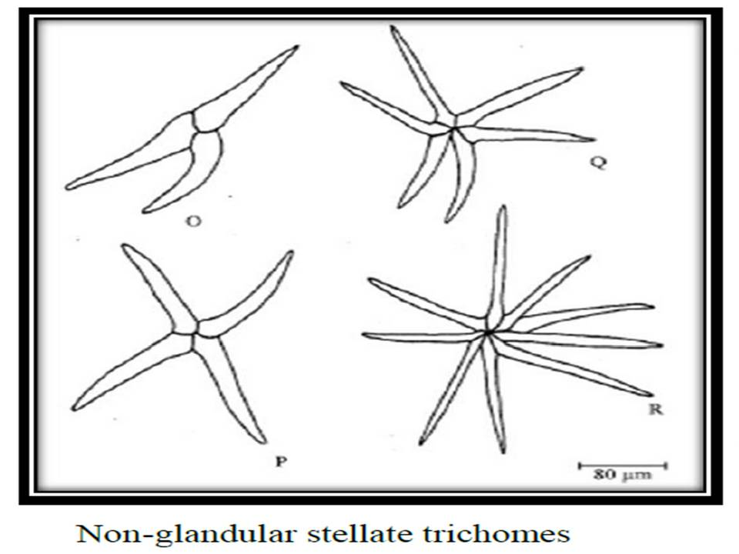

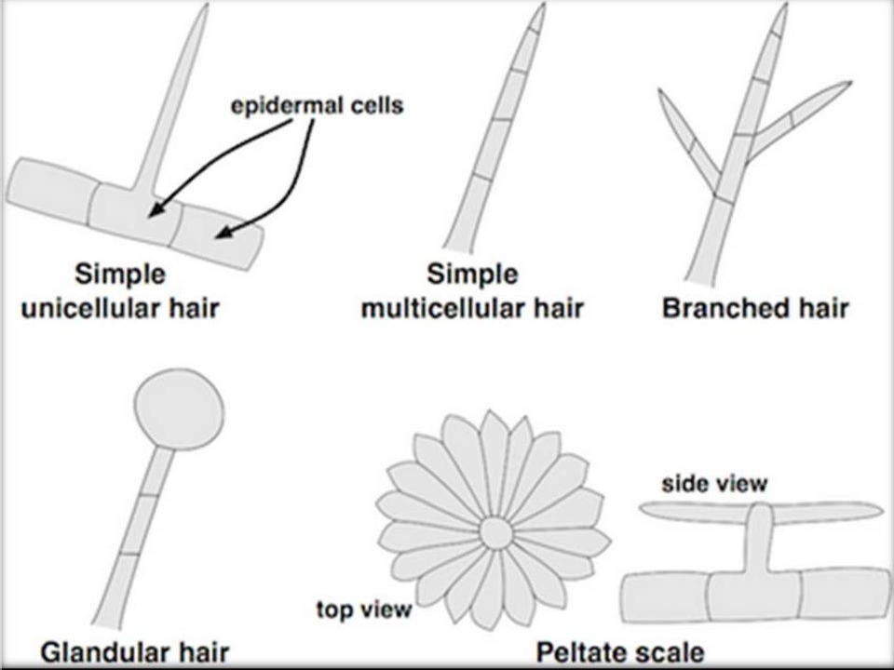

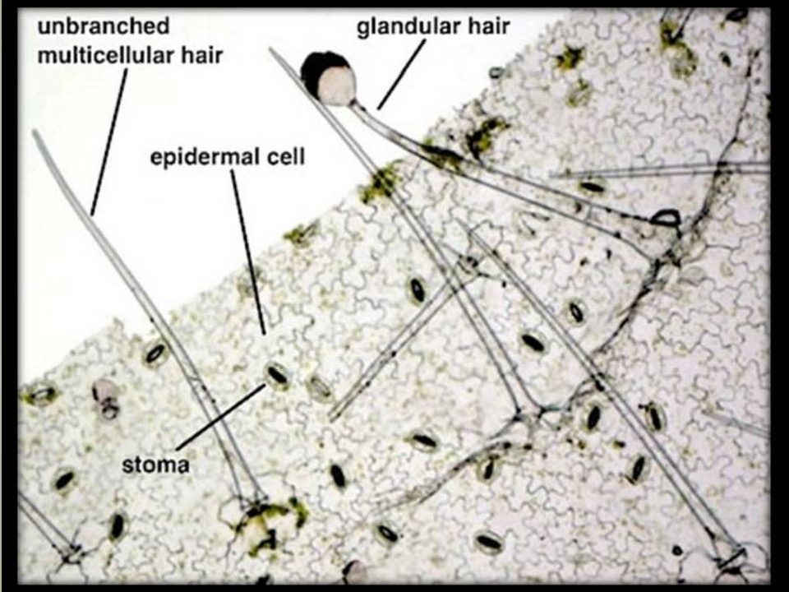

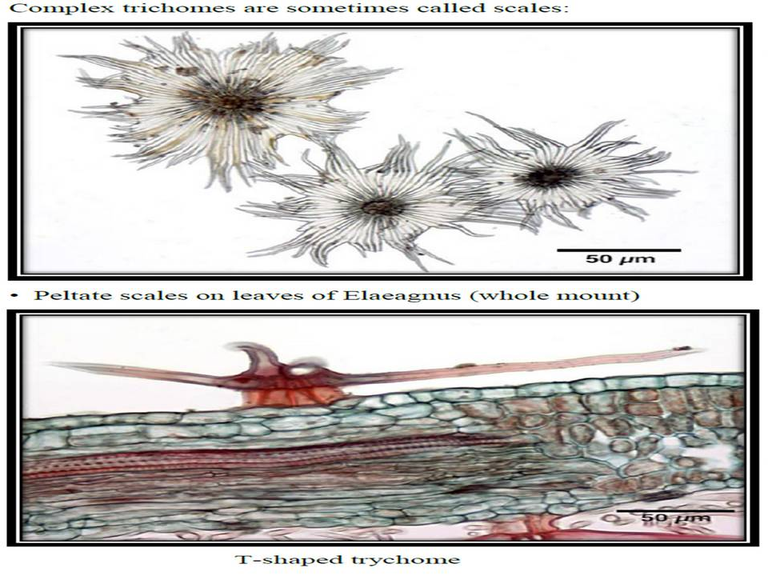

- Cork tissue: is made up of dead cells with thick walls, with no intercellular spaces, found in older stems and roots of dicot plants.
- Collenchyma: Is the tissue frequently found underneath the epidermis of many stems and leaf stalks.
- Fibers: Tissue composed of spindle- shaped or elongated cells with pointed ends and thick walled.
e.g. ginger.
Fibers are best differentiated on the basis of the tissue in which they occur. e.g. Cortical fibers, pericyclic fibers, xylem fibers and phloem fibers.

Xylem:
Elongated water- conducting cell with lignified and thickened – pitted cell wall.
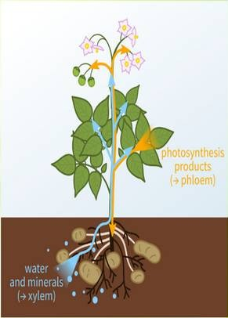
- Vessels: Are the fundamental conducting elements of the xylem of the angiosperms. There are different types of vessels:
a-Spiral (Senna and Belladonna).
- Annular (Senna and belladonna).
- Reticulate ( Gentian, Ginger, Rhubarb).
- Pitted vessels.

