المحاضرة 4 تشريح وفسلجه ( تشريح الجهاز الهضمي البشري ) / قسم هندسة الاجهزه الطبيه / أ . د . خيري عبدالله داود
Lecture 4 Anatomy and Physiology
Prof. Ph.D. Khairy Abdullah Dawood
Anatomy and Physiology of Human Digestive System
Length of gastrointestinal tract 30 feet in adult .
Digestive system divided to 8 parts :
Mouth , Esophagus , Stomach , Small intestine , Large intestine , Liver , Pancreas , Gall bladder .
Mouth : is an oval shaped as a cavity inside the skull .
Structures of the mouth :
Lips , gum , teeth , hard and soft palate , tongue and salivary glands .
Tongue : Is a muscular organ (skeletal muscle ) , covered by mucous membrane . There are thousands of Papillae ( taste buds ) .
There are four types of taste buds functionally : Sweet , sour , bitter , and salty ( Look to the picture ) .
Salivary glands : 3 paired , 2 parotid , 2 sublingual , 2 submandibular , all these glands produce saliva .
Teeth ; Adult teeth
8 Incisors ( 4 top and 4 bottom )
4 Cuspids (canine , 2 top and 2 bottom )
8 premolars ( 4 top and 4 bottom )
12 molars ( 6 top and 6 bottom ) including 4 wisdom teeth .
Total 32 tooth .
Baby teeth or milk teeth 20 ( 10 top and 10 bottom )
4 incisors 2 canine 4 molars
Pharynx : Conducting zone of digestive system and respiratory system . Muscles of pharynx push food to esophagus .
Epiglottis : flap elastic cartilage attached to the larynx prevent food from going into trachea .
Esophagus : Food pipe , muscular tube passes from the pharynx to the stomach . It passes posterior to the trachea , and enter the stomach through a hole of diaphragm , its length 25 cm .
Diaphragm : It is important part of the body for digestive system and respiratory system . It is a muscular membrane separate thoracic cavity from the abdominal cavity .
Stomach :
- Stomach is a dilated structure of GIT (gastro-intestinal tract )muscular organ located on the left side of upper abdomen .
- Stomach is located between esophagus and duodenum ( first part of small intestine ) .
- Stomach have four anatomical divisions : Cardia , Fundus , body , pylorus .
- Stomach have two sphincter (muscular valve ) , upper between esophagus and stomach , lower between stomach and duodenum ( first part of small intestine).
- Wall of human stomach consists of mucosa , submucosa , muscles ( smooth muscles ) , Subserosa , and serosa ( peritoneum ) .
Functions of Stomach :
1 – Second stage of digestion after chewing . 2 – Stomach release Pepsin which digest proteins to polypeptide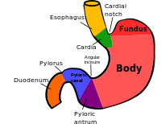sid . 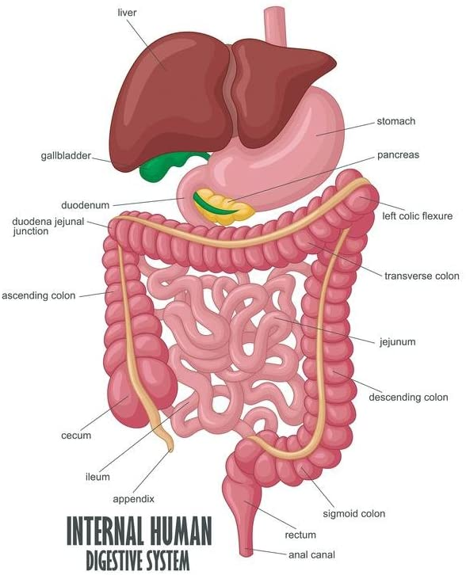
3 – It secrete hydrochloric acid which provides acidic medium to kill or inhibit bacteria .
4 – Digested food converted to Chyme , moved down slowly by peristaltic movement .
Instruments or devices used in diagnosis and treatment of Digestive system :
1 – Gastroscope
2 - Duodenoscope 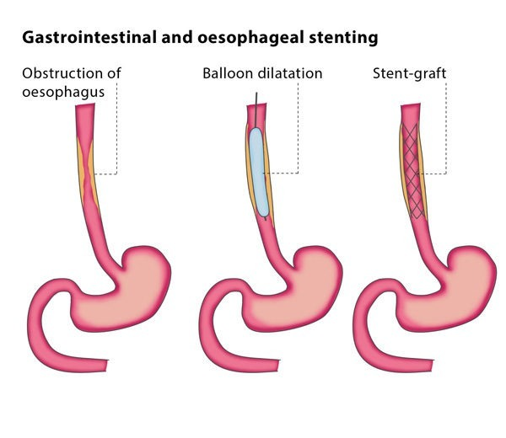
3 – Colonscope
4 – Sonar scan
5 - Balloon dilator

